**Practical 1**

**Aim : Study of Cloud Computing & Architecture**

1. **Aim:**To study cloud architecture and cloud computing model.
2. **Objectives:** From this experiment, the student will be able to

* provide an overview of concepts of Cloud Computing .
* To encourage students to indulge into research in Cloud Computing.

1. **Outcomes:** The learner will be able to

* understand and appreciate cloud architecture.
* analyze the local and global impact of computing on

individuals, organizations, and society.

* recognize the need for, and an ability to engage in life-long learning.

1. **Hardware / Software Required:**Ubuntu operating system, Internet
2. **Theory:**

Cloud computing enables companies to consume compute resources as a utility -- just like electricity -- rather than having to build and maintain computing infrastructures in-house. Cloud computing promises several attractive benefits for businesses and end users.

Three of the main benefits of cloud computing include:

• [Self-service provisioning](http://searchcloudprovider.techtarget.com/definition/User-self-provisioning): End users can spin up computing resources for almost any type of workload [on-demand](http://searchdatacenter.techtarget.com/definition/on-demand-computing).

• [Elasticity](http://searchcio.techtarget.com/definition/IT-elasticity): Companies can scale up as computing needs increase and then scale down again as demands decreases.

[Pay per use](http://searchcio.techtarget.com/definition/metered-services): Computing resources are measured at a granular level, allowing users to pay only for the resources and workloads they use.

Cloud computing services can be [Private](http://searchcloudcomputing.techtarget.com/definition/private-cloud), [Public](http://searchcloudcomputing.techtarget.com/definition/public-cloud) or [Hybrid](http://searchcloudcomputing.techtarget.com/definition/hybrid-cloud).

Private cloud services are delivered from a business' data center to internal users. This model offers versatility and convenience, while preserving management, control and security. Internal customers may or may not be billed for services through [IT chargeback](http://searchaws.techtarget.com/definition/IT-chargeback-showback).

In the Public cloud model, a third-party provider delivers the cloud service over the Internet. Public cloud services are sold on-demand, typically by the minute or the hour. Customers only pay for the [CPU](http://whatis.techtarget.com/definition/CPU-central-processing-unit) cycles, [storage](http://searchstorage.techtarget.com/definition/storage) or [bandwidth](http://searchenterprisewan.techtarget.com/definition/bandwidth) they consume.  Leading public cloud providers include Amazon Web Services ([AWS](http://whatis.techtarget.com/definition/Amazon-Web-Services-AWS)), Microsoft [Azure](http://searchwindowsserver.techtarget.com/definition/Microsoft-Azure-Windows-Azure), IBM/SoftLayer and [Google Compute Engine](http://searchaws.techtarget.com/definition/Google-Compute-Engine).

Hybrid cloud is a combination of public cloud services and on-premises private cloud – with orchestration and automation between the two.

Companies can run mission-critical workloads or sensitive applications on the private cloud while using the public cloud for workloads that must scale on-demand. The goal of hybrid cloud is to create a unified, automated, scalable environment which takes advantage of all that a public cloud infrastructure can provide, while still maintaining control over mission-critical data.

Types of cloud computing:

IT people talk about three different kinds of cloud computing, where different services are being provided for you. Note that there's a certain amount of vagueness about how these things are defined and some overlap between them.

* Infrastructure as a Service (IaaS) means you're buying access to raw computing hardware over the Net, such as servers or storage. Since you buy what you need and pay-as-you-go, this is often referred to as utility computing. Ordinary web hosting is a simple example of IaaS: you pay a monthly subscription or a per-megabyte/gigabyte fee to have a hosting company serve up files for your website from their servers.
* Software as a Service (SaaS) means you use a complete application running on someone else's system. Web-based email and Google Documents are perhaps the best-known examples. Zoho is another well-known SaaS provider offering a variety of office applications online.
* Platform as a Service (PaaS) means you develop applications using Web-based tools so they run on systems software and hardware provided by another company. So, for example, you might develop your own ecommerce website but have the whole thing, including the shopping cart, checkout, and payment mechanism running on a merchant's server. Force.com (from salesforce.com) and the Google App Engine are examples of PaaS.
* Advantages and disadvantages of cloud computing

Advantages: The pros of cloud computing are obvious and compelling. If your business is selling books or repairing shoes, why get involved in the nitty gritty of buying and maintaining a complex computer system? If you run an insurance office, do you really want your sales agents wasting time running anti-virus software, upgrading word-processors, or worrying about hard-drive crashes? Do you really want them cluttering your expensive computers with their personal emails, illegally shared [MP3](http://www.explainthatstuff.com/how-mp3players-work.html) files, and naughty YouTube videos—when you could leave that responsibility to someone else? Cloud computing allows you to buy in only the services you want, when you want them, cutting the upfront capital costs of computers and peripherals. You avoid equipment going out of date and other familiar IT problems like ensuring system security and reliability. You can add extra services (or take them away) at a moment's notice as your business needs change. It's really quick and easy to add new applications or services to your business without waiting weeks or months for the new computer (and its software) to arrive.

Disadvantages: Instant convenience comes at a price. Instead of purchasing computers and software, cloud computing means you buy services, so one-off, upfront capital costs become ongoing operating costs instead. That might work out much more expensive in the long-term.

If you're using software as a service (for example, writing a report using an online word processor or sending emails through webmail), you need a reliable, high-speed, [broadband](http://www.explainthatstuff.com/howbroadbandworks.html) Internet connection functioning the whole time you're working. That's something we take for granted in countries such as the United States, but it's much more of an issue in developing countries or rural areas where broadband is unavailable.

If you're buying in services, you can buy only what people are providing, so you may be restricted to off-the-peg solutions rather than ones that precisely meet your needs. Not only that, but you're completely at the mercy of your suppliers if they suddenly decide to stop supporting a product you've come to depend on. (Google, for example, upset many users when it [announced](http://www.zdnet.com/google-apps-axes-export-support-for-doc-and-other-old-microsoft-office-formats-7000004884/) in September 2012 that its cloud-based Google Docs would drop support for old but de facto standard Microsoft Office file formats such as .DOC, .XLS, and .PPT, giving a mere one week's notice of the change—although, after public pressure, it later extended the deadline by three months.) Critics charge that cloud-computing is a return to the bad-old days of mainframes and proprietary systems, where businesses are locked into unsuitable, long-term arrangements with big, inflexible companies. Instead of using "generative" systems (ones that can be added to and extended in exciting ways the developers never envisaged), you're effectively using "dumb terminals" whose uses are severely limited by the supplier. Good for convenience and security, perhaps, but what will you lose in flexibility? And is such a restrained approach good for the future of the Internet as a whole? (To see why it may not be, take a look at Jonathan Zittrain's eloquent book [The Future of the Internet—And How to Stop It](http://futureoftheinternet.org/).)

1. **Conclusion:**

Cloud computing enables a convenient and on-demand network access to a wide range of resources. The different services and also the deployment models allow flexible service provider interaction with minimal human intervention. It saves costs but also can lead to risk issues and suspension of resources when in huge quantity.

**Practical 2**

**Aim : Installation and Configuration of Virtualization using KVM.**

Prerequisite: 1.Virtual Box/Virtual Machine

2. Ubuntu iso file

Steps: Installation of Ubuntu Virtual Box

Step 1:Start the virtualBox and Click on New

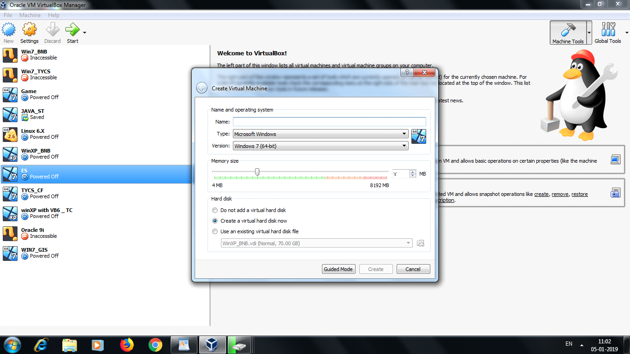

Step 2: Now Give the name as Cloud_Computing

Select type Linux

Version Ubuntu(32bit)/Ubuntu64(bit)

And Select Virtual HardDisk

And Click on Create button

Step 3: Now start the Virual Machine and Select the Ubuntu iso file and click on start

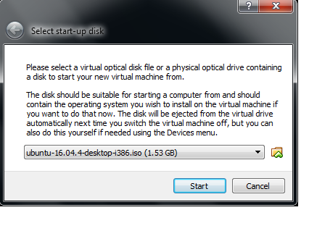

Now see the below ScreenShots for installation

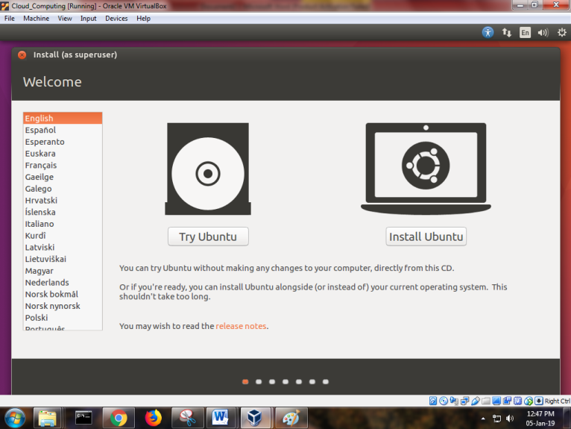

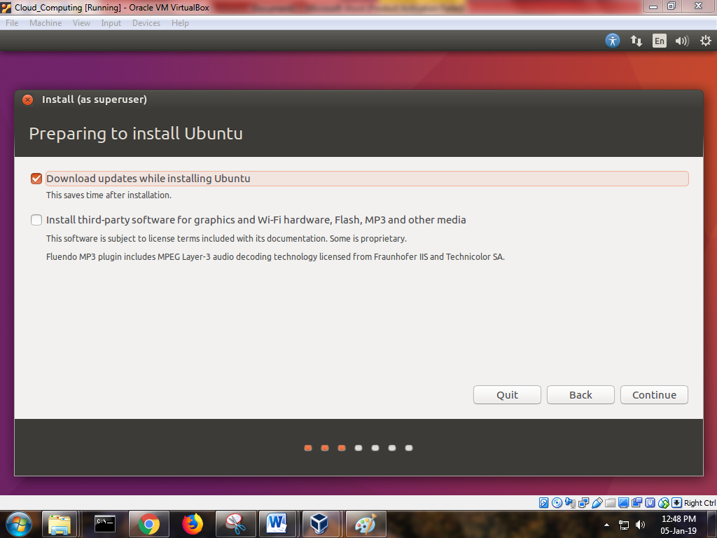

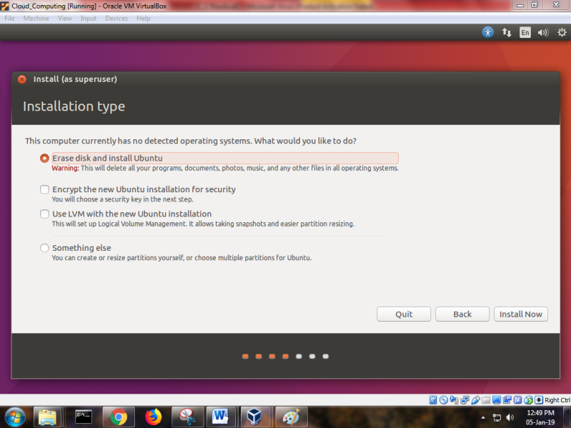

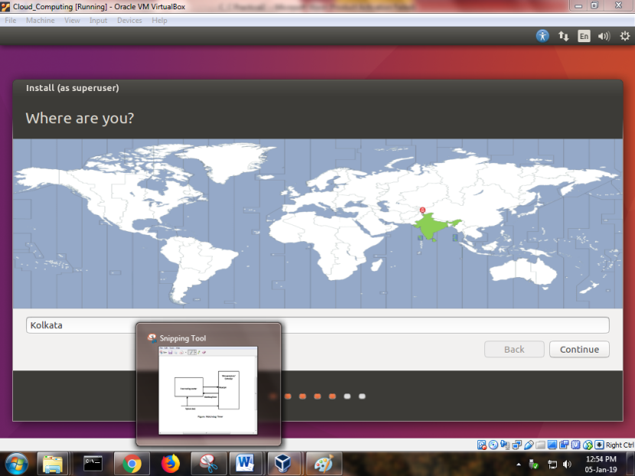

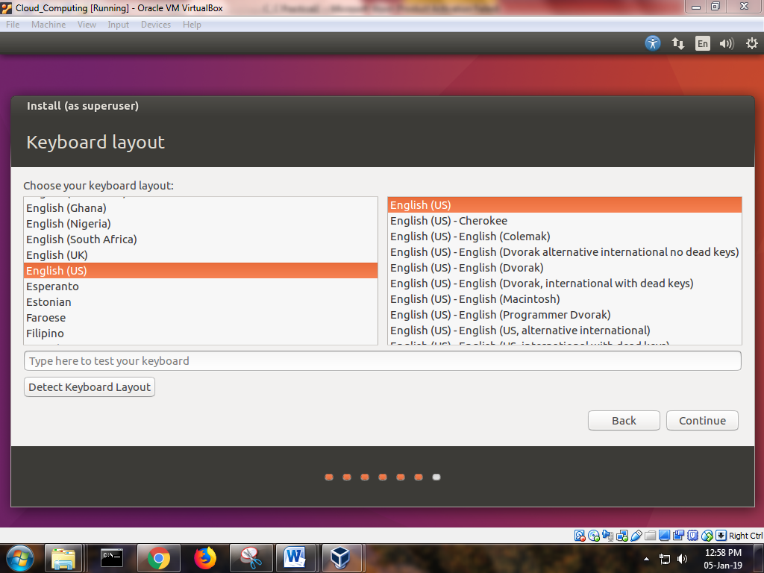

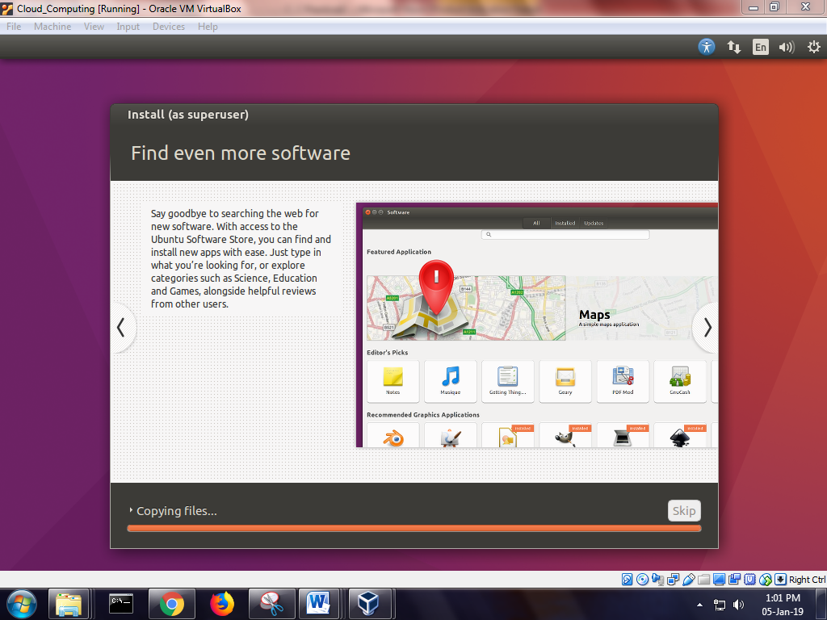

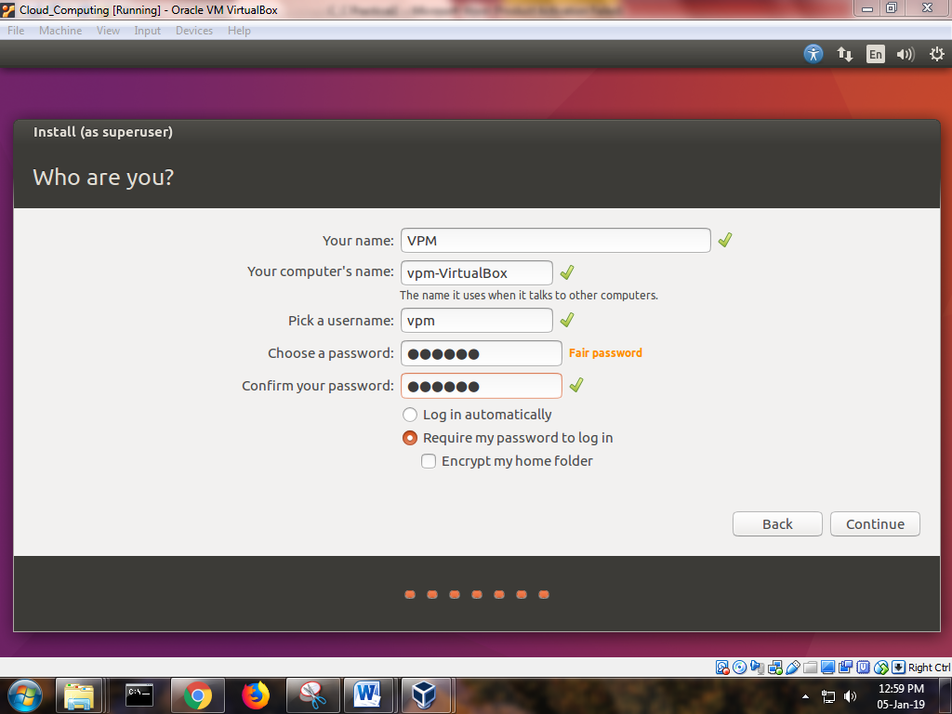

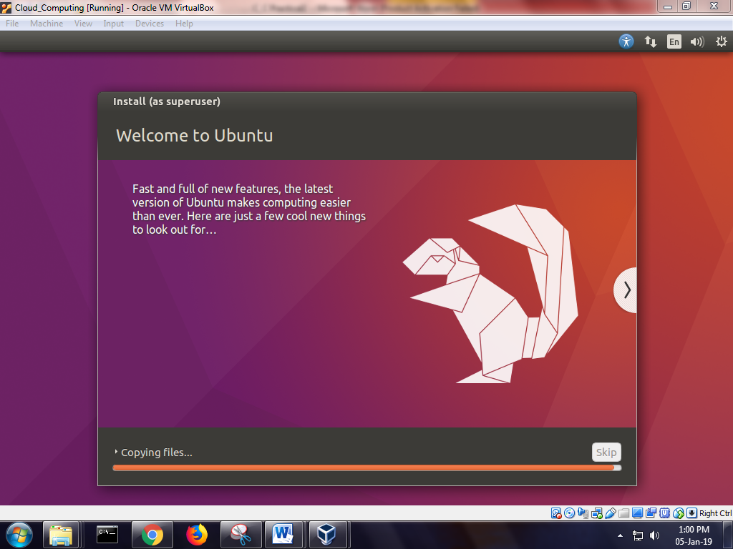

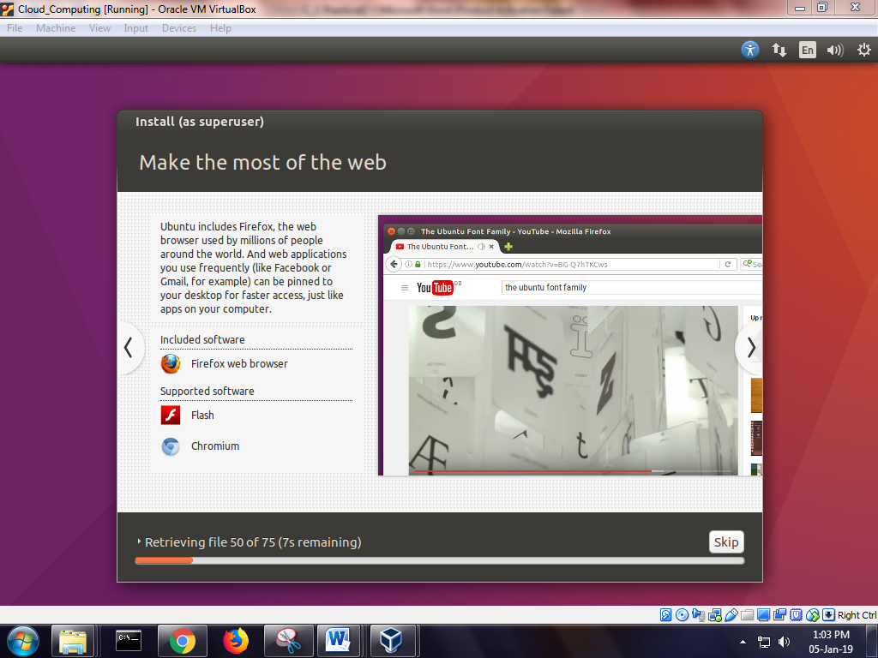

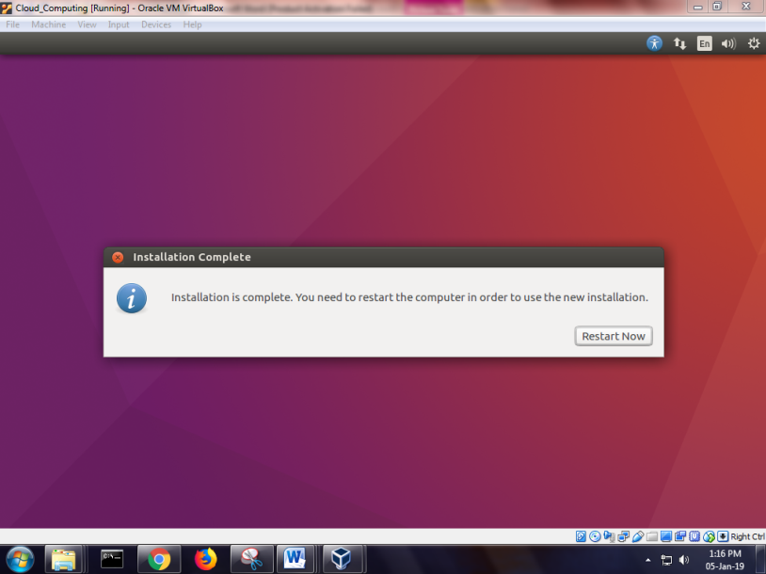

Step4 : Now open the terminal and perform the following command

sudogrep -c "svm\|vmx" /proc/cpuinfo

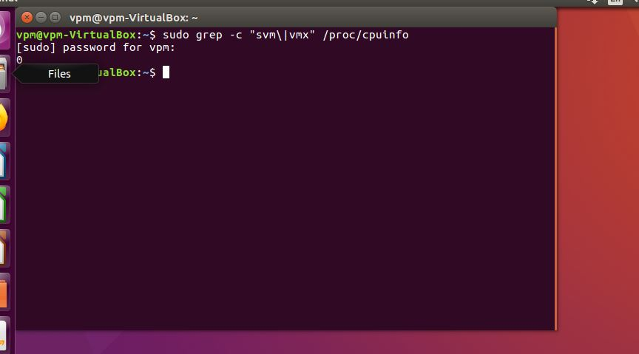

sudo apt-get install qemu-kvmlibvirt-bin bridge-utilsvirt-manager

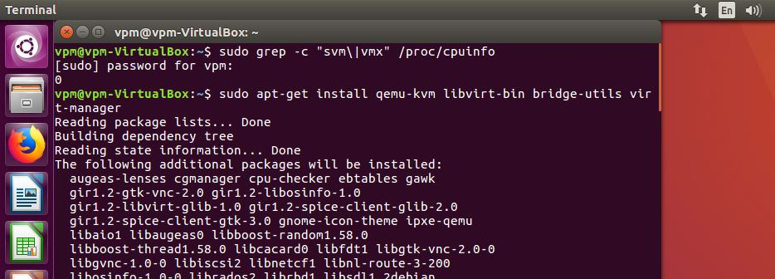

Sudoadduser shraddha

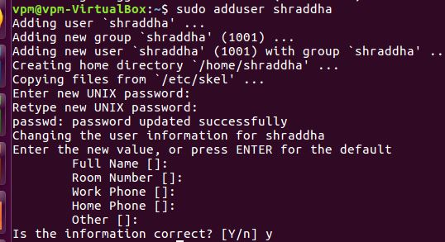

Sudoadduser shraddha libvirtd

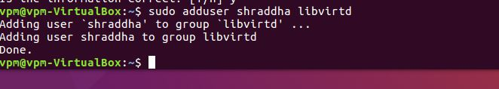

virsh -c qemu:///system list

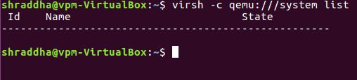

Virt-manager

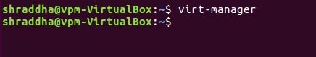

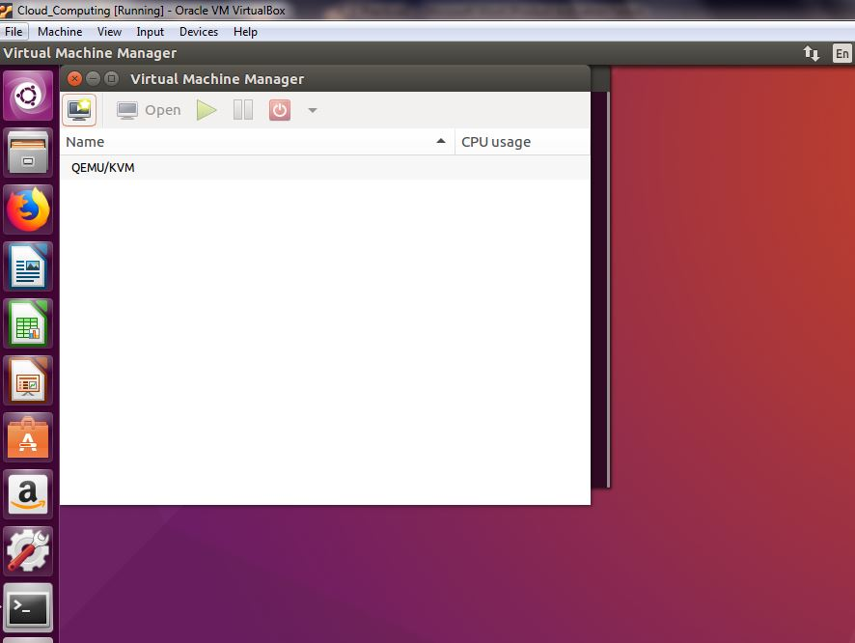

Click on new virtual machine in qemu and perform the following step

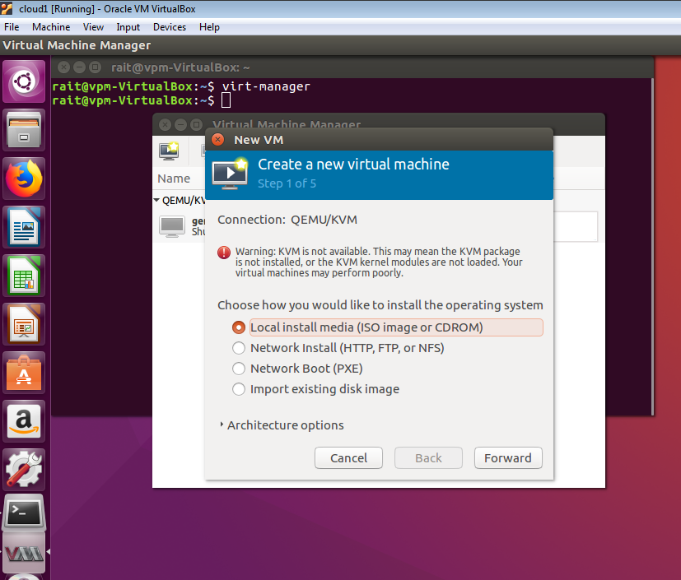

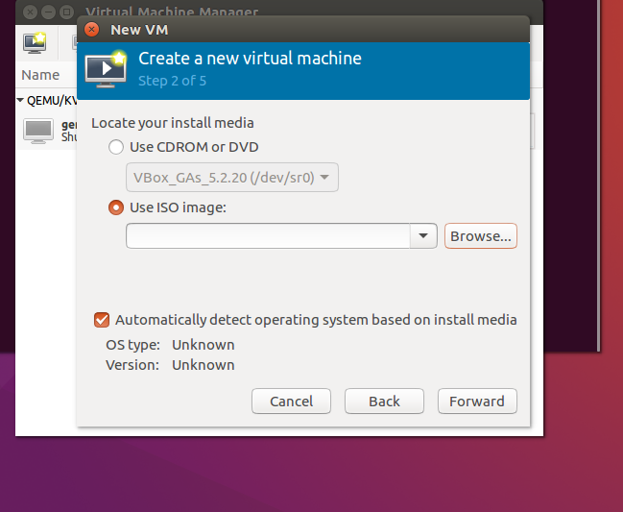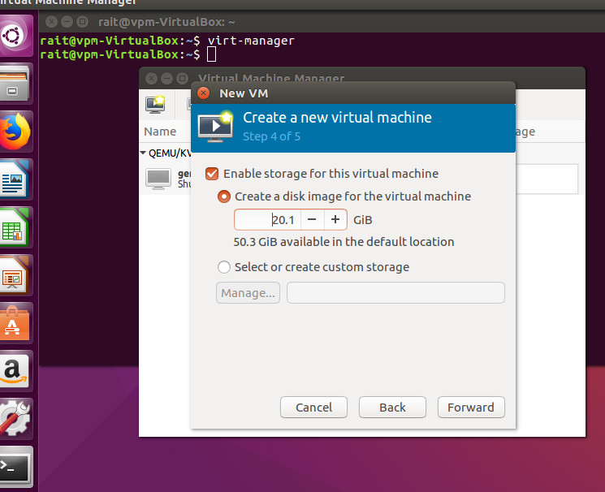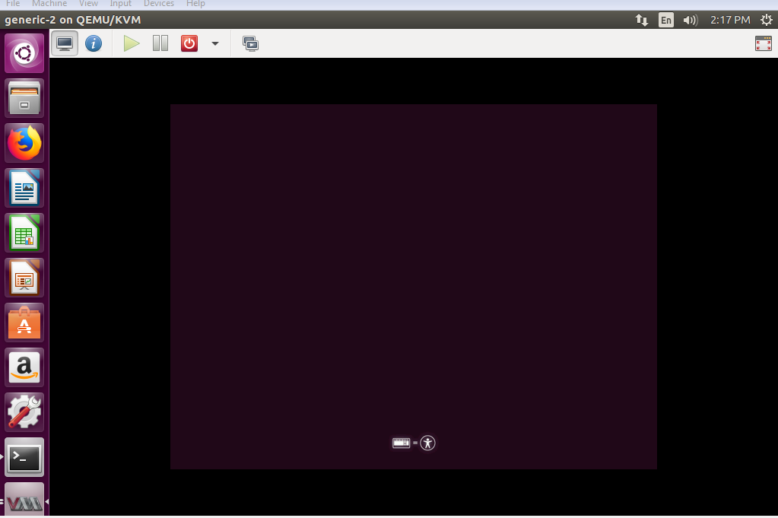

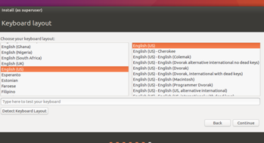

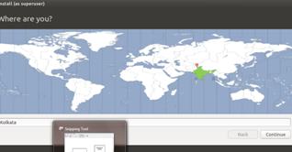

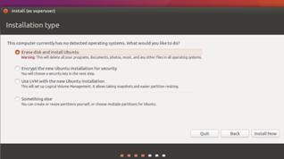

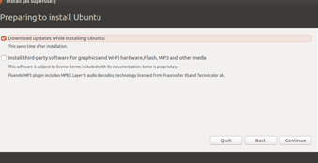

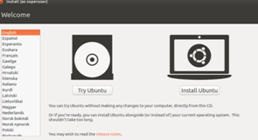

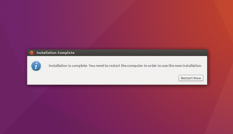

After that you will get final output

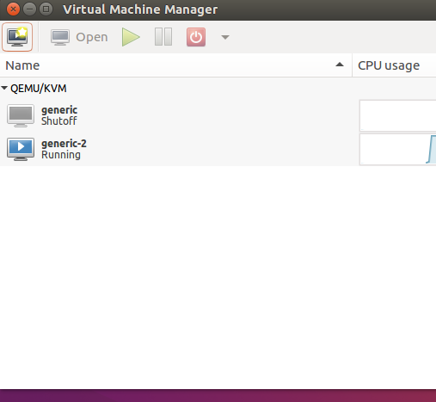

**PRACTICAL 3**

**Aim: Study and Implementation of Infrastructure as a Service**

**Theory**:

Infrastructure as a service (IaaS) is a form of cloud computing that provides virtualized computing resources over the internet.

IaaS is one of the three main categories of cloud computing services, alongside software as a service (SaaS) and platform as a service (PaaS)

IaaS quickly scales up and down with demand, letting you pay only for what you use. It helps you avoid the expense and complexity of buying and managing your own physical servers and other datacenter infrastructure.

Each resource is offered as a separate service component, and you only need to rent a particular one for as long as you need it. A cloud computing service provider, such as Azure, manages the infrastructure, while you purchase, install, configure, and manage your own software—operating systems, middleware, and applications.

**Procedure** :

Steps:

1. Open link <https://mail.zoho.com/signup.do>

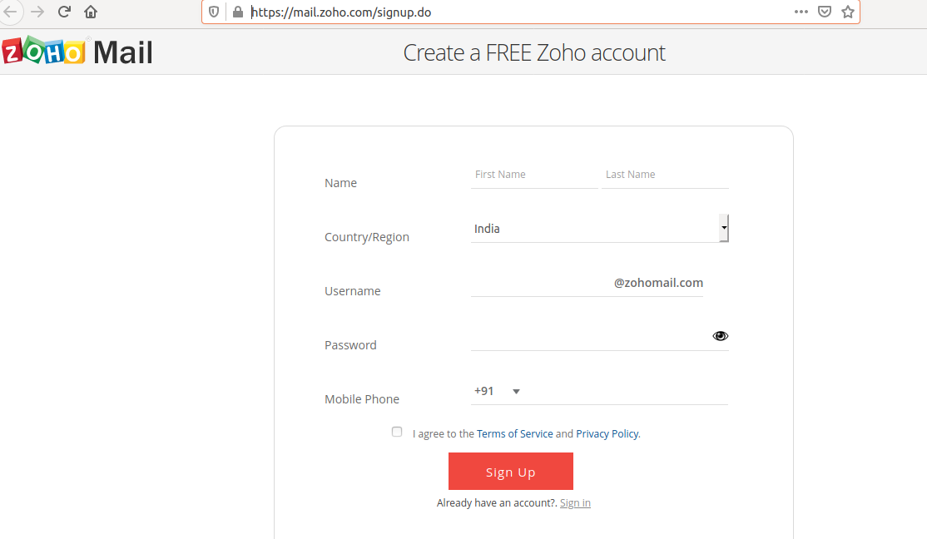

1. Fill data

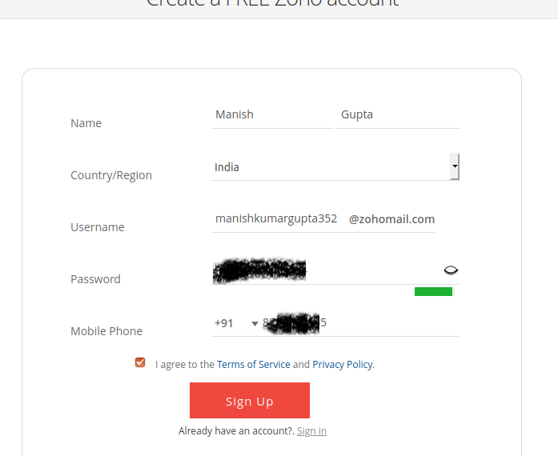

1. Verify the otp
2. After that ‘Remind me later’
3. Creating a zoho account is done

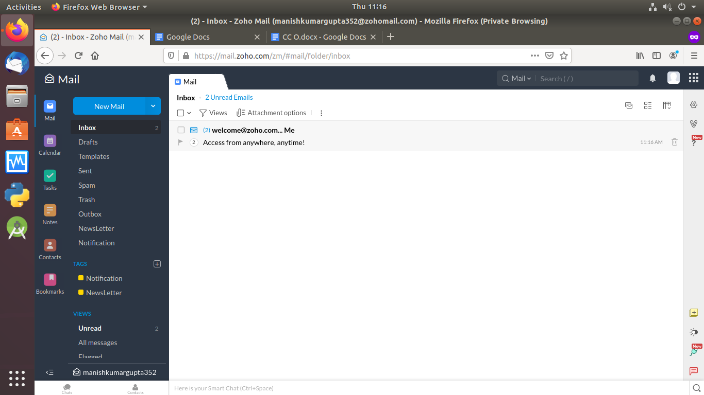

1. Now open <https://platform9.com/>

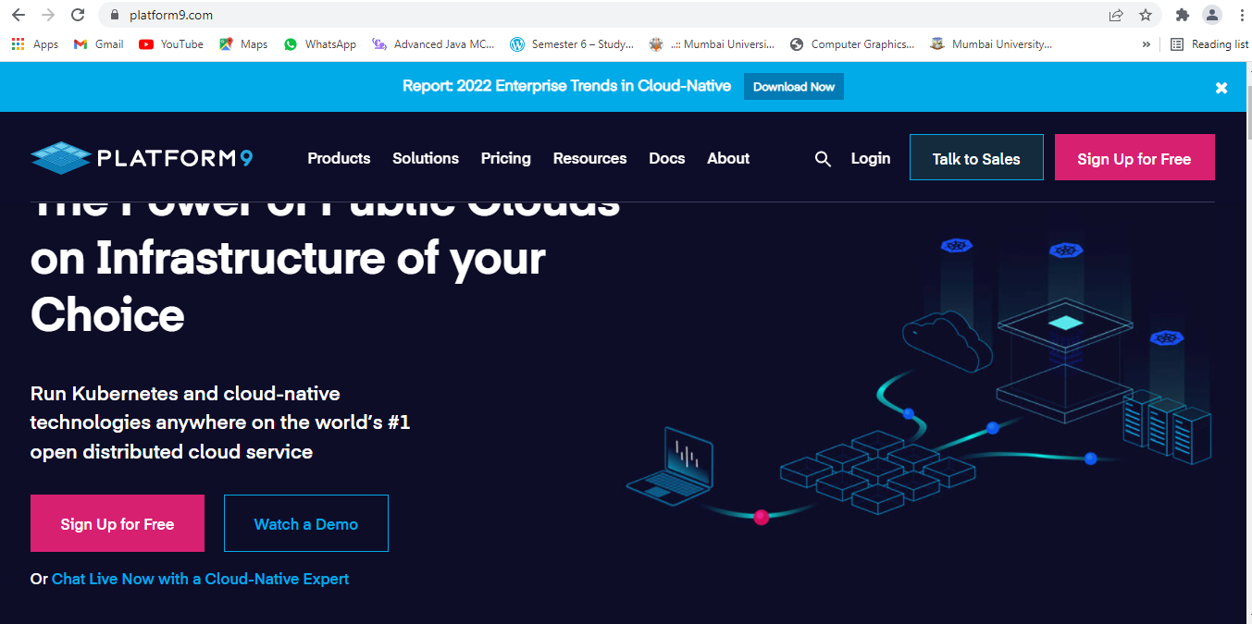

1. click on sign up for free

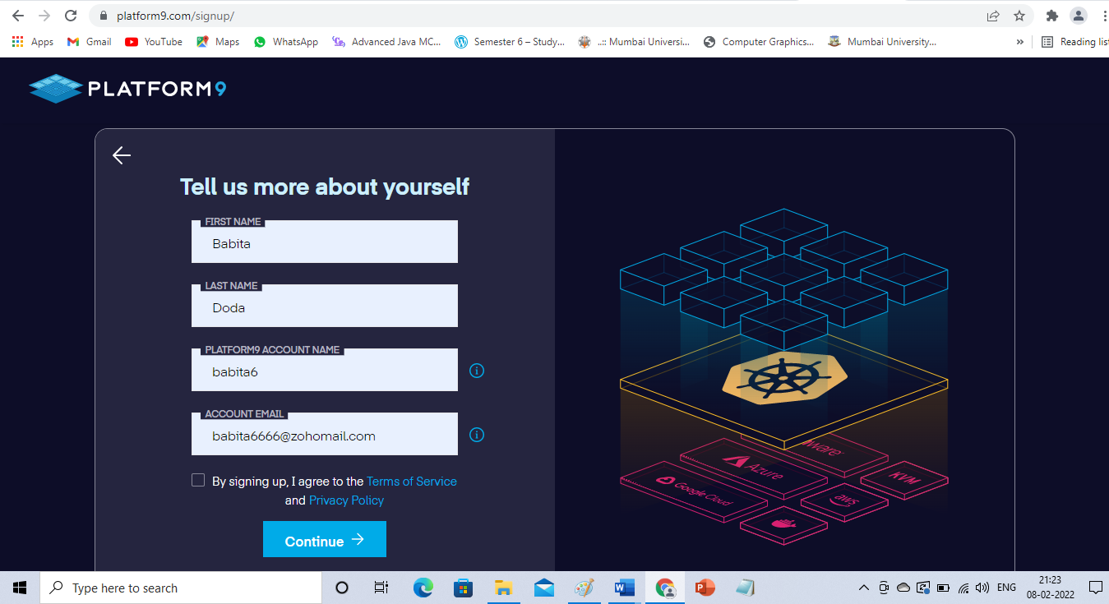

1. Now click on continue
2. fill all the details and click on start
3. Give the User Name and Password and click on login
4. Give business email(Zoho Email id), you will receive mail from platform9. I with the url will be given.
5. Click on that url and login to platform9
6. openstack platform look like this

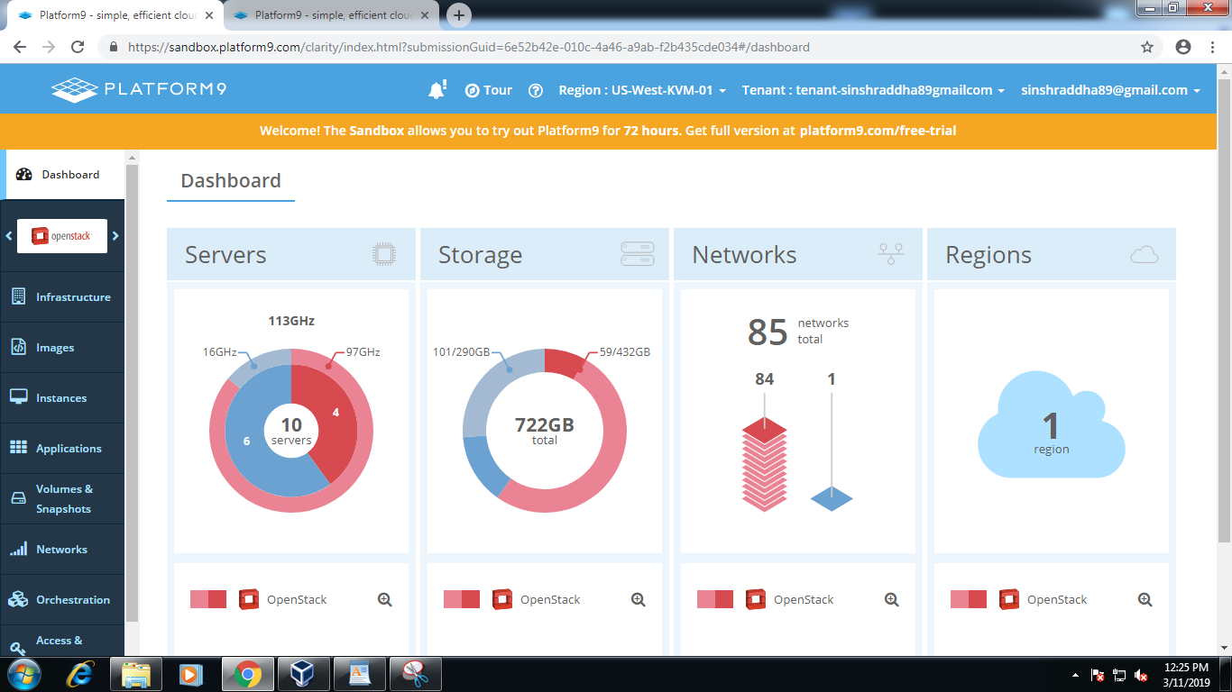

1. Now click on Instance on left side

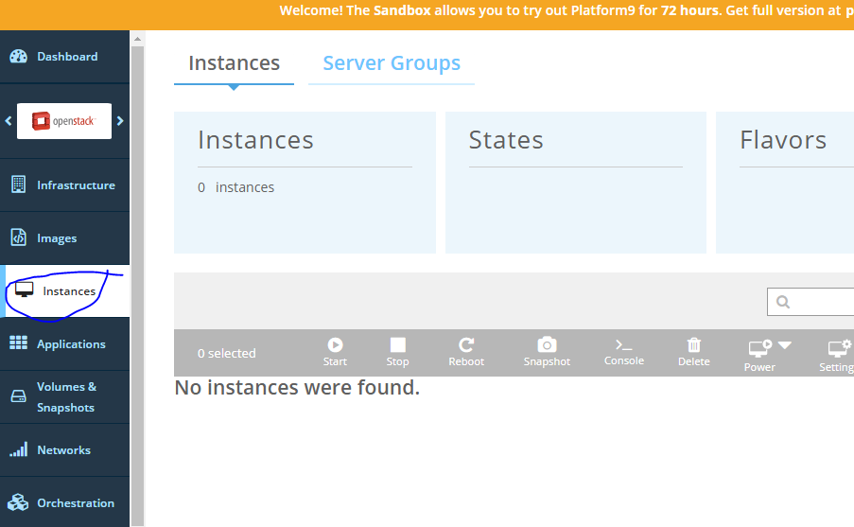

1. And click on Add VM instance

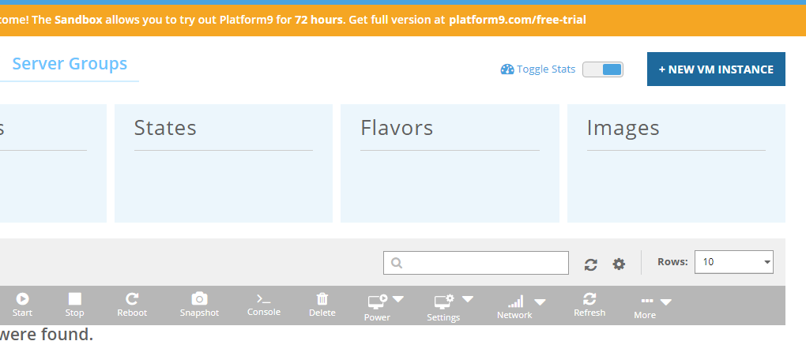

select Ubuntu 16.0.4 and click on next

click m1.small and click on next

select Auto allocate network and click on next

give instance name and click on next

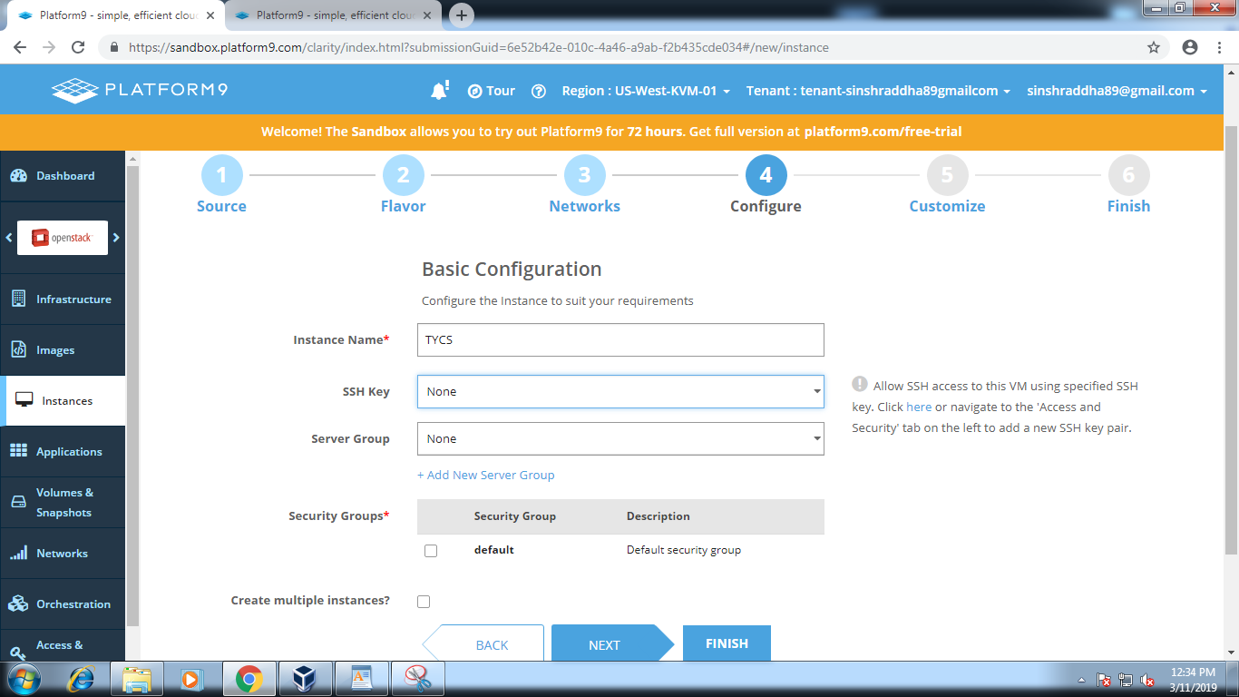

now click on finish

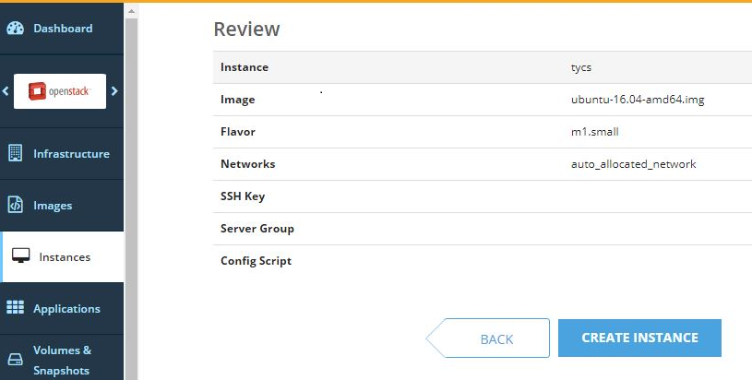

Now Click on CREATE INSTANCE

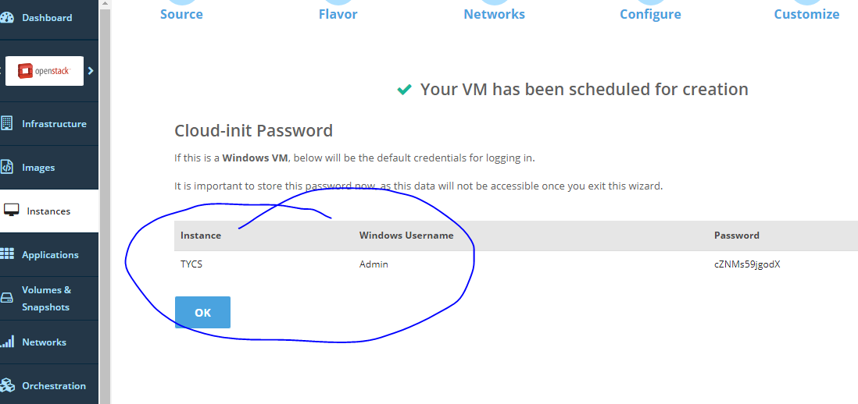

virtual machine created successfully

1. click on Instance tab and check the virtual machine

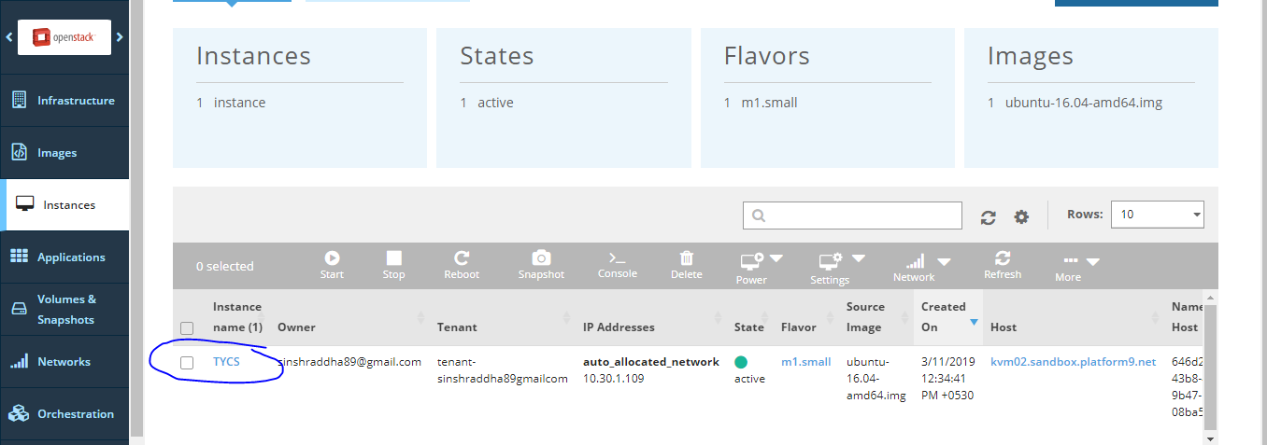

1. click on that machine it will give all the information

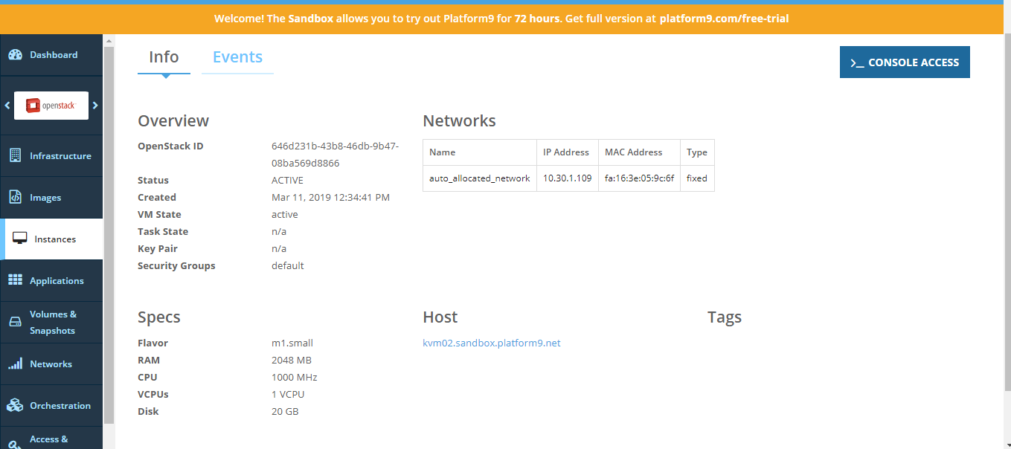

1. For creating Tenant and user Select tenant and user tab present in left side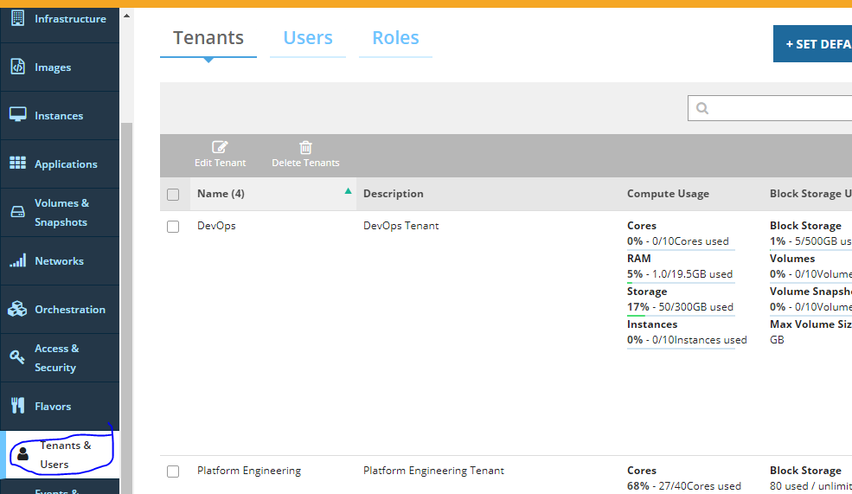

now click on a Create new Tenant

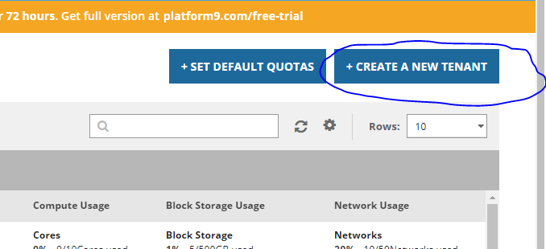

fill the details and click on next

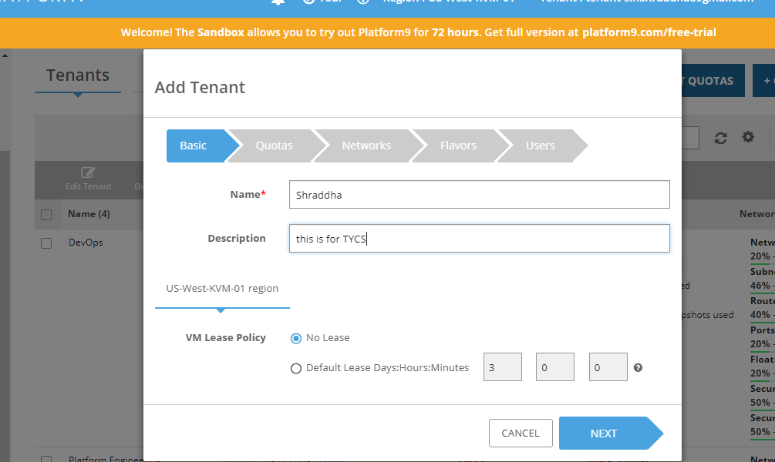

Now click on set Default quota and click on next

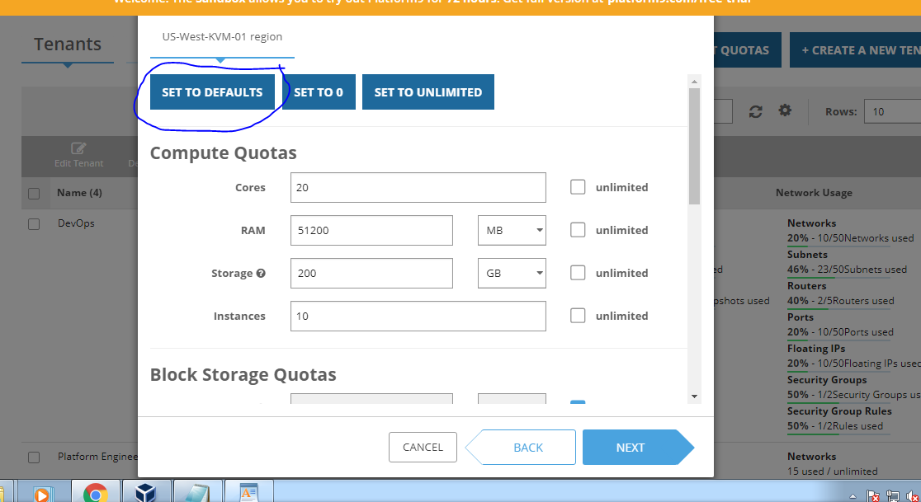

select the network and click on next

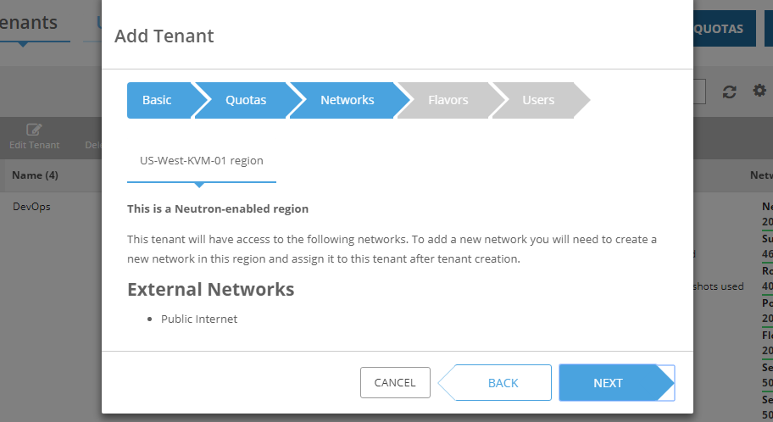

select the public flaovar and click on next

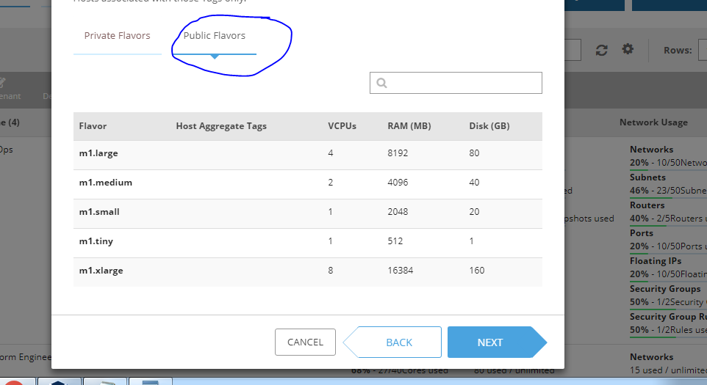

click on create tenant

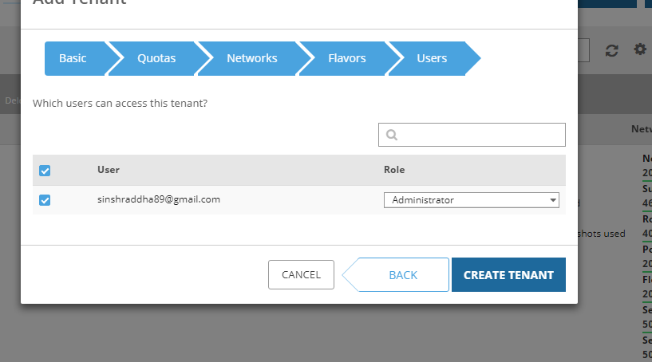

**Practical 4**

**Aim: Study and implementation of Storage as a Service**

1. **Aim:** To study and implementation of Storage as a Service
2. **Objectives:** From this experiment, the student will be able to

* To make the students understand use of cloud as Platform, Storage as a service.
* To learn the efficient tools to implement the technique

1. **Outcomes:** The learner will be able to

* Implement Infrastructure , storage as a Service.
* To understand, identify, analyze and design the problem, implement and validate the solution including both hardware and software.
* To use cloud techniques, and tools necessary for computing practice.

1. **Hardware / Software Required:**Ubuntu operating system, Virtual machine, WAMP/ZAMP server, Any tool or technology can be used for implementation of web application e.g., JAVA, PHP, etc
2. **Theory:**

**Collaborating on Word Processing:**

You use your word processor most likely some version of Microsoft Word—to write memos, letters, thank you notes, fax coversheets, reports, newsletters, you name it. The word processor is an essential part of our computing lives. There are a number of web-based replacements for Microsoft’s venerable Word program are available. All of these programs let you write your letters and memos and reports from any computer, no installed software necessary, as long as that computer has a connection to the Internet. And every document you create is housed on the web, so you don’t have to worry about taking your work with you. It’s cloud computing at its most useful, and it’s here today.

**Exploring Web-Based Word Processors:**

There are a half-dozen or so really good web-based word processing applications, led by the ever-popular Google Docs. We’ll start our look at these applications with Google’s application and work through the rest in alphabetic order.

**Google Docs:**

Google Docs (docs.google.com) is the most popular web-based word processor available today. Docs is actually a suite of applications that also includes Google Spreadsheets and Google Presentations; the Docs part of the Docs suite is the actual word processing application. Like all things Google, the Google Docs interface is clean and, most important, it works well without imposing a steep learning curve. Basic formatting is easy enough to do, storage space for your documents is generous, and sharing collaboration version control is a snap to do. When you log in to Google Docs with your Google account, you see the page. This is the home page for all the Docs applications (word processing, spreadsheets, and presentations); all your previously created documents are listed on this page. The leftmost pane helps you organize your documents. You can store files in folders, view documents by type (word processing document or spreadsheet), and display documents shared with specific people.

**Collaborating on Spreadsheets :**

If the word processor is the most-used office application, the spreadsheet is the second most-important app. Office users and home users alike use spreadsheets to prepare budgets, create expense reports, perform “what if” analyses, and otherwise crunch their numbers. And thus we come to those spreadsheets in the cloud, the web-based spreadsheets that let you share your numbers with other users via the Internet. All the advantages of webbased word processors apply to web-based spreadsheets— group collaboration, anywhere/anytime access, portability, and so on.

**Exploring Web-Based Spreadsheets:**

Several web-based spreadsheet applications are worthy competitors to Microsoft Excel. Chief among these is Google Spreadsheets, which we’ll discuss first, but there are many other apps that also warrant your attention. If you’re at all interested in moving your number crunching and financial analysis into the cloud, these web-based applications are worth checking out.

**Google Spreadsheets**

Google Spreadsheets was Google’s first application in the cloud office suite first known as Google Docs & Spreadsheets and now just known as Google Docs. As befits its longevity, Google Spreadsheets is Google’s most sophisticated web-based application. You access your existing and create new spreadsheets from the main Google Docs page (docs.google.com). To create a new spreadsheet, click the New button and select Spreadsheet; the new spreadsheet opens in a new window and you can edit it.

**Collaborating on Presentations:**

One of the last components of the traditional office suite to move into the cloud is the presentation application. Microsoft PowerPoint has ruled the desktop forever, and it’s proven difficult to offer competitive functionality in a web-based application; if nothing else, slides with large graphics are slow to upload and download in an efficient manner. That said, there is a new crop of web-based presentation applications that aim to give PowerPoint a run for its money. The big players, as might be expected, are Google and Zoho, but there are several other applications that are worth considering if you need to take your presentations with you on the road—or collaborate with users in other locations.

**Google Presentations:**

If there’s a leader in the online presentations market, it’s probably Google Presentations, simply because of Google’s dominant position with other webbased office apps. Google Presentations is the latest addition to the Google Docs suite of apps, joining the Google Docs word processor and Google Spreadsheets spreadsheet application. Users can create new presentations and open existing ones from the main Google Docs page (docs.google.com). Open a presentation by clicking its title or icon. Create a new presentation by selecting New, then Presentation. Your presentation now opens in a new window on your desktop. What you do get is the ability to add title, text, and blank slides; a PowerPoint-like slide sorter pane; a selection of predesigned themes. the ability to publish your file to the web or export as a PowerPoint PPT or Adobe PDF file; and quick and easy sharing and collaboration, the same as with Google’s other web-based apps.

**Collaborating on Databases:**

A database does many of the same things that a spreadsheet does, but in a different and often more efficient manner. In fact, many small businesses use spreadsheets for database-like functions. A local database is one in which all the data is stored on an individual computer. A networked database is one in which the data is stored on a computer or server connected to a network, and accessible by all computers connected to that network. Finally, an online or web-based database stores data on a cloud of servers somewhere on the Internet, which is accessible by any authorized user with an Internet connection. The primary advantage of a web-based database is that data can easily be shared with a large number of other users, no matter where they may be located. When your employee database is in the cloud.

**Exploring Web-Based Databases:**

In the desktop computing world, the leading database program today is Microsoft Access. (This wasn’t always the case; dBase used to rule the database roost, but things change over time.) In larger enterprises, you’re likely to encounter more sophisticated software from Microsoft, Oracle, and other companies. Interestingly, none of the major database software developers currently provide web-based database applications. Instead, you have to turn to a handful of start-up companies (and one big established name) for your online database needs.

**Cebase**

Cebase (www.cebase.com) lets you create new database applications with a few clicks of your mouse; all you have to do is fill in a few forms and make a few choices from some pull-down lists. Data entry is via web forms, and then your data is displayed in a spreadsheet-like layout, You can then sort, filter, and group your data as you like. Sharing is accomplished by clicking the Share link at the top of any data page. You invite users to share your database via email, and then adjust their permissions after they’ve accepted your invitation.

1. **Result:**

_____________________________SNAPSHOTS_______________________________

Step 1: Sign into the Google Drive website with your Google account.

If you don’t have a Google account, you can create one for free. Google Drive will allow you to store your files in the cloud, as well as create documents and forms through the Google Drive web interface.

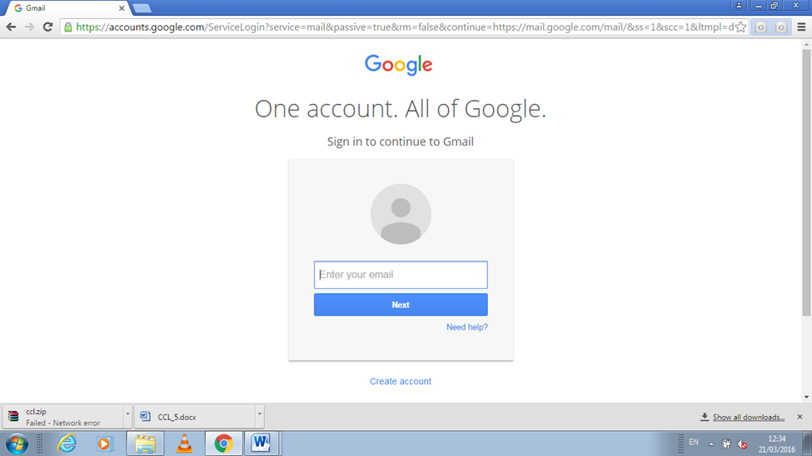

Step 2: Add files to your drive.

There are two ways to add files to your drive. You can create Google Drive documents, or you can upload files from your computer. To create a new file, click the CREATE button. To upload a file, click the “Up Arrow” button next to the CREATE button.

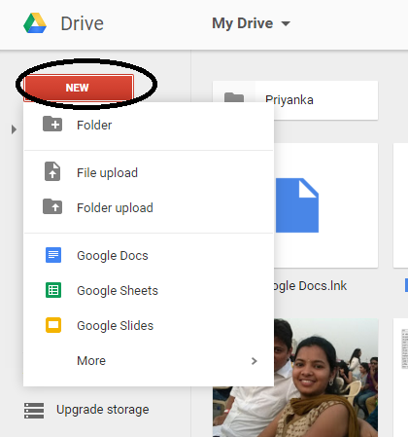

Step 3: Change the way your files are displayed.

You can choose to display files by large icons (Grid) or as a list (List). The List mode will show you at a glance the owner of the document and when it was last modified. The Grid mode will show each file as a preview of its first page. You can change the mode by clicking the buttons next to the gear icon in the upper right corner of the page.

// List Mode

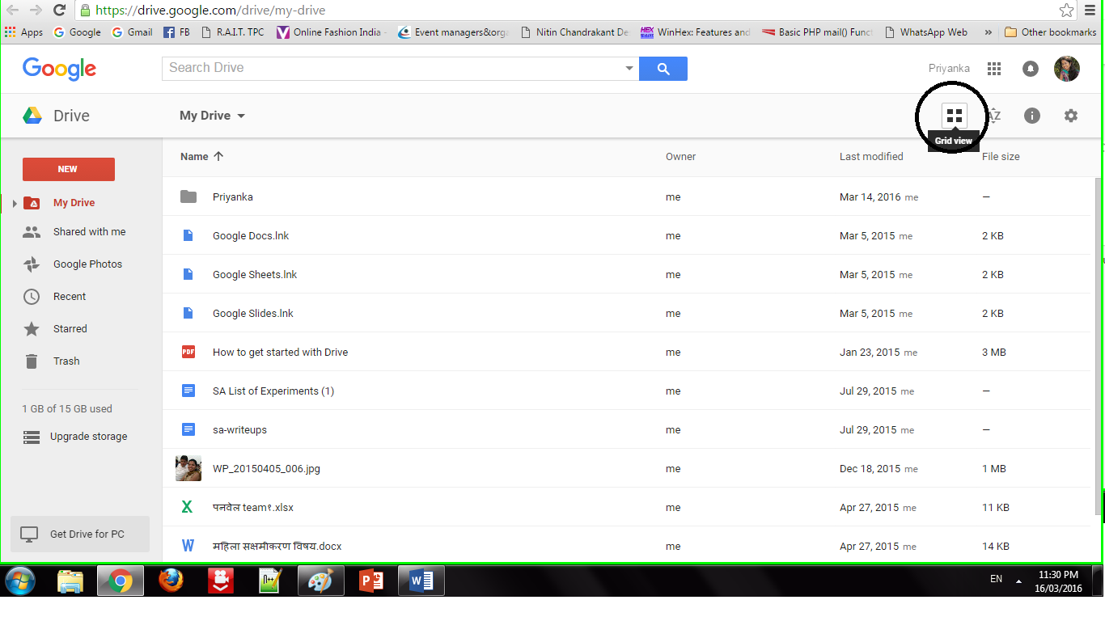

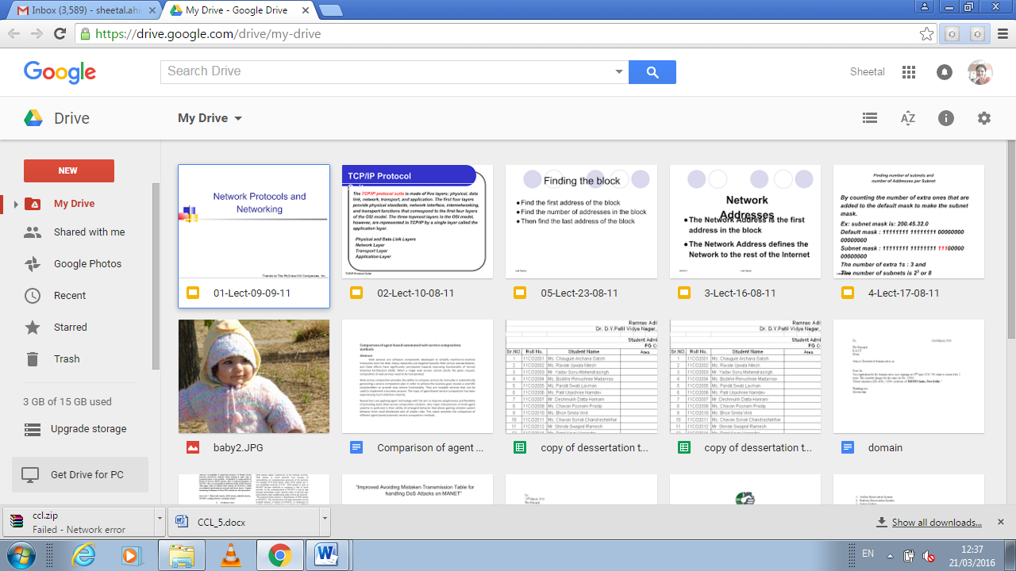

Step 4: Use the navigation bar on the left side to browse your files.

“My Drive” is where all of your uploaded files and folders are stored. “Shared with Me” are documents and files that have been shared with you by other Drive users. “Starred” files are files that you have marked as important, and “Recent” files are the ones you have most recently edited.

•You can drag and drop files and folders around your Drive to organize them as you see fit.

•Click the Folder icon with a “+” sign to create a new folder in your Drive. You can create folders inside of other folders to organize your files.

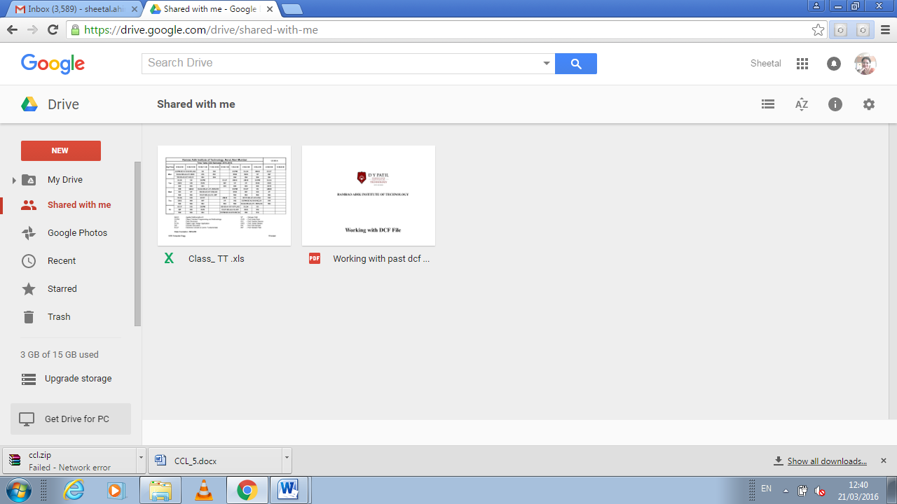

Step 5: Search for files.

You can search through your Google Drive documents and folders using the search bar at the top of your page. Google Drive will search through titles, content, and owners. If a file is found with the exact term in the title, it will appear under the search bar as you type so that you can quickly select it.

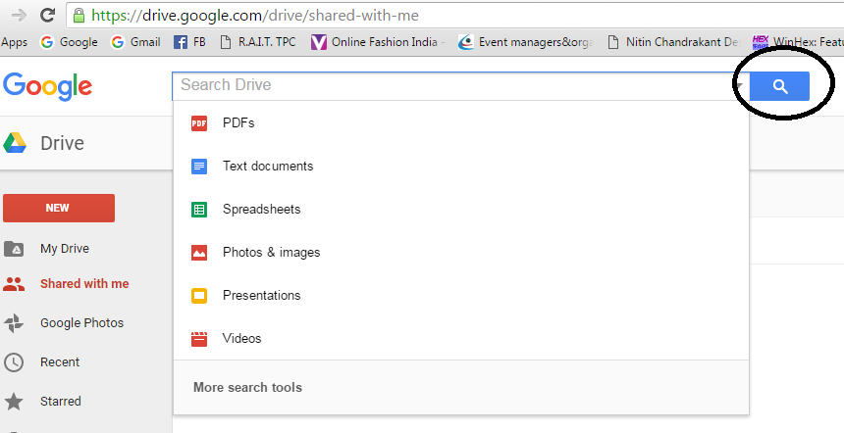

Step 1: Click the NEW button.

A menu will appear that allows you to choose what type of document you want to create. You have several options by default, and more can be added by clicking the “More “ link at the bottom of the menu:

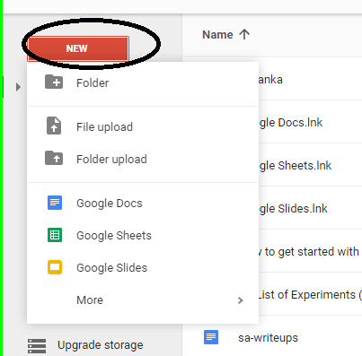

Step 2: Create a new file.

Once you’ve selected your document type, you will be taken to your blank document. If you chose Google Docs/Sheets/Slides , you will be greeted by a wizard that will help you configure the feel of your document.

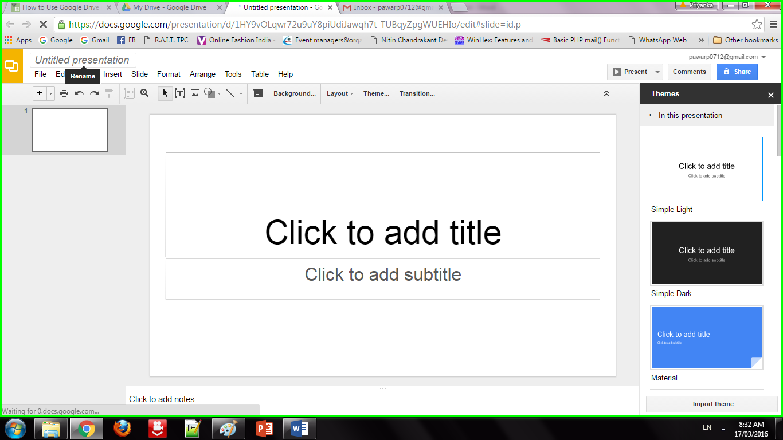

Step 3: Name the file.

At the top of the page, click the italic gray text that says “Untitled <file type>”. When you click it, the “Rename document” window will appear, allowing you to change the name of your file.

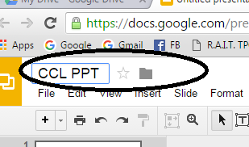

Step 4: Edit your document.

Begin writing your document as you would in its commercially-equivalent. You will most likely find that Google Drive has most of the basic features, but advanced features you may be used to are not available.

1.Your document saves automatically as you work on it.

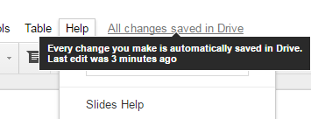

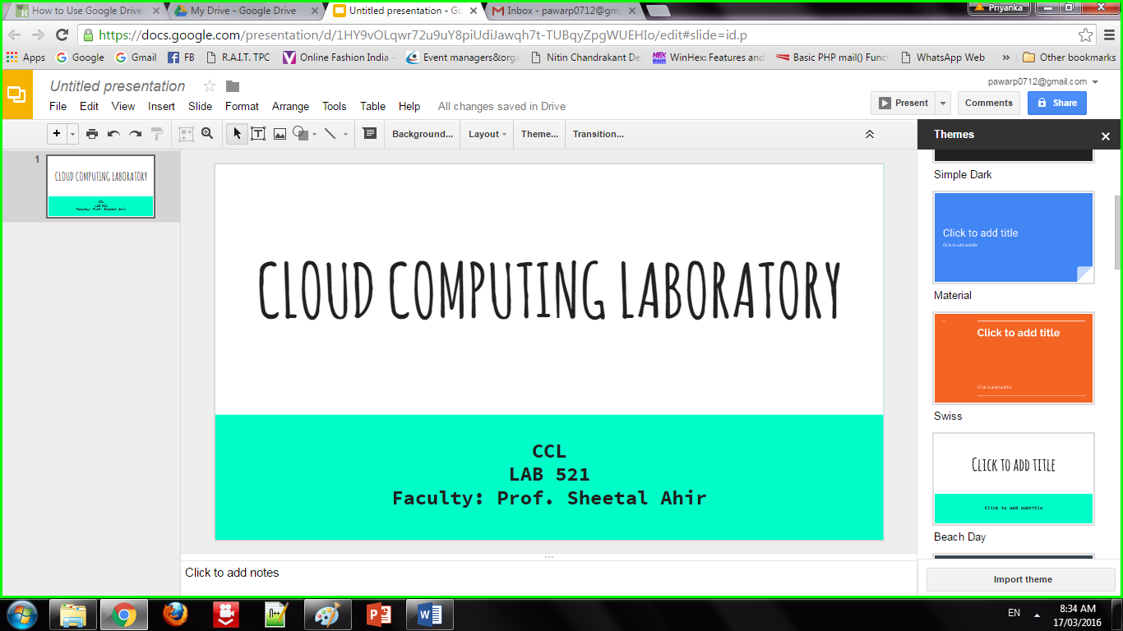

Step 5: Export and convert the file.

If you want to make your file compatible with similar programs, click File and place your cursor over “Download As”. A menu will appear with the available formats. Choose the format that best suits your needs. You will be asked to name the file and select a download location. When the file is downloaded, it will be in the format you chose.

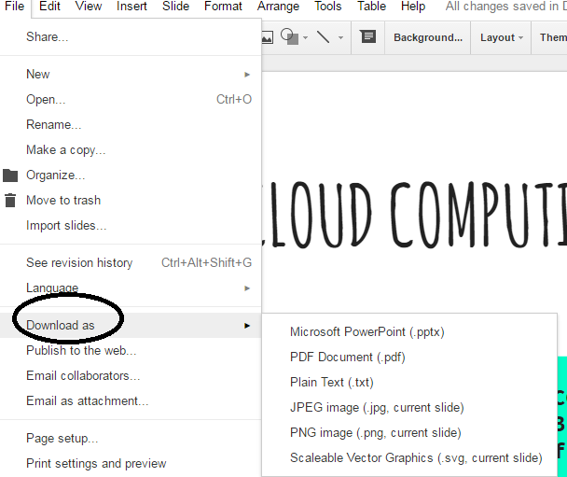

Step 6: Share your document.

Click File and select Share, or click the blue Share button in the upper right corner to open the Sharing settings. You can specify who can see the file as well as who can edit it.

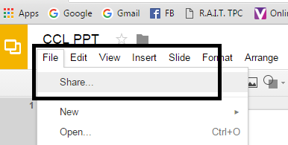

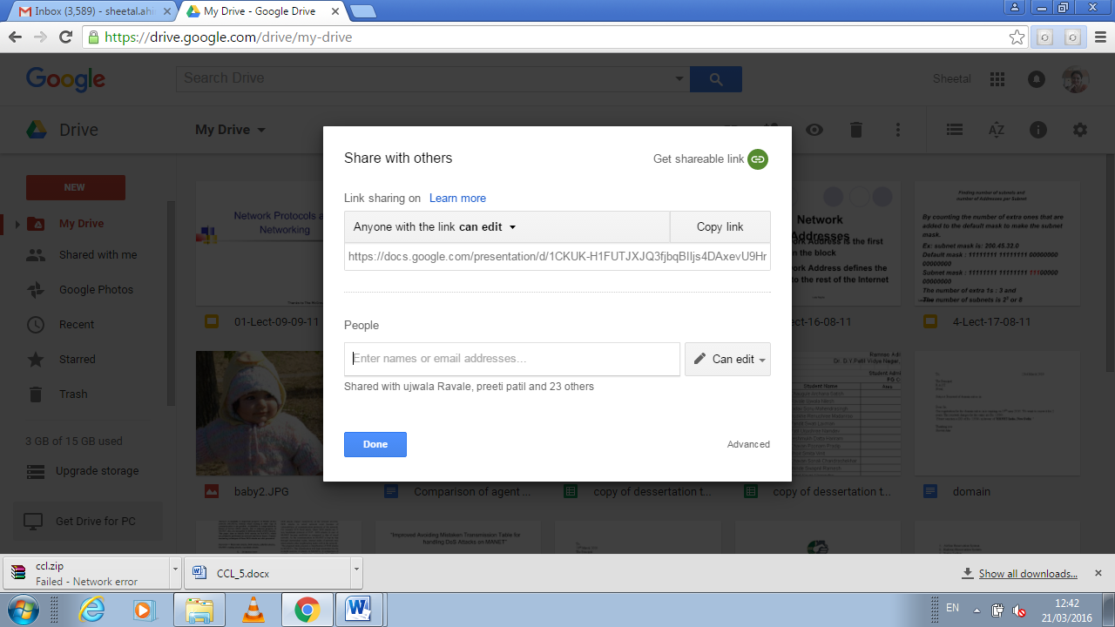

Other Capabilities

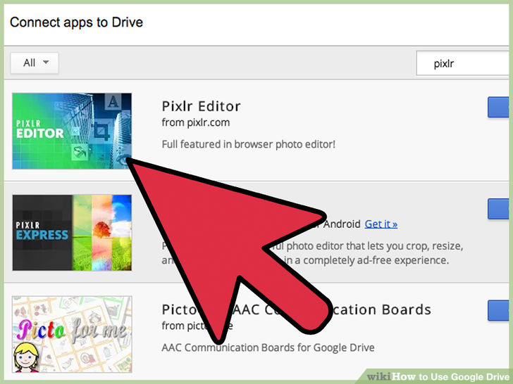

1. Edit photos

2. Listen Music

3. Do drawings

4. Merge PDFs

1. **Conclusion:**

Google Docs provide an efficient way for storage of data. It fits well in Storage as a service (SaaS). It has varied options to create documents, presentations and also spreadsheets. It saves documents automatically after a few seconds and can be shared anywhere on the Internet at the click of a button.

**Practical 5**

**Aim : Study and implementation of identity management**

Step1 write amazon free account in google

**or**

Click on link below.

<https://aws.amazon.com/console/>

Go to “My Account” > “AWS Management Console”.

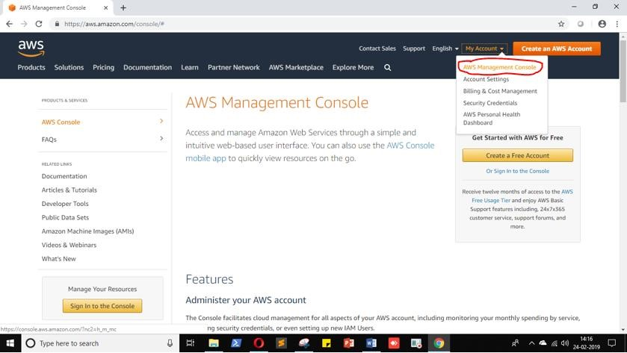

Click on “Create a new AWS account”.

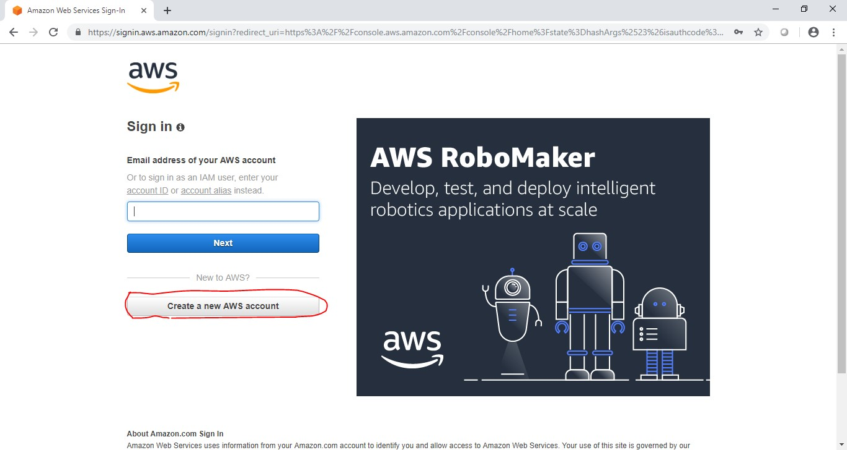

Fill the form and click “Continue”.

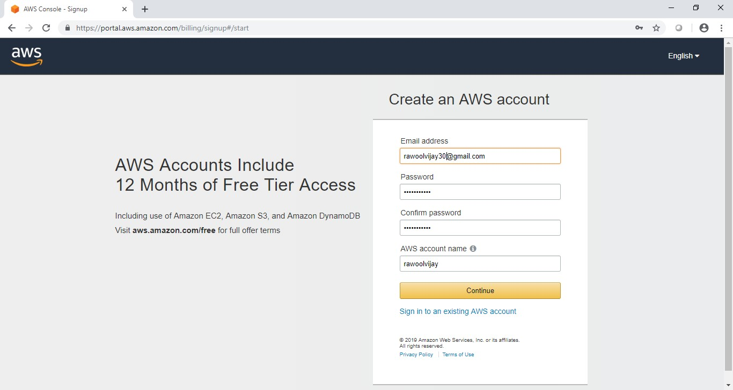

Fill other details (fake details) and click on “Create Account and Continue”.

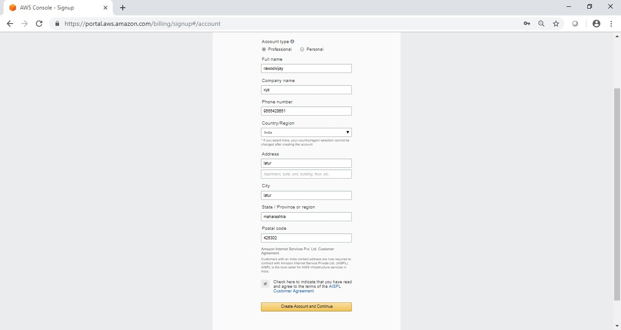

Now most curtail step AWS will ask for credit card details and other details.

You have to close the browser.

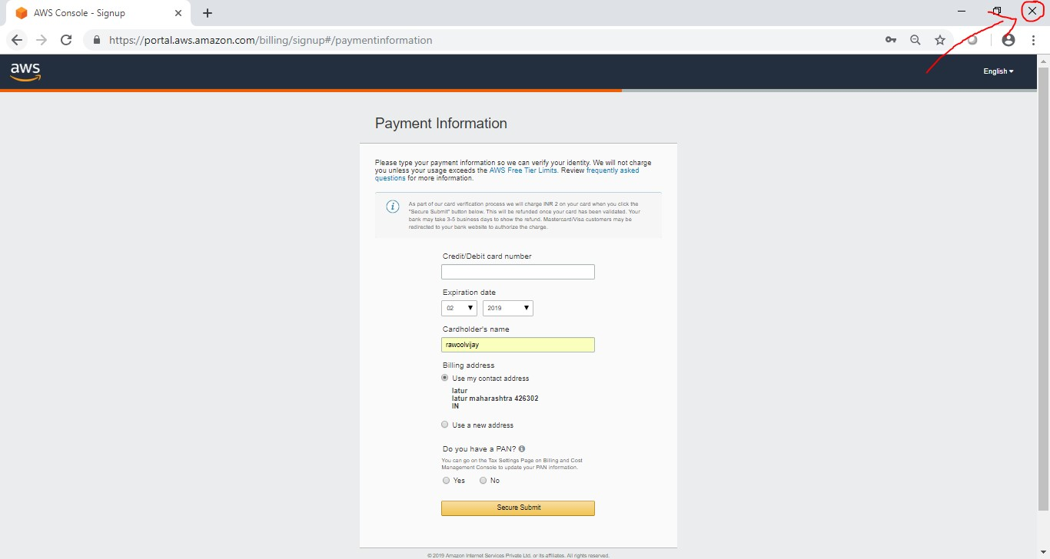

Now again navigate to link below. <https://aws.amazon.com/console/>

Go to “My Account” > “AWS Management Console”.



Enter your ID and click on “Next”.

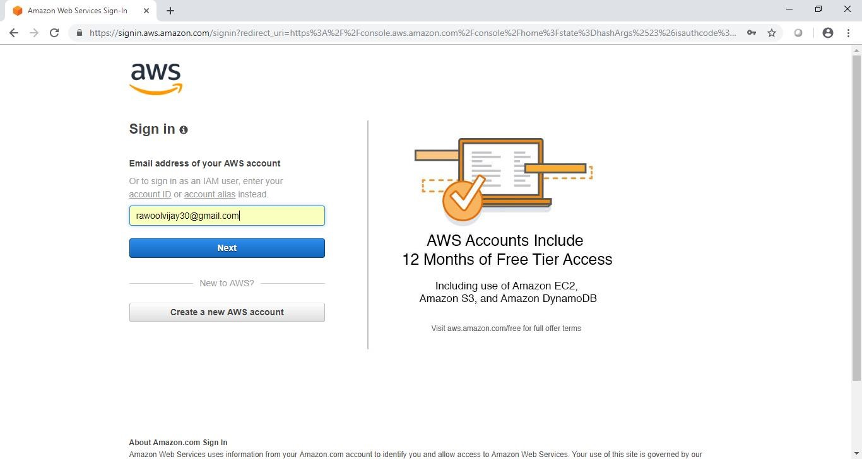

Enter your password and click on “Sign in”.

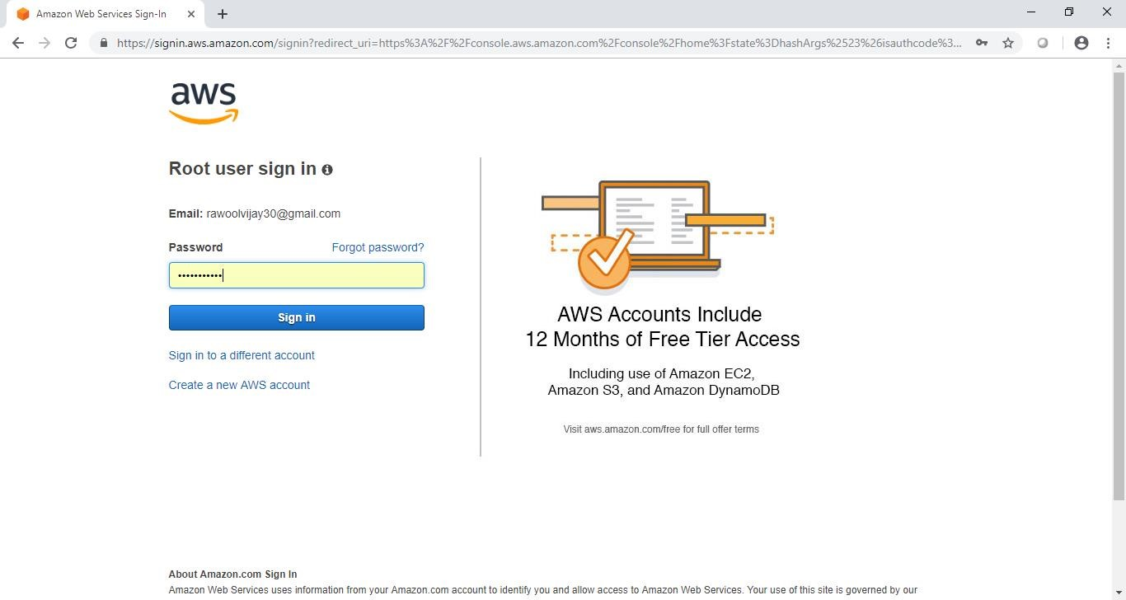

Now it will redirect you to home page without asking any other details. Now to we have to add user and group and assign them privilages.

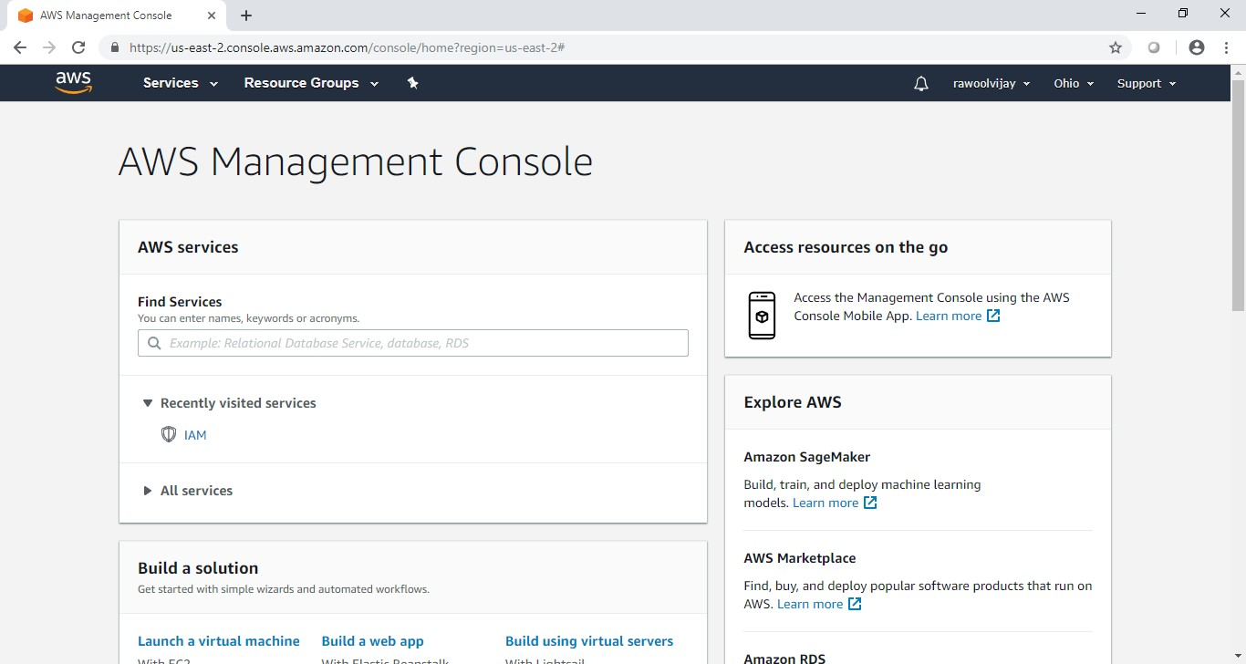

Go to “My Security Credentials”.

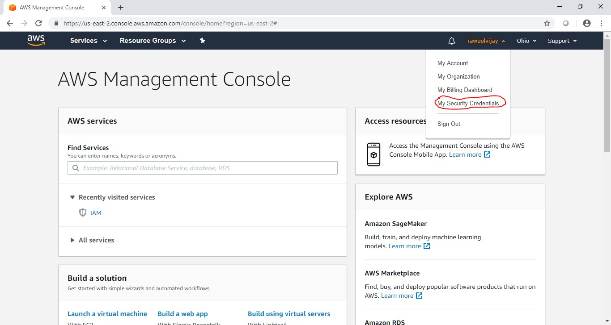

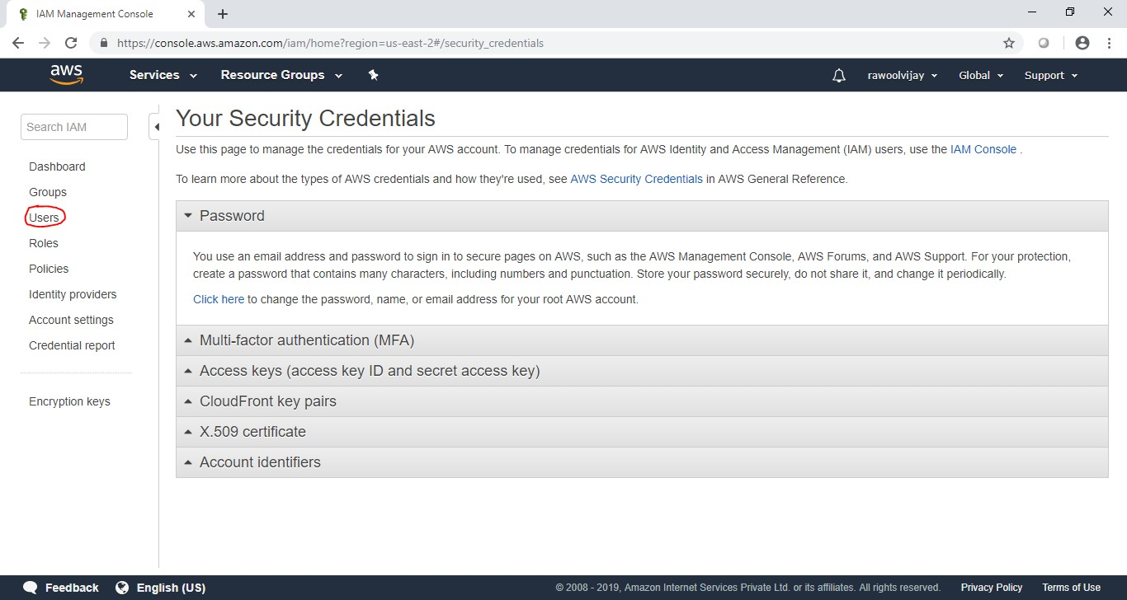

Click on “Users”.

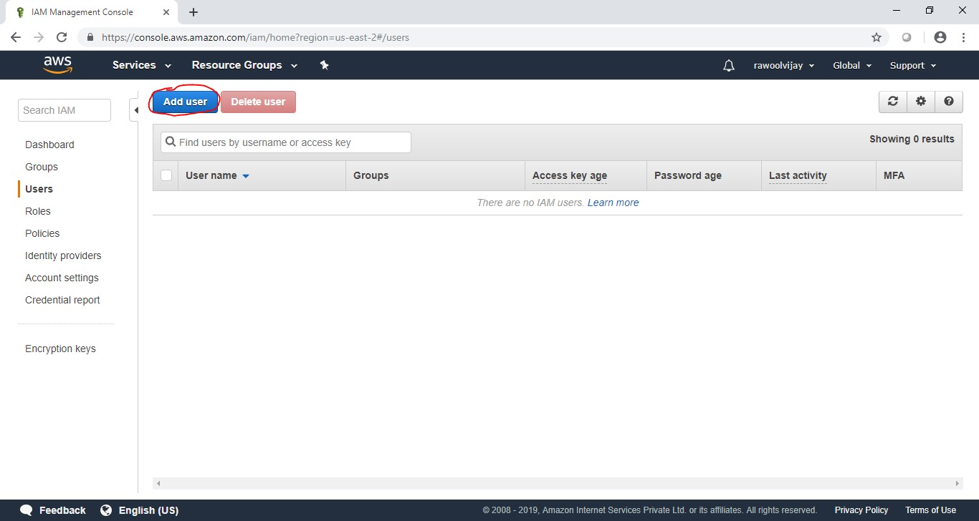

Click on “Add user”.

Enter the name for the user. Check the check box in front of “Programmatic access” and “AWS Management Console access”.

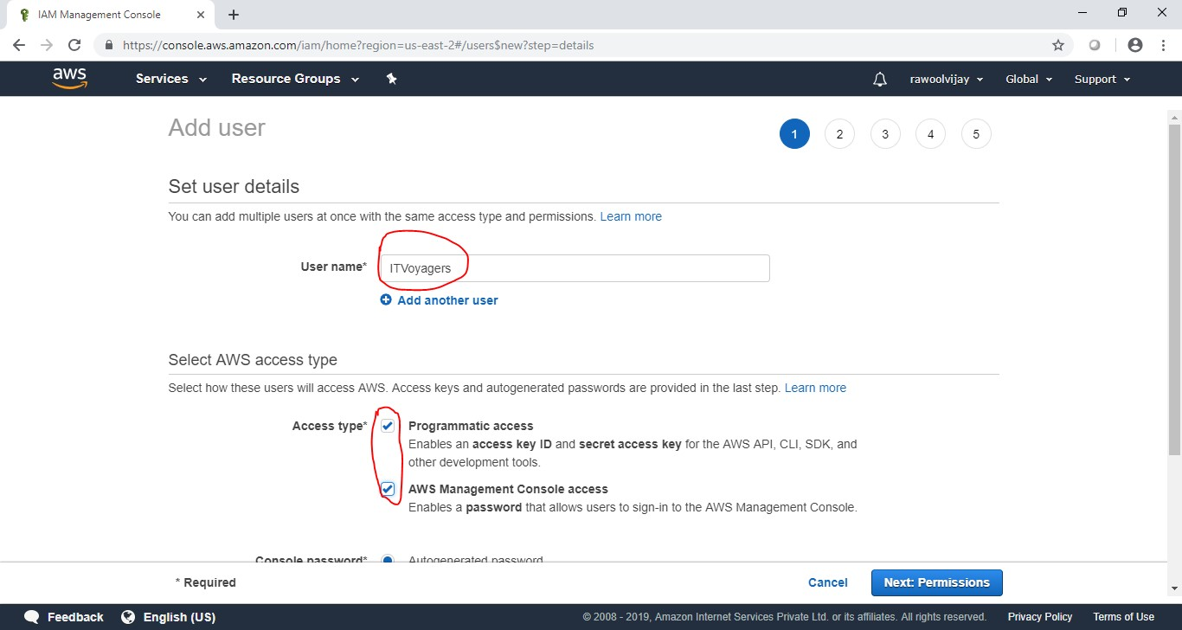

Scroll down and select “Custom password” and enter the password for the new user and click on “Next: Permissions”.

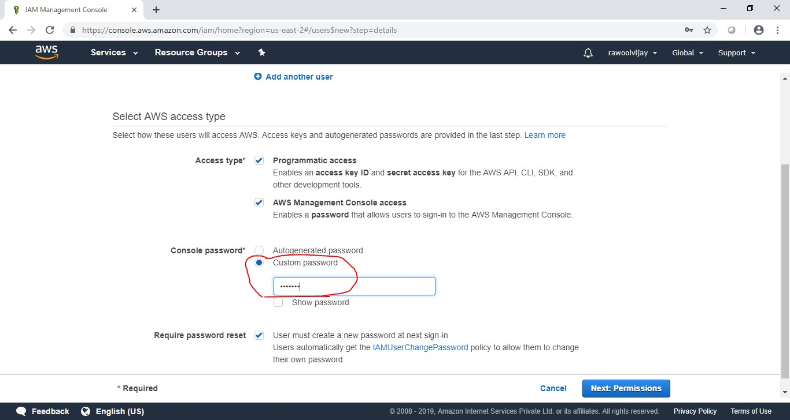Next it allow you to create group or you can just pass it. We are going to create group click on “Create group”.

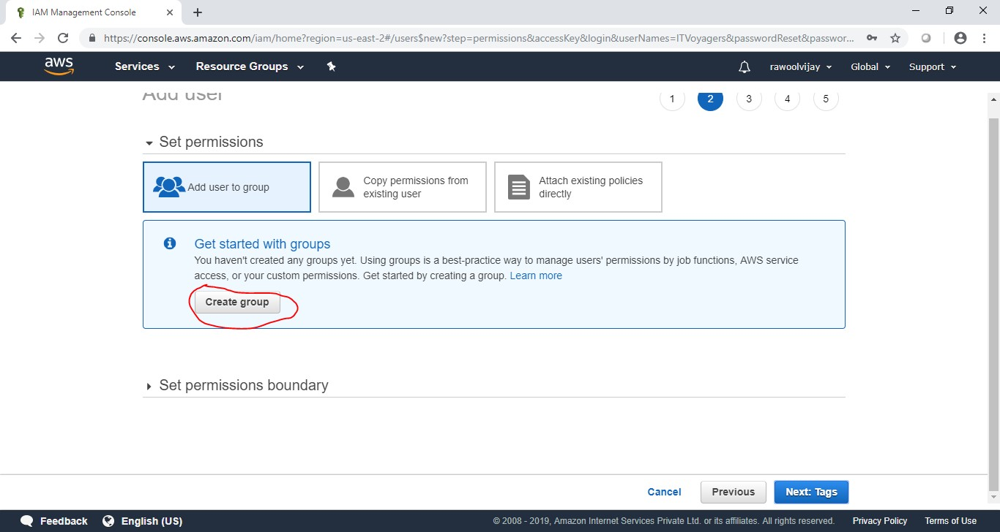Following window will appear.

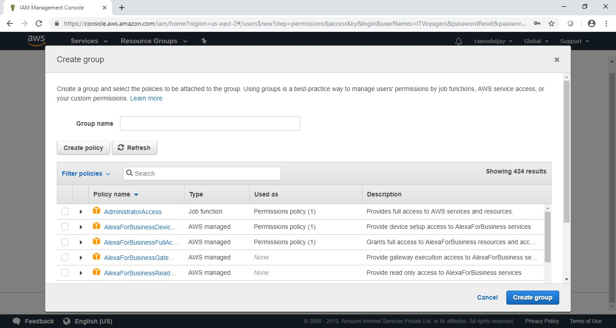

Give name to group, assign the their permissions and click on “Create group”.

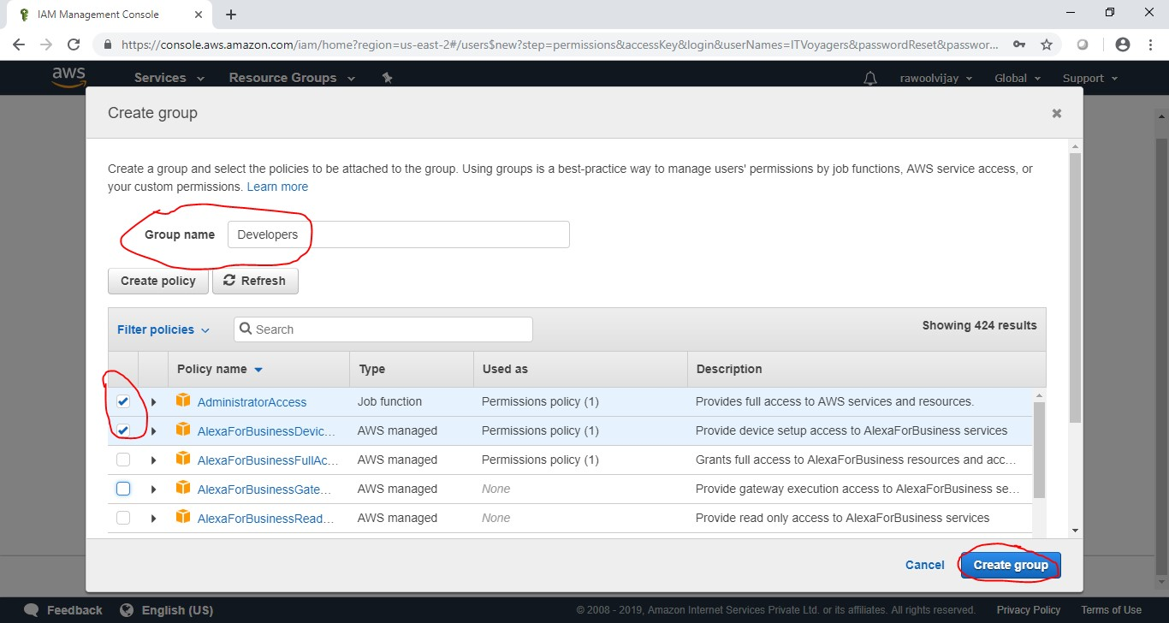

Your group is created now click on “Next: Tags”.

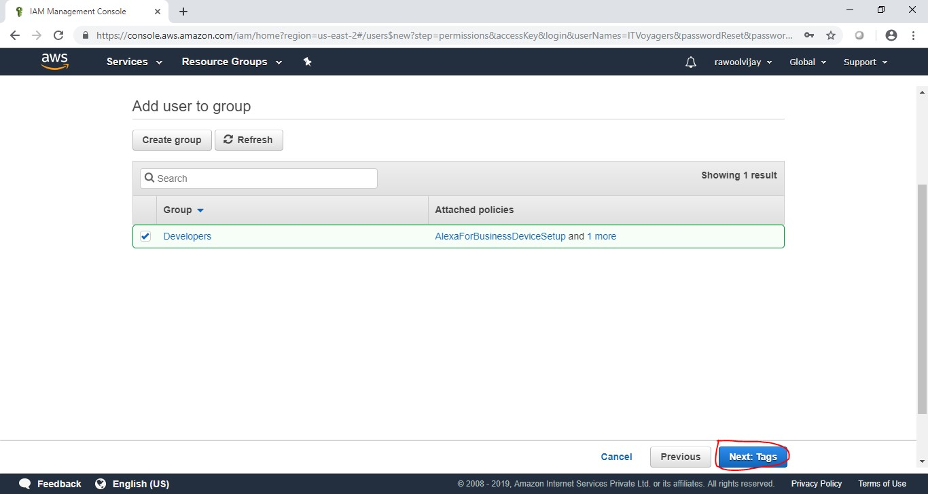

Click on “Next: Review”.

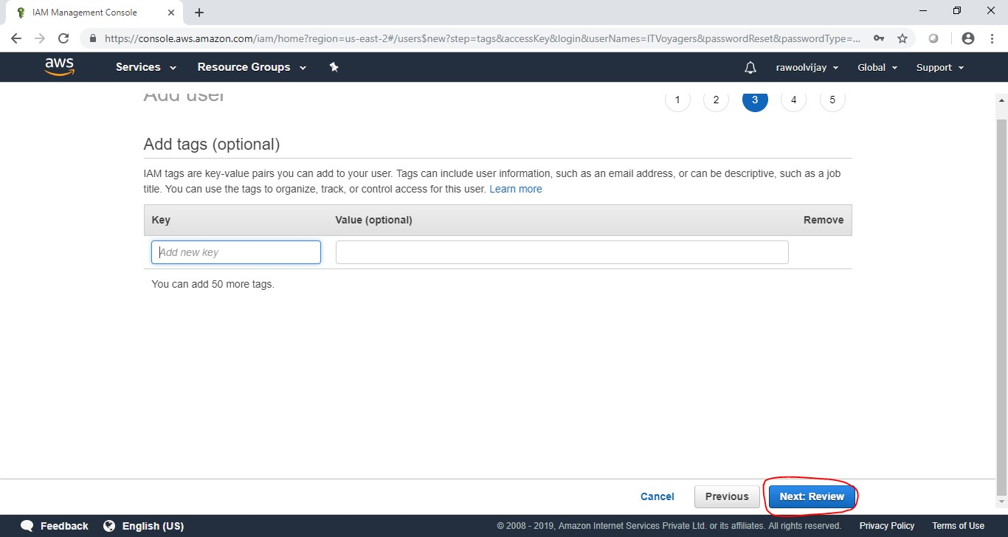Check the Review for the user and click on “Create user”.

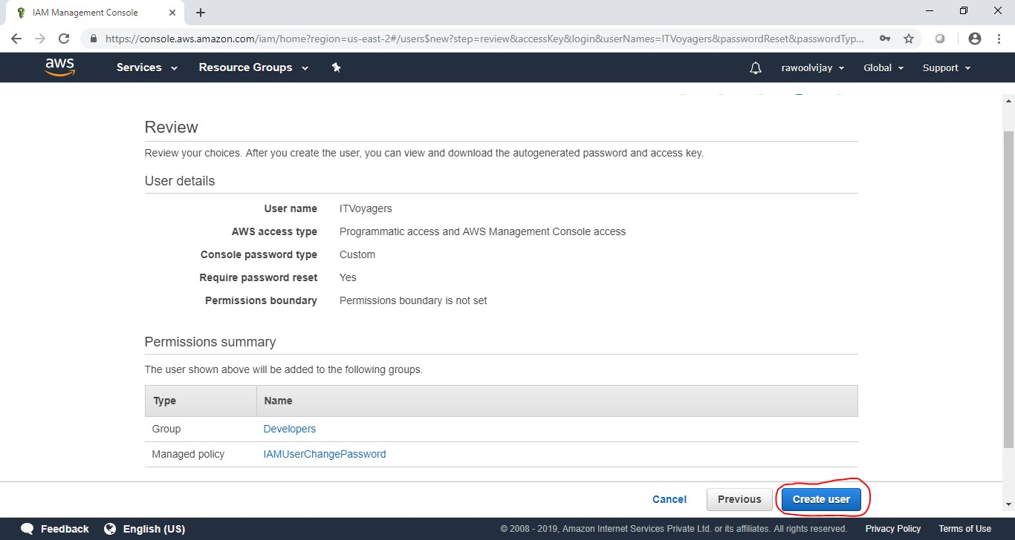

Click on “Close”.

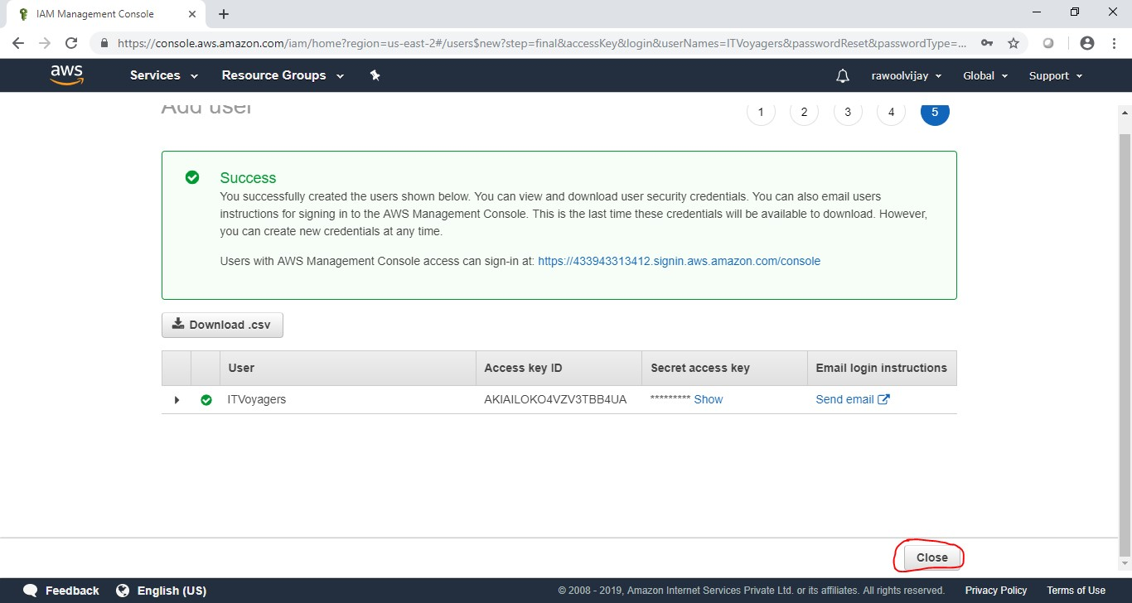

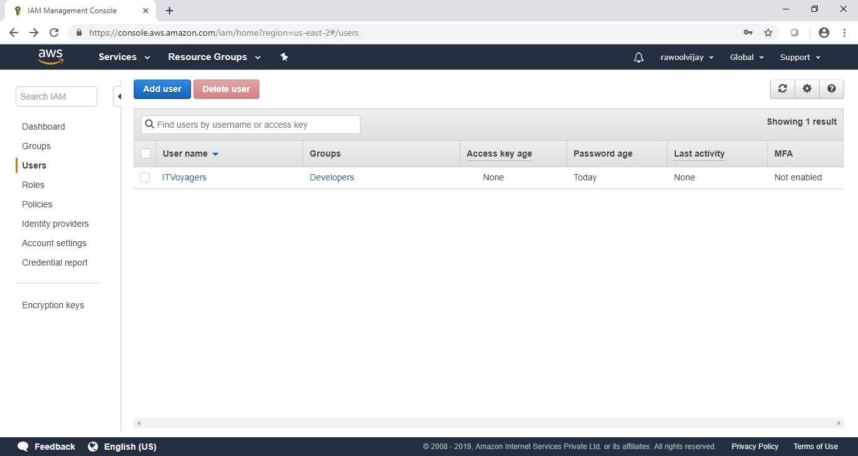

Click on “Group”. You will see the group you just created.

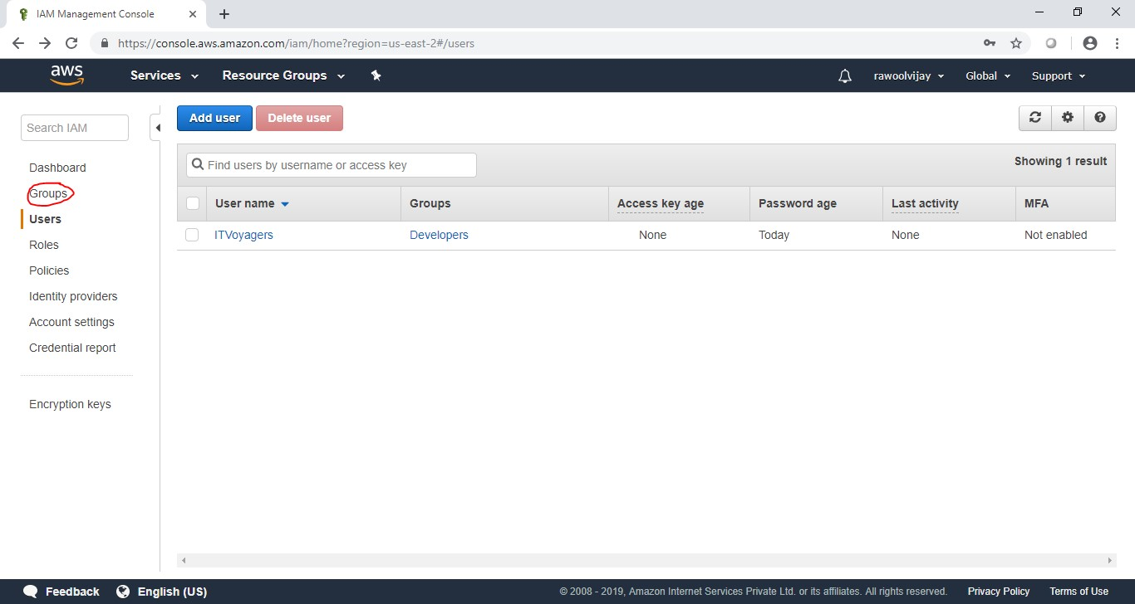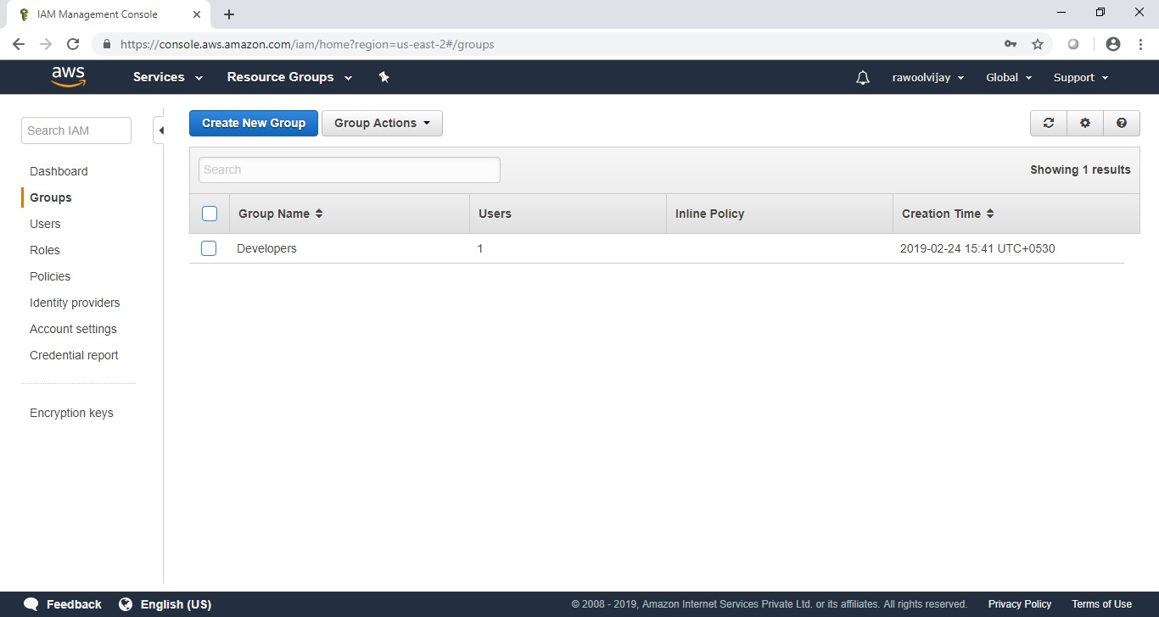

Now log out of admin account and try to login as user (newly created).

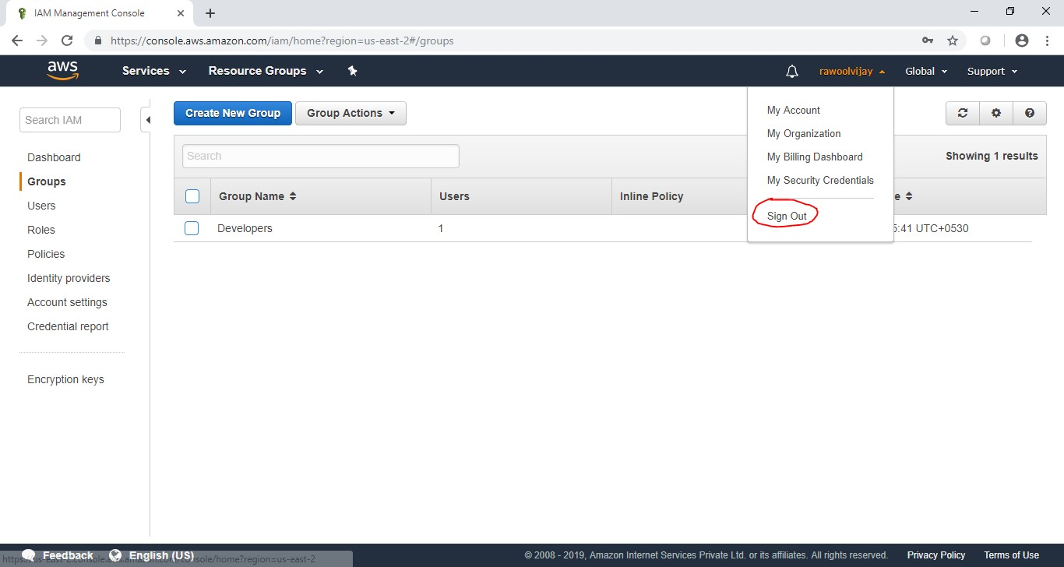

Navigate to link below.

<https://aws.amazon.com/console/>

Go to “My Account” > “AWS Management Console



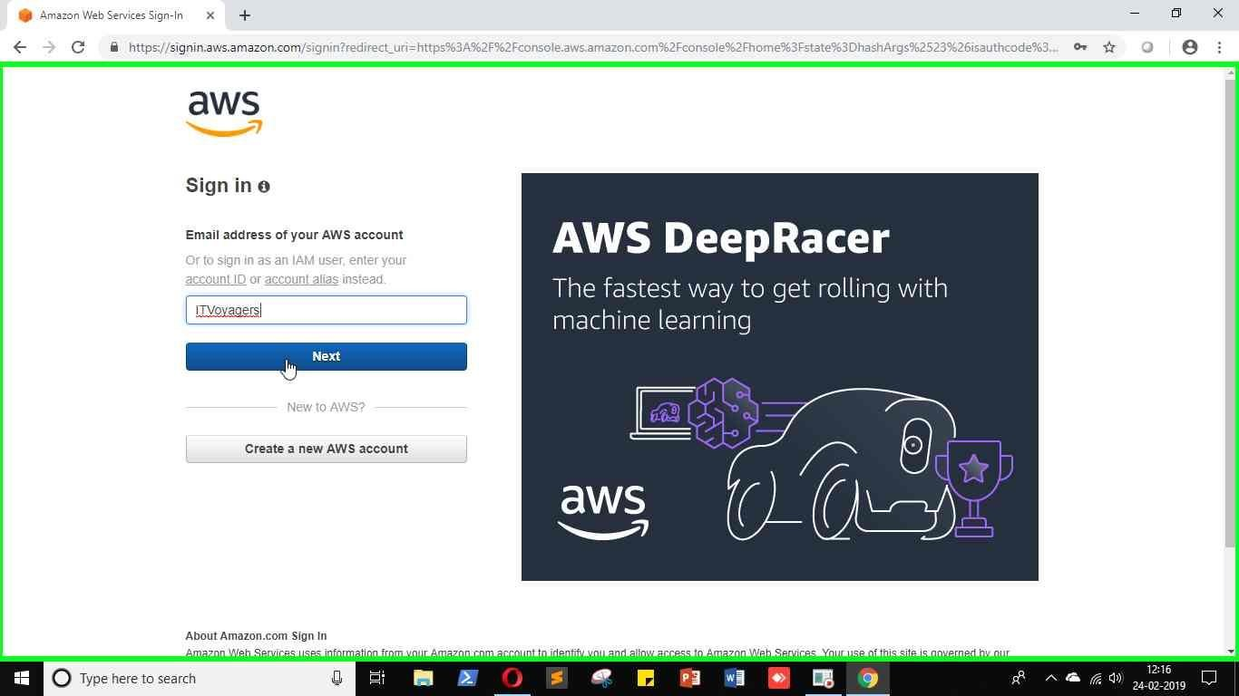

Just login to your users account.

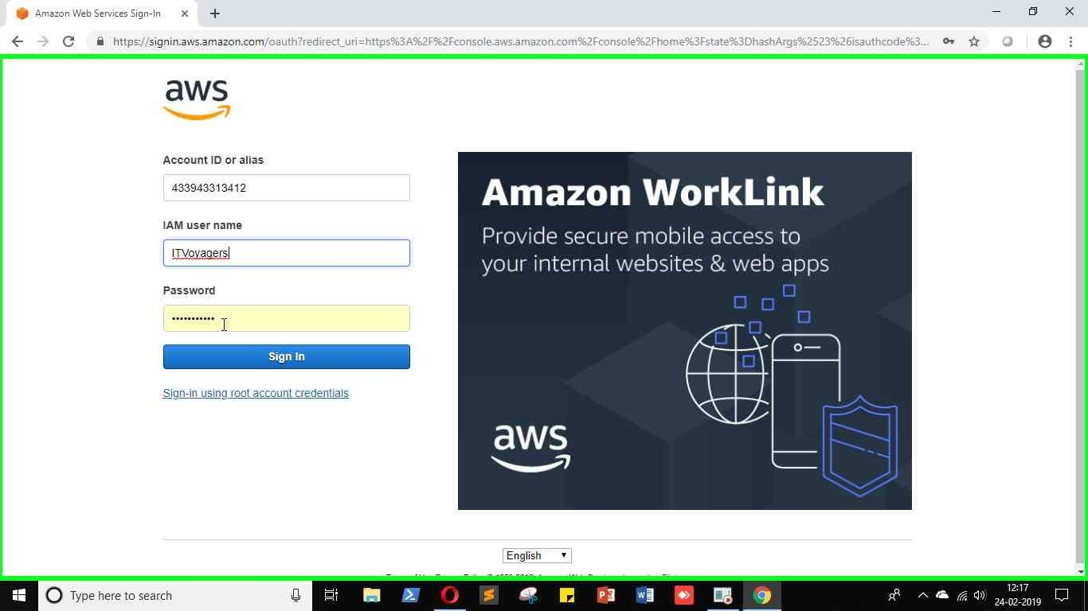

It will ask you to change the password which is been set by administrator.

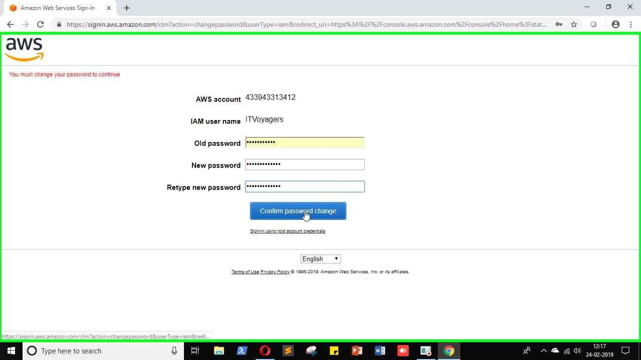

You will be redirected to home screen.

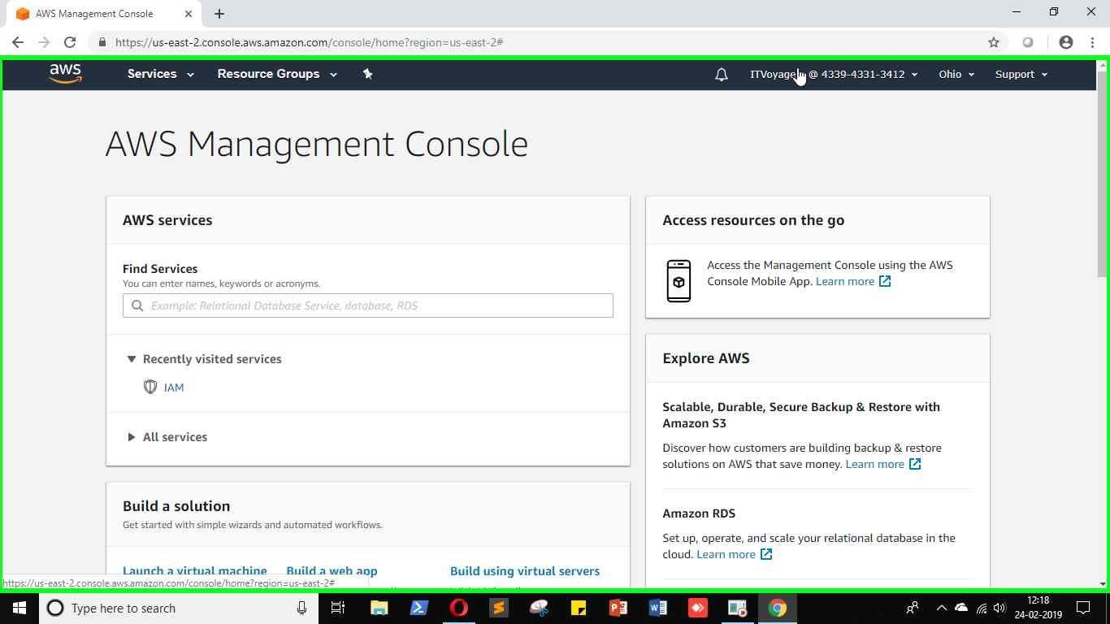

Practical 6

**AIM: Study Cloud Security management.**

Click on link below.

<https://aws.amazon.com/console/>

Go to “My Account” > “AWS Management Console”.





Just login to your users account.





Once you logged in go to “My Security Credentials”.

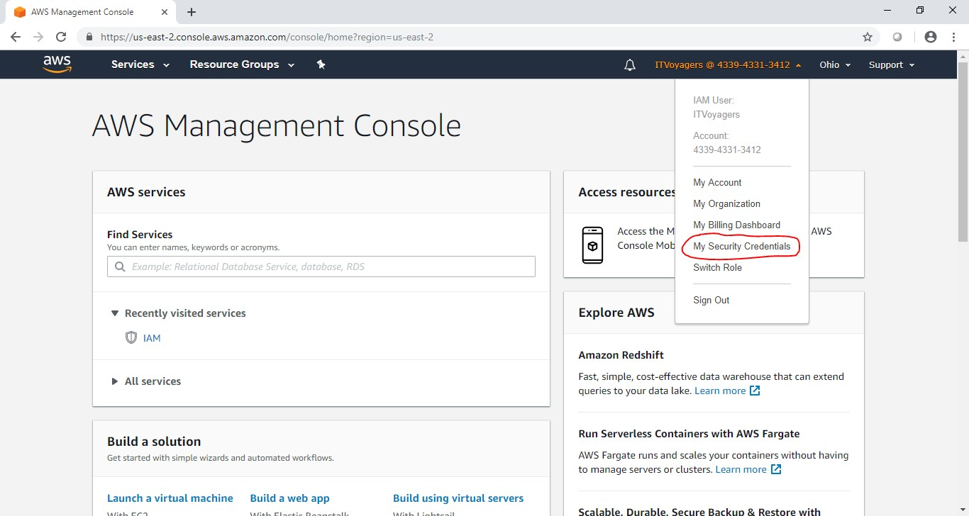

Scroll down you will find “Multi-factor authentication (MFA)”

Click on “Assign MFA device”

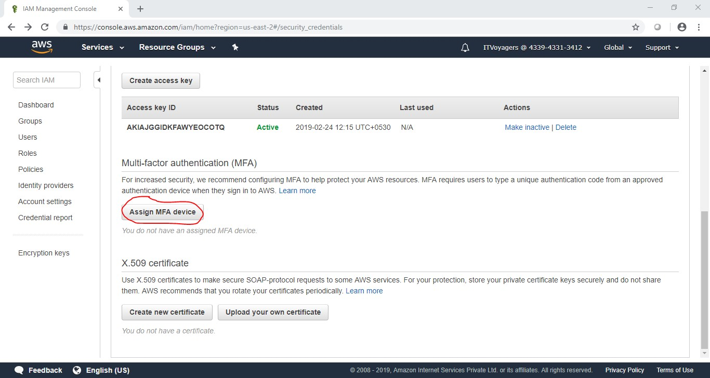

We will select first option “Virtual MFA device” and click on “Continue”

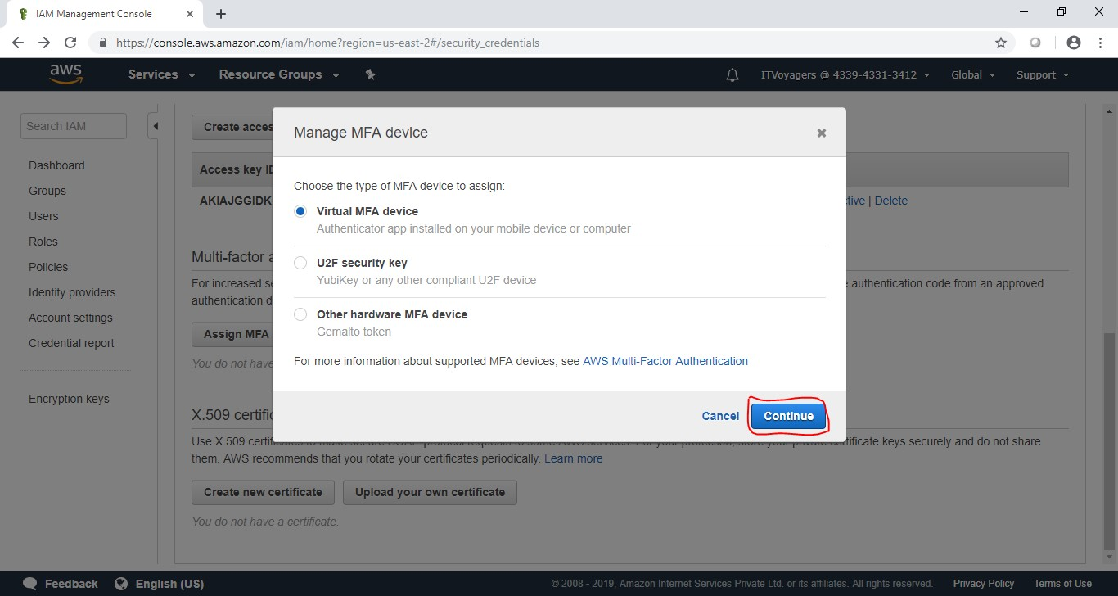

So concept is we will use third party app to generate OTP which will help us to authenticate ourselves during logging in. It will add a security layer to our account.

Now we have to download “2FA Authenticator (2FAS)” app on our mobile.

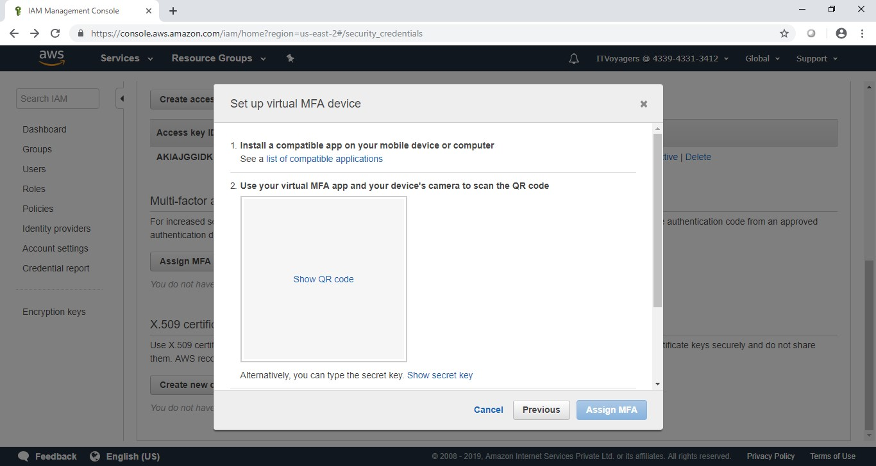

Click on “Show QR code” to display QR code.

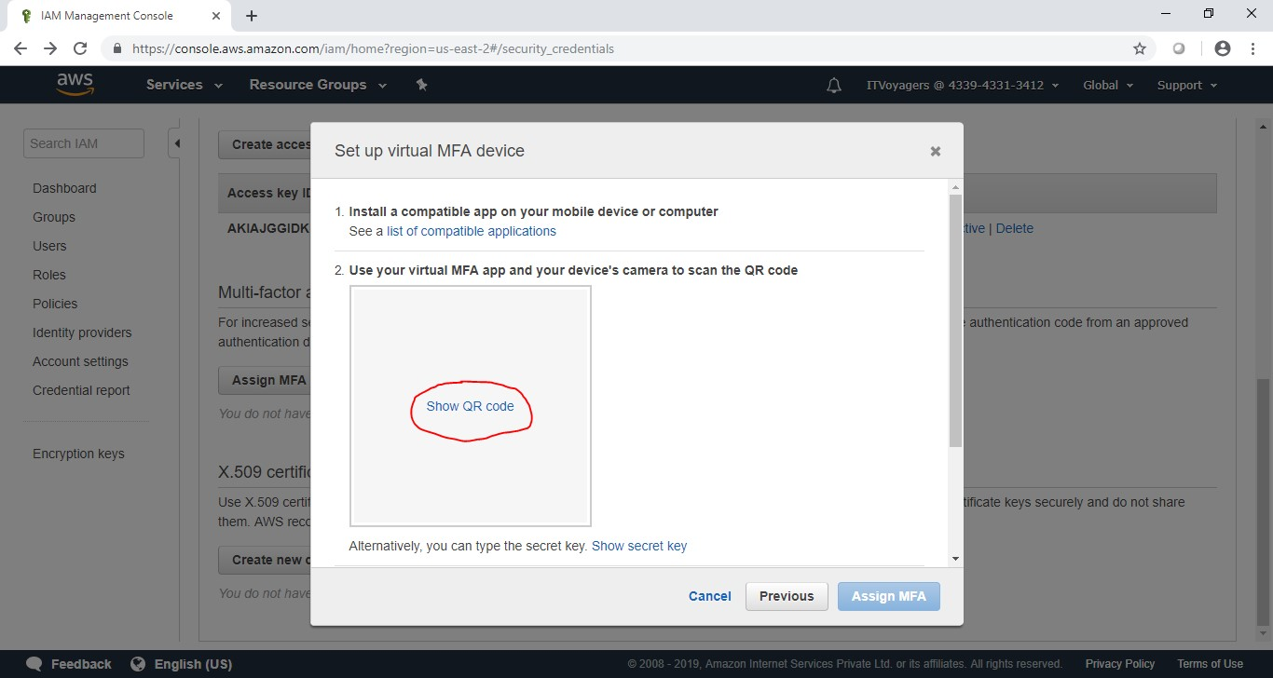

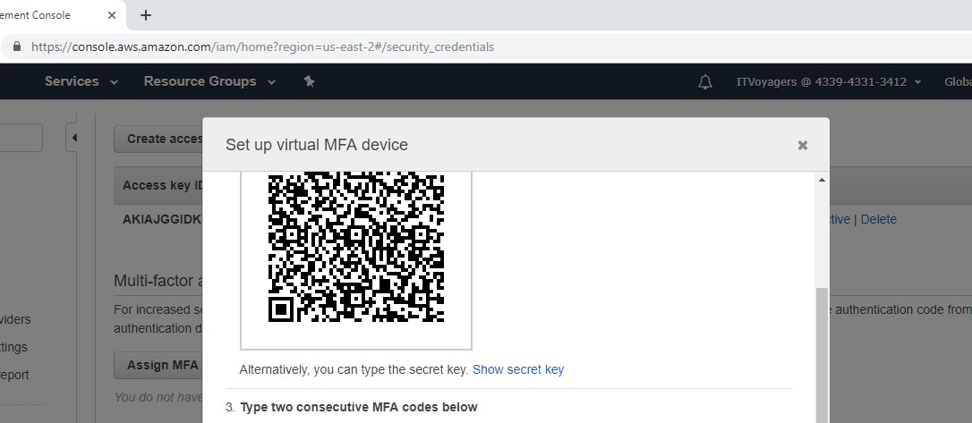

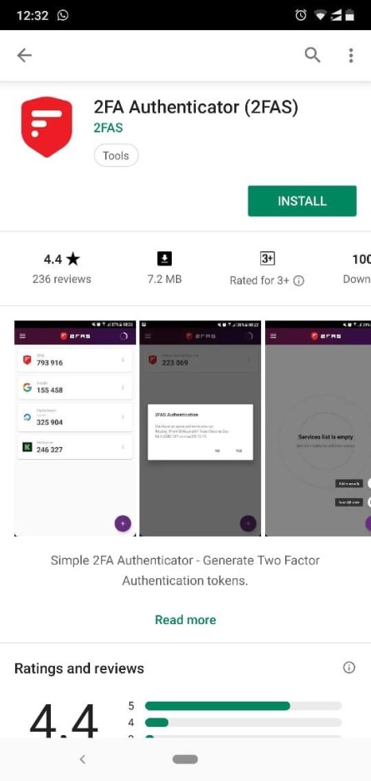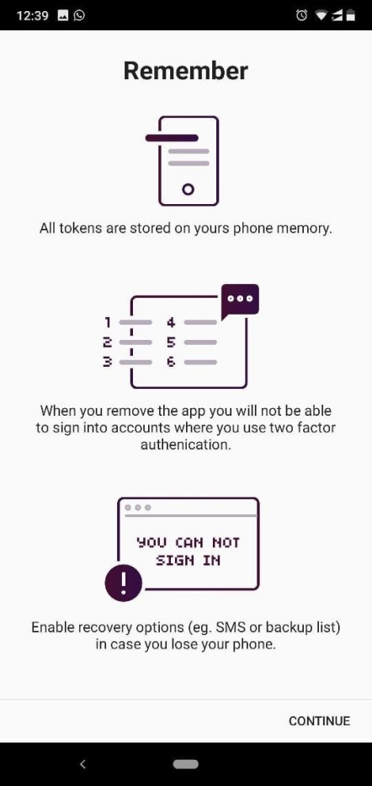

Open the app

click on



“



Continue



”

Now click on  and click on “Scan QR code”.

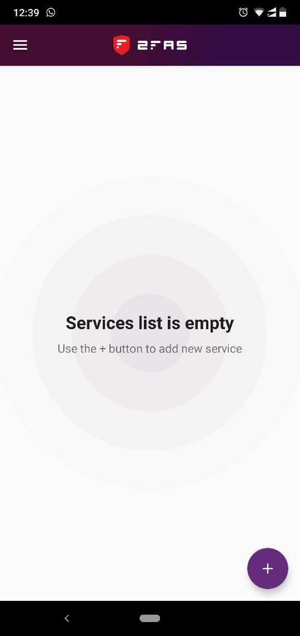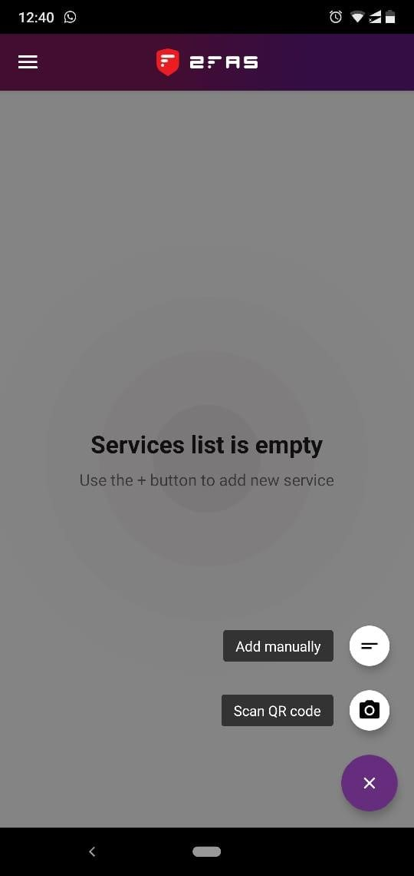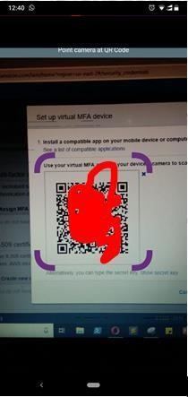

First we have to enter 2 OTP which we will receive on app and click “Assign MFA”.

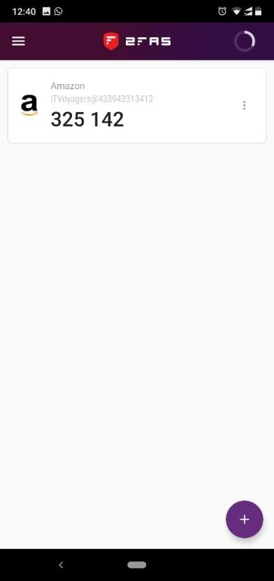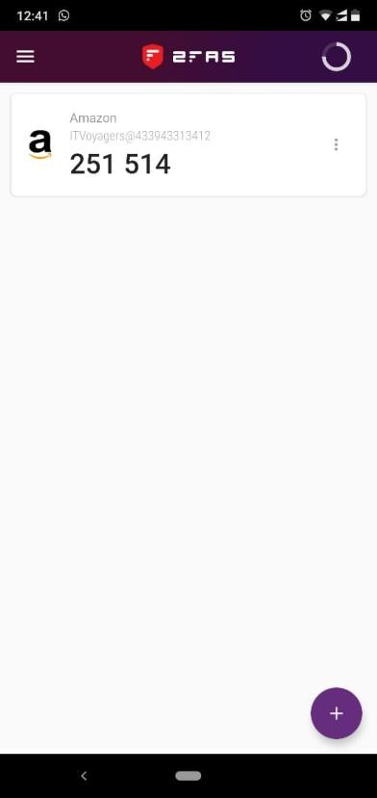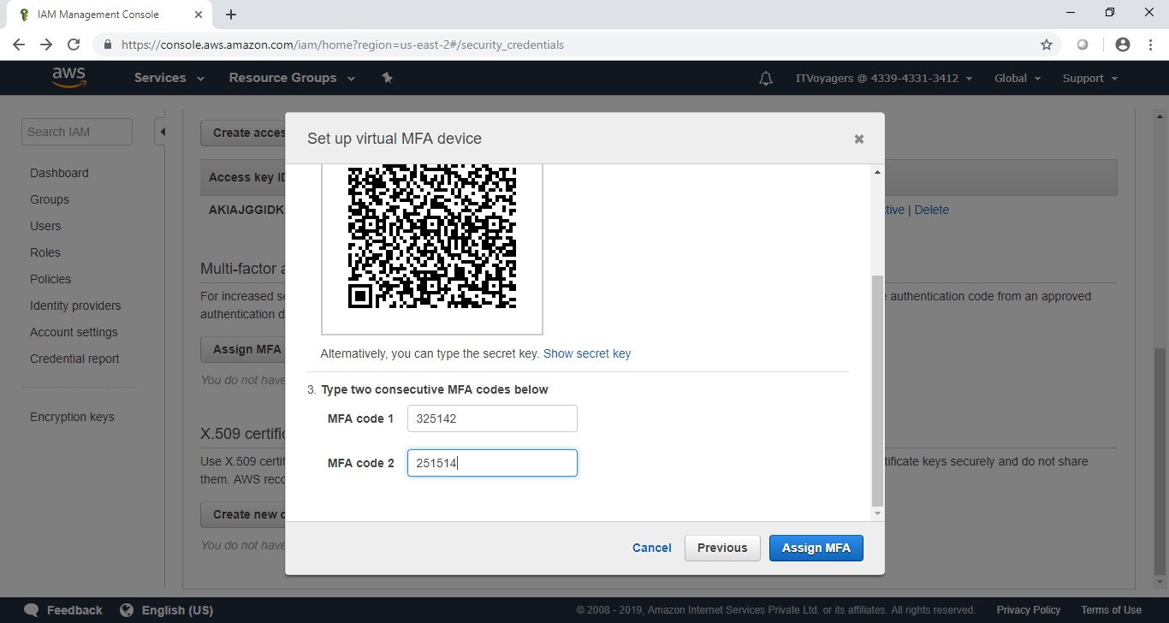

Click on “Close”

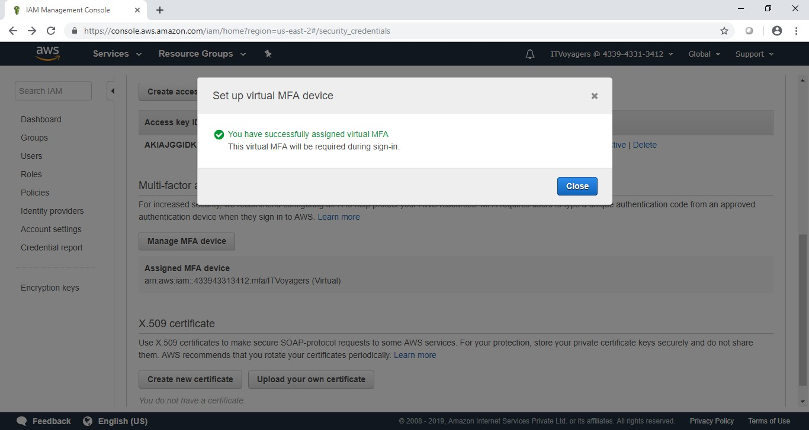

Copy your Account ID Account ID: 4173-8923-0188

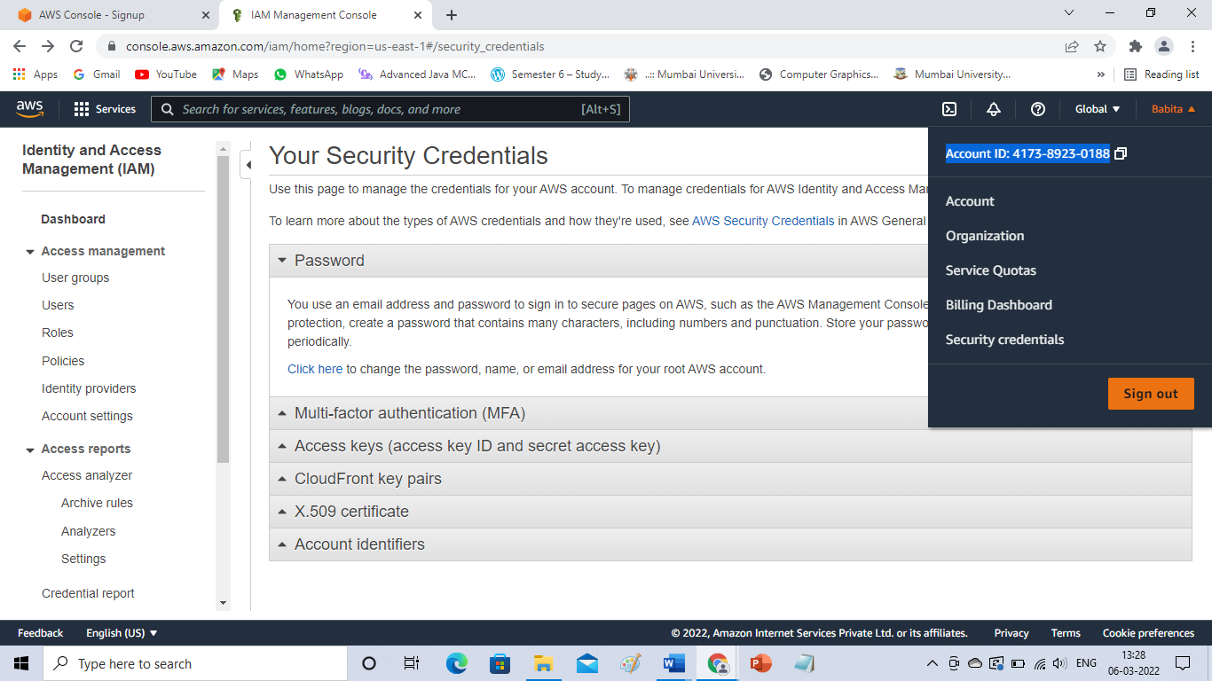

Log out from the account.

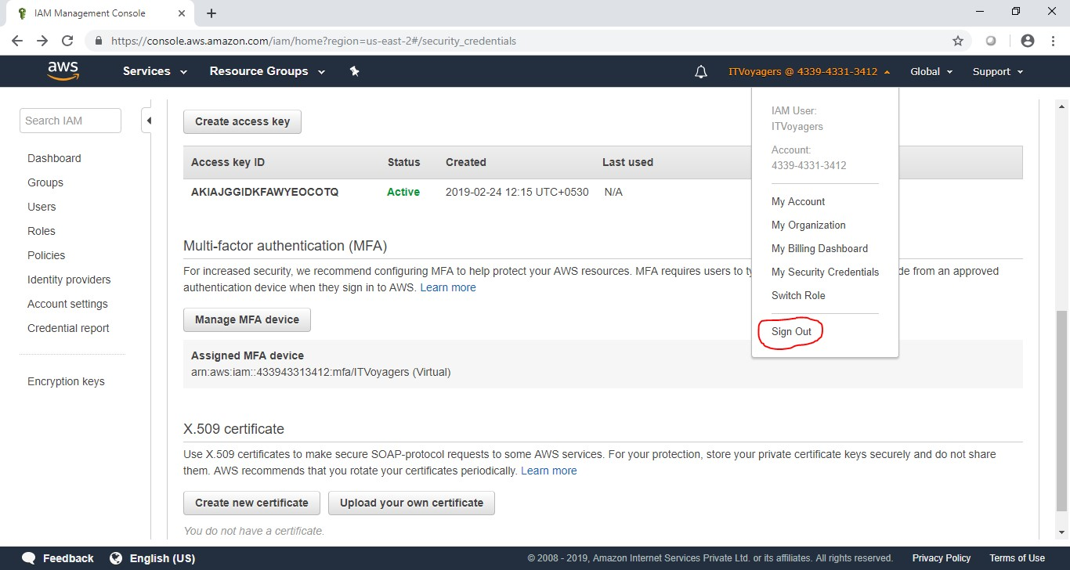

Now again try to log in to your account.

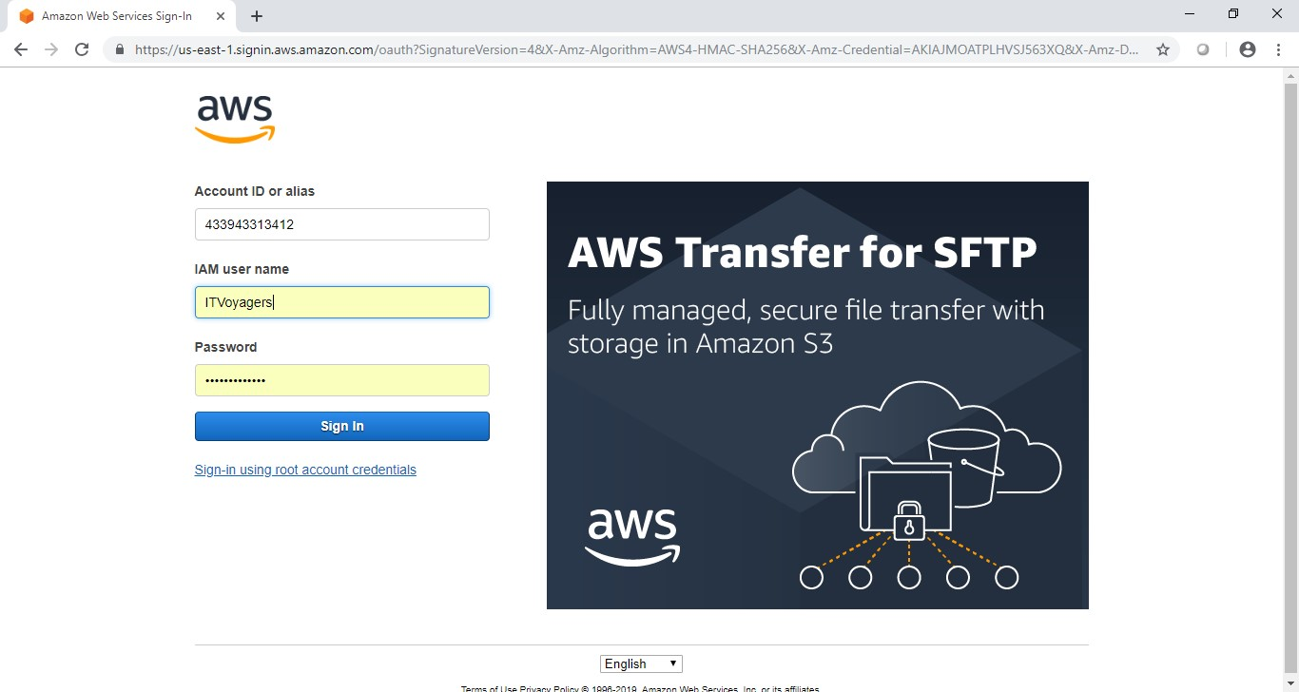

It will ask for MFA code. You get new code after every 30 seconds, just enter the valid MFA code and click on “Submit” to login.

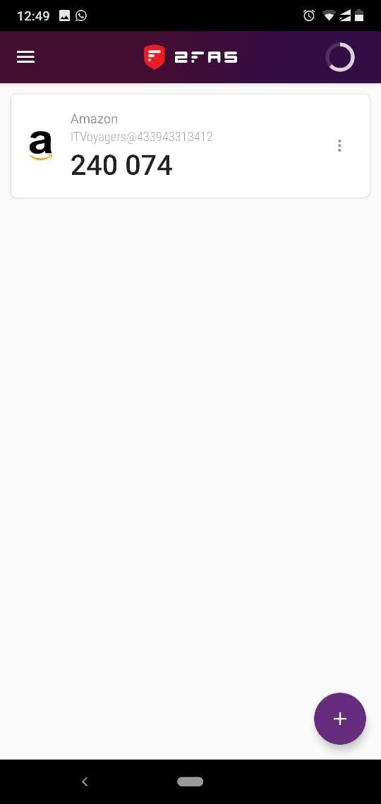

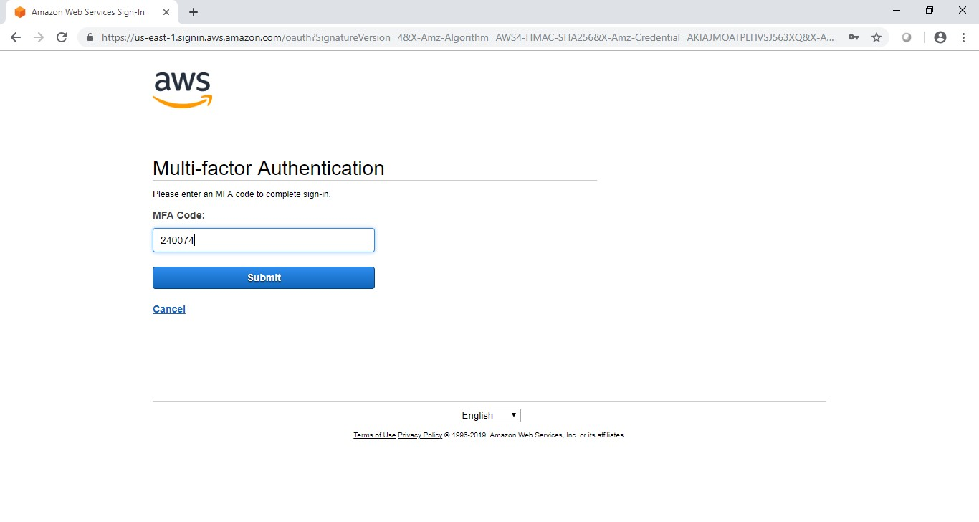

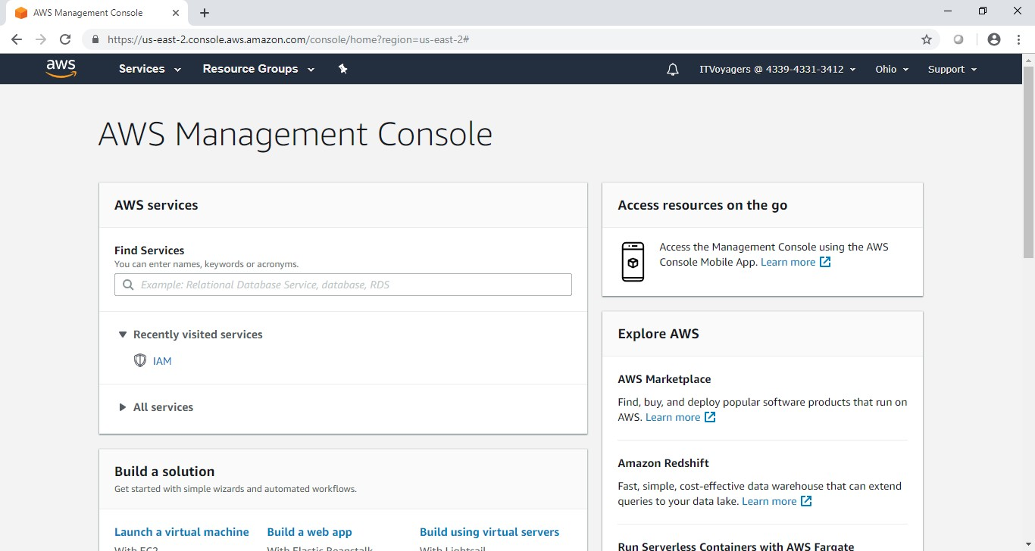

**Practical 7**

**Aim : Write a program for web feed.**

**STEP 1: Install the software “RSSBuilder**

* open google write rss builder
* open <https://sourceforge.net/projects/rss-builder/>
* click download

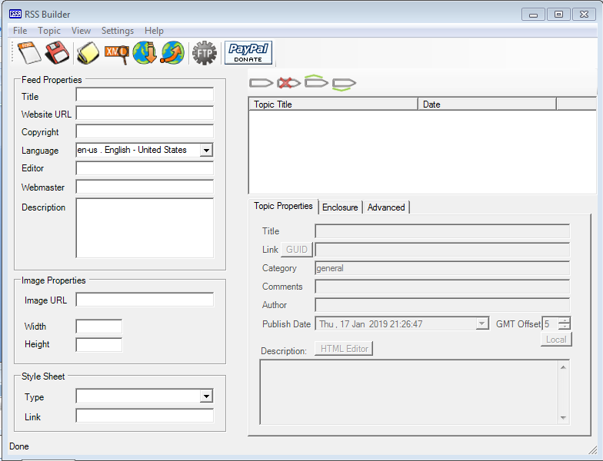

**STEP 2: Fill it**

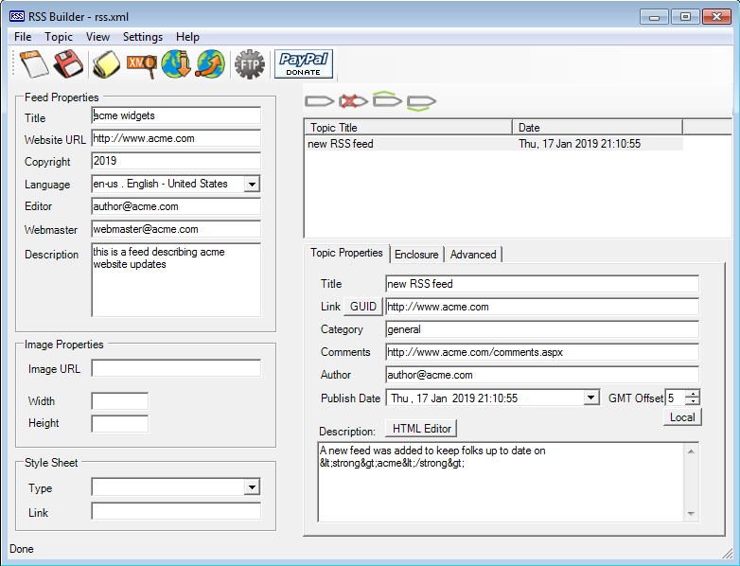

**Save With Extension Rss.Xml**

**STEP 3: Open the software visual studio 2010**

**Do the following**

**File ̶˃ new ̶˃ website ̶˃ visual C# ̶˃ ASP.NET website ̶˃ OK**

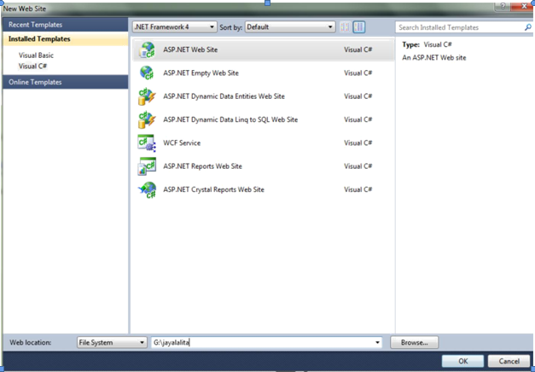

**STEP 4: Now copy that rss file which was savedwith .xml extention inside your website folder**

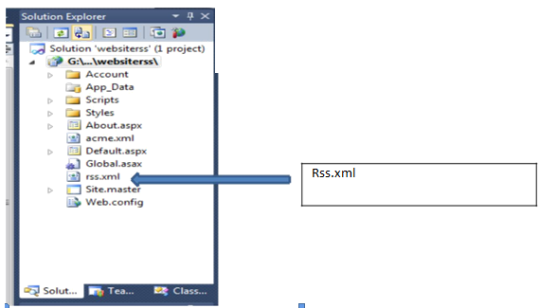

**STEP 5: Type this in default .aspx**

**<p>here is ur <a href="rss.xml">feed</a>.</p>**

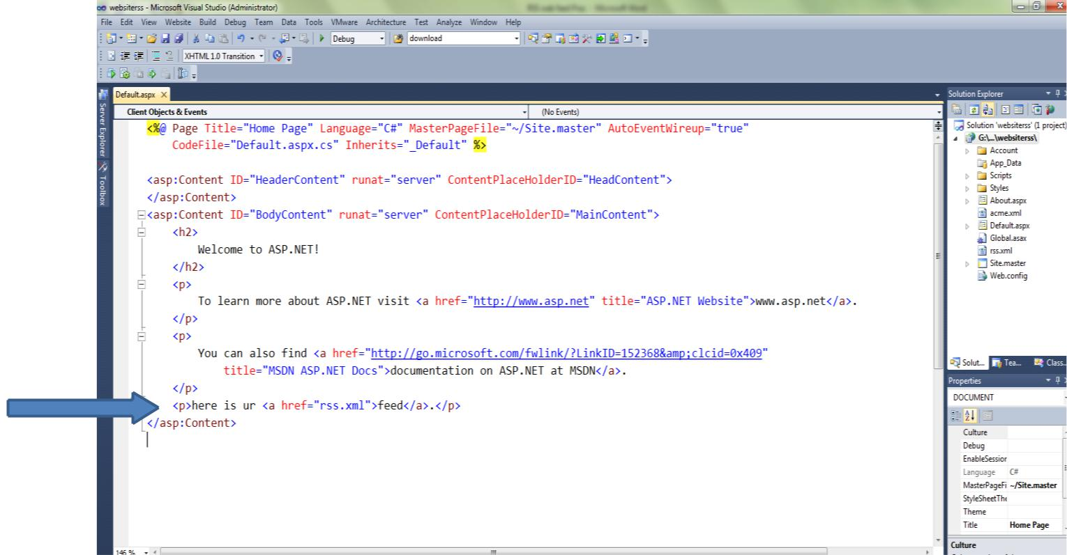

**STEP 6: Run the page**

**STEP 7: output**

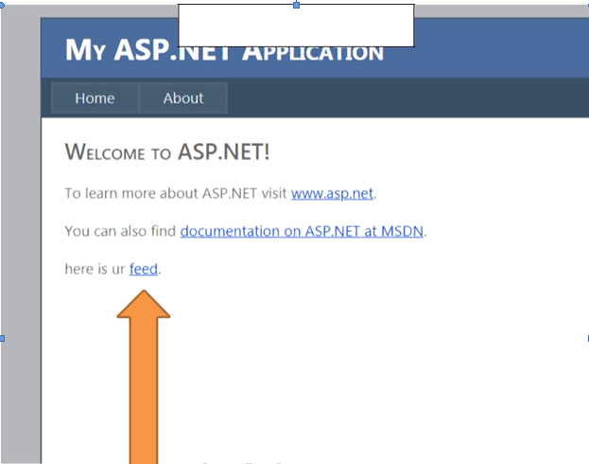

**Click On feed**

**STEP 8: The RSS web feed as output**

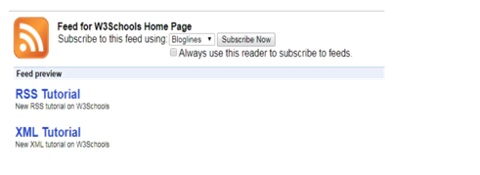

**Practical 8**

**Aim: Study and implementation of Single-Sing-On.**

Go to following link.

<https://auth0.com/learn/how-to-implement-single-sign-on/>

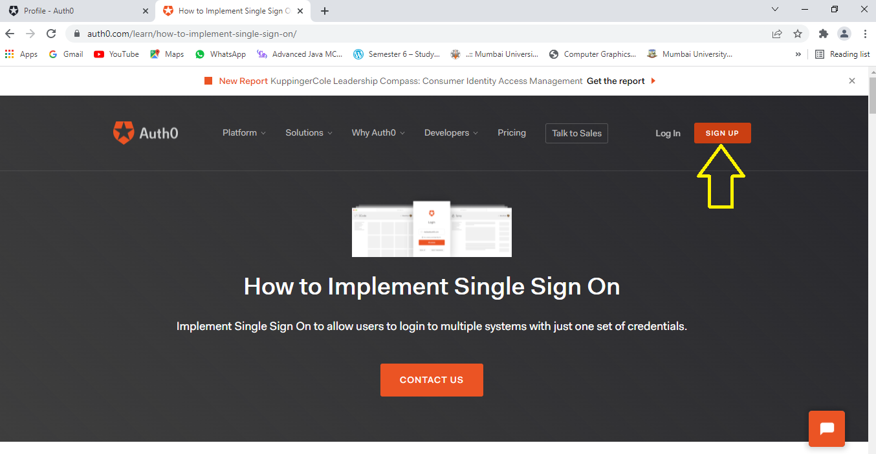

Steps

* Click on sign up
* Enter Your Email ID
* Click continue
* Set password

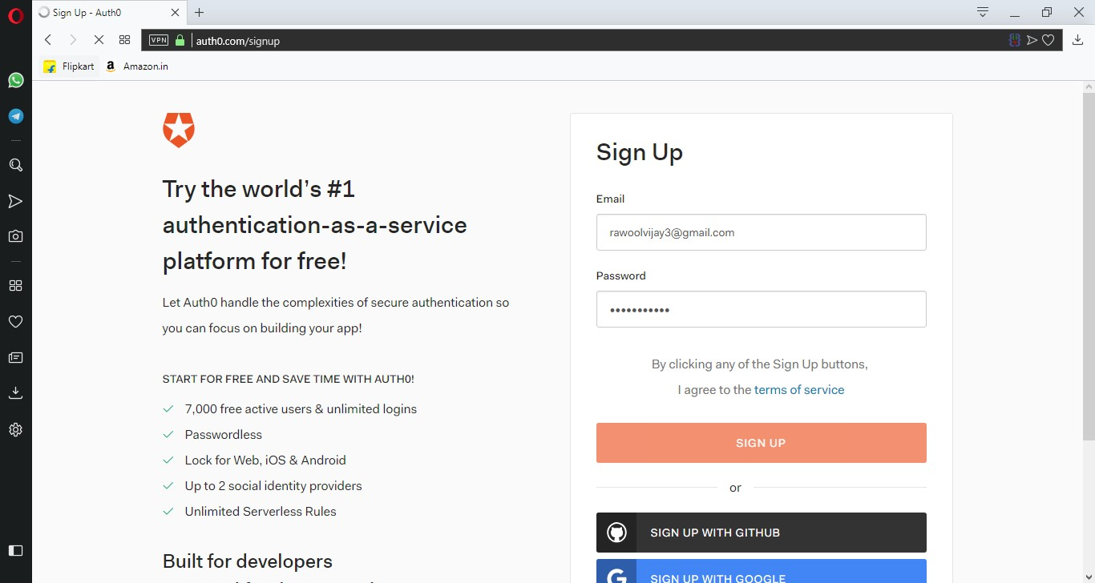

* In “ACCOUNT TYPE” panel select “Personal” then
* Click next

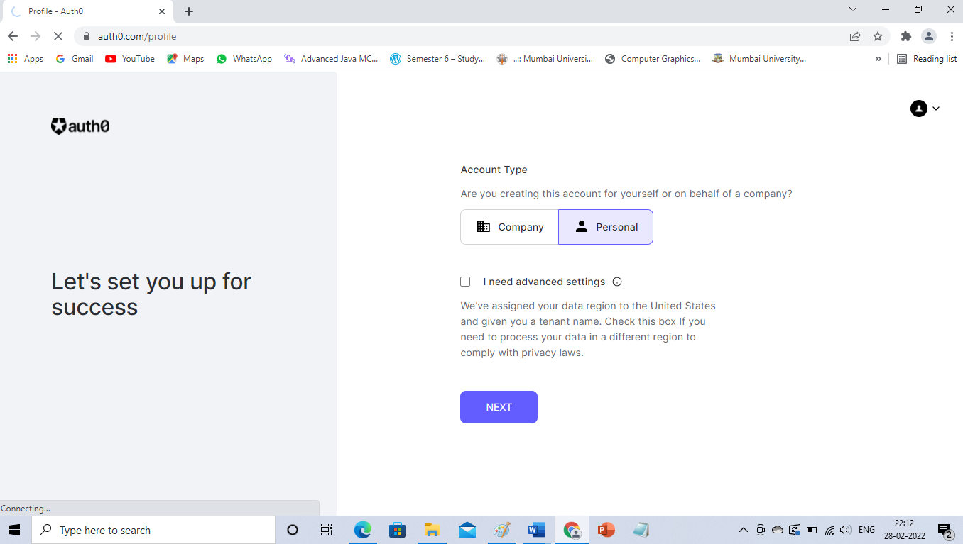

* You will See the dashboard

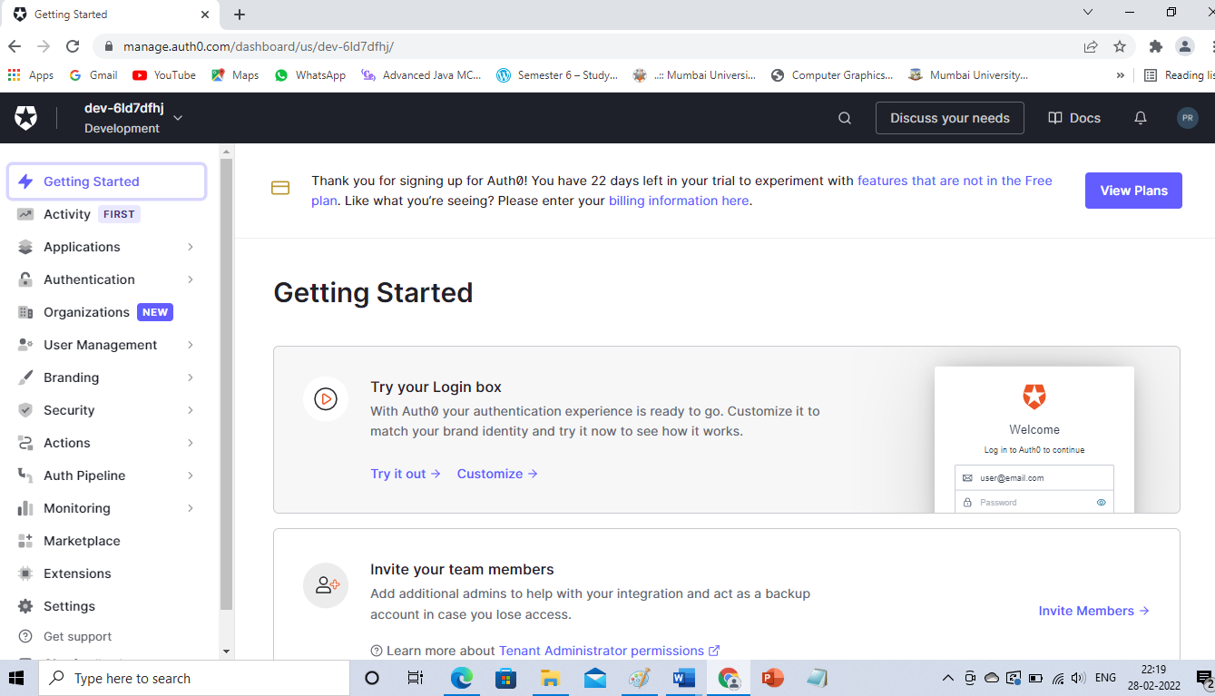

* Now go to Authentication------Social

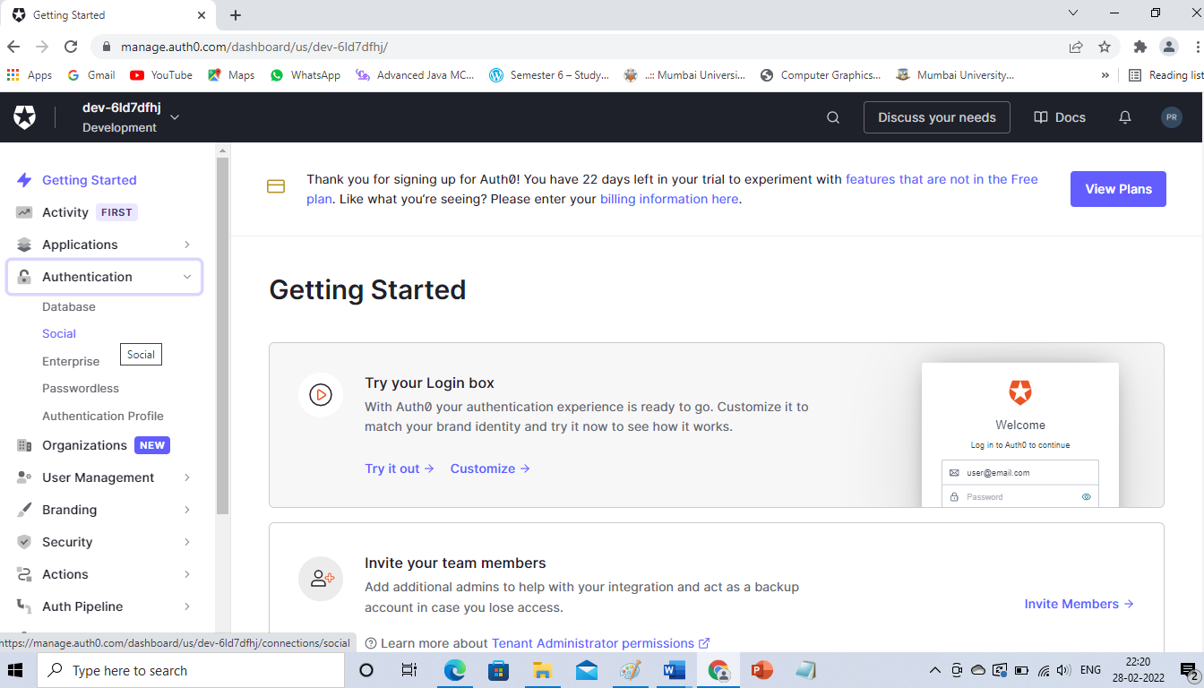

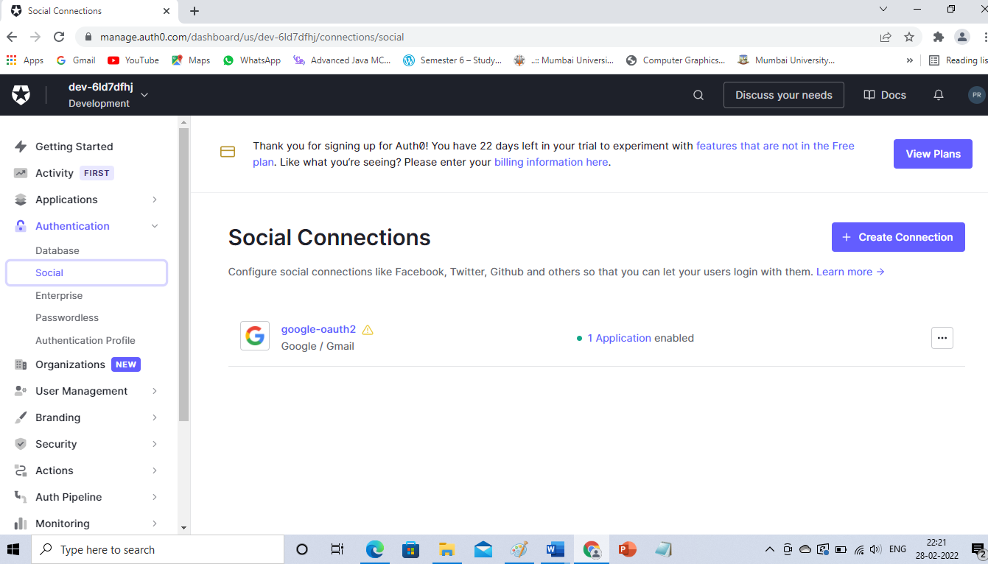

* Now click on google-oauth2
* Click on Try Connection

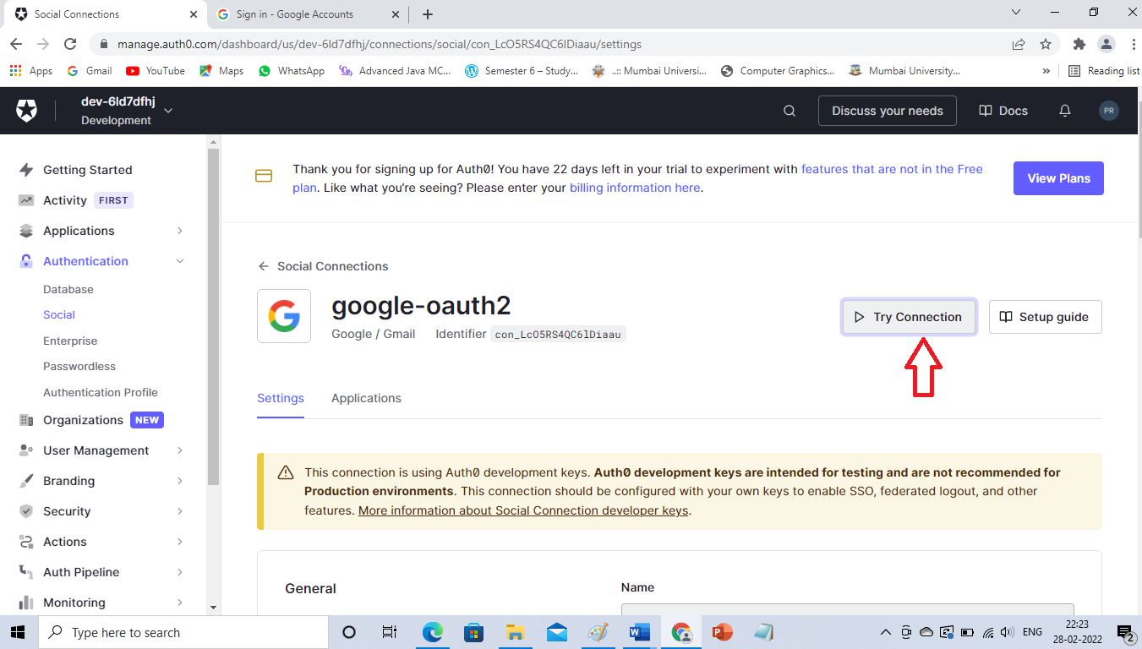

* You will get redirected to Google Accounts.
* Now enter your Email ID and password and submit.

Practical 9

**Aim: User Management in Cloud.**

First open XAMPP Control Panel and start “Apache” and “MySQL” services.

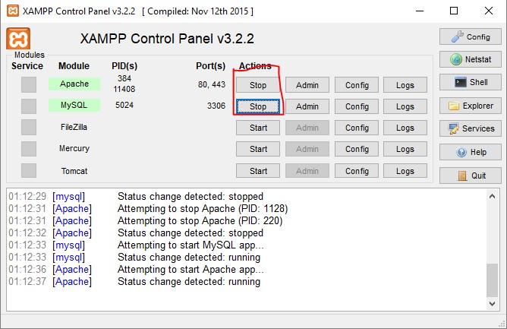

Open browser and type “localhost/owncloud/” in URL bar and press “enter”.

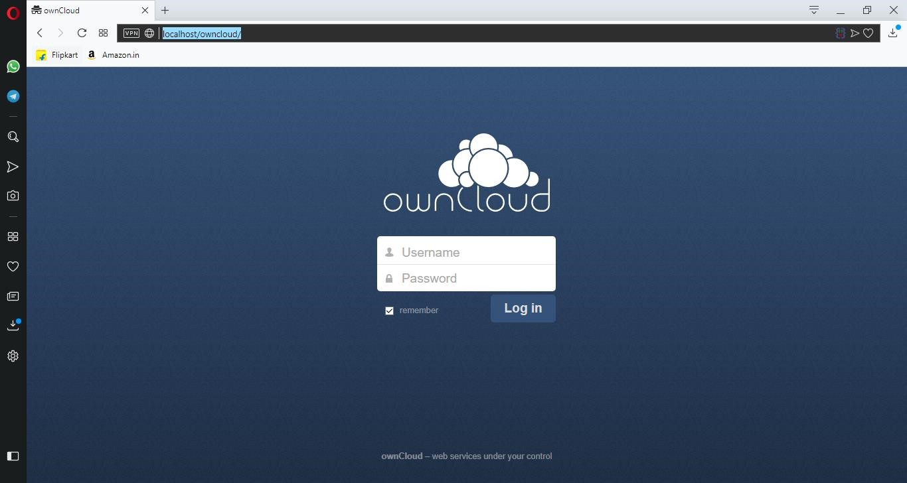

Enter admin name and password which you have set while creating account and click on “Log in”.

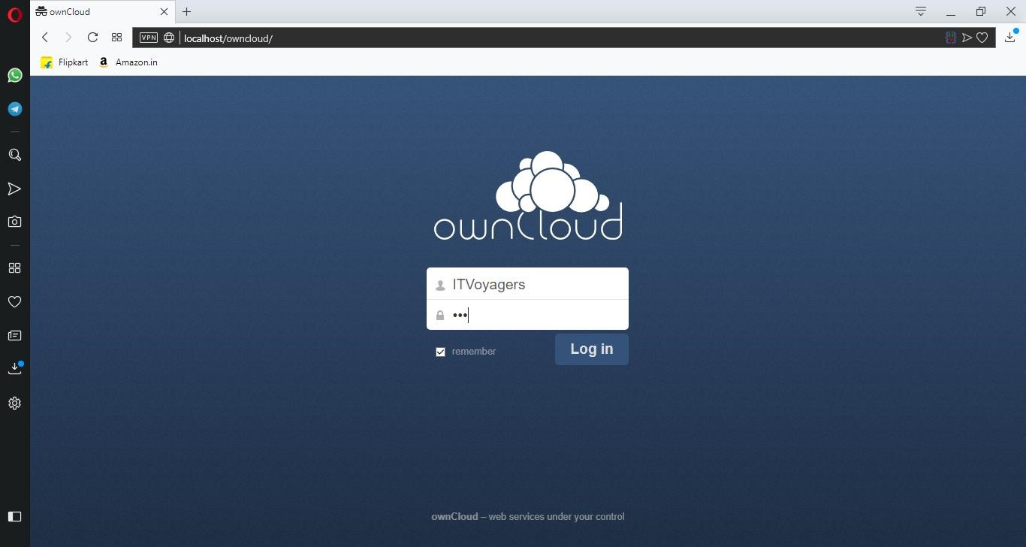

Following dashboard will get load.

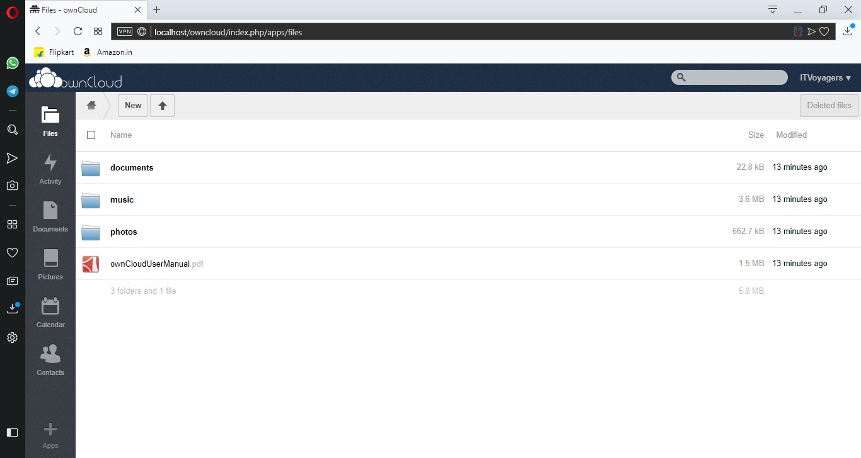

Now go to “Users”.

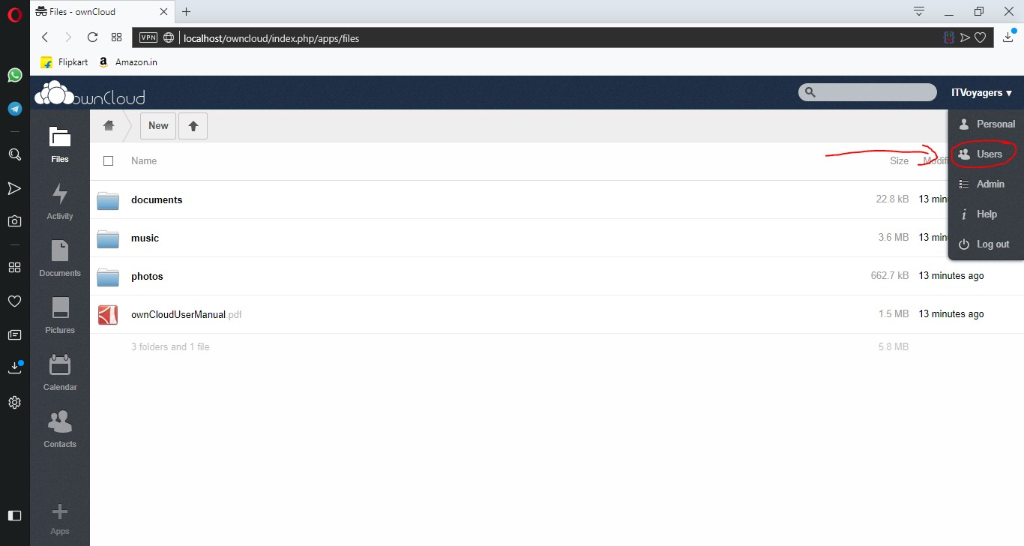

You can see that there is only user which is admin, which is in Group admin

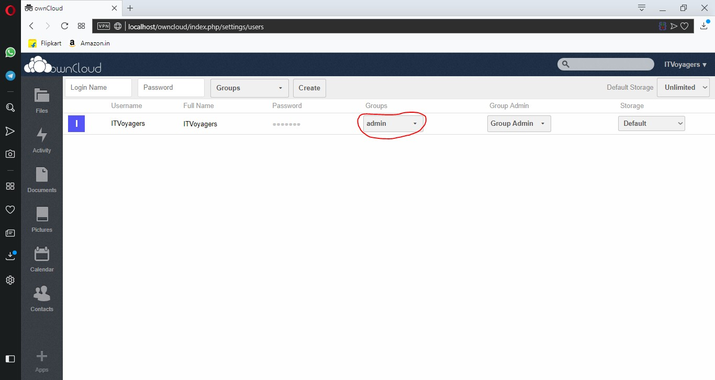

Now let’s add group, for that go to “Group” > “add group”.

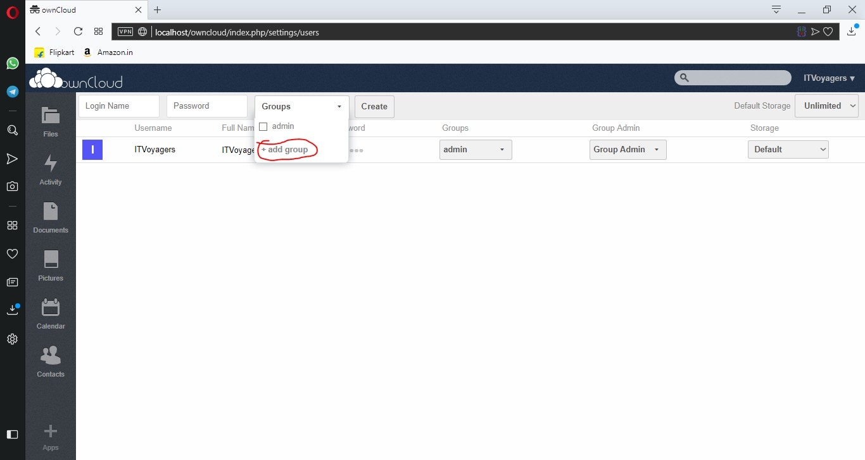

Enter group name and press “enter”.

Enter group name and press “enter”.

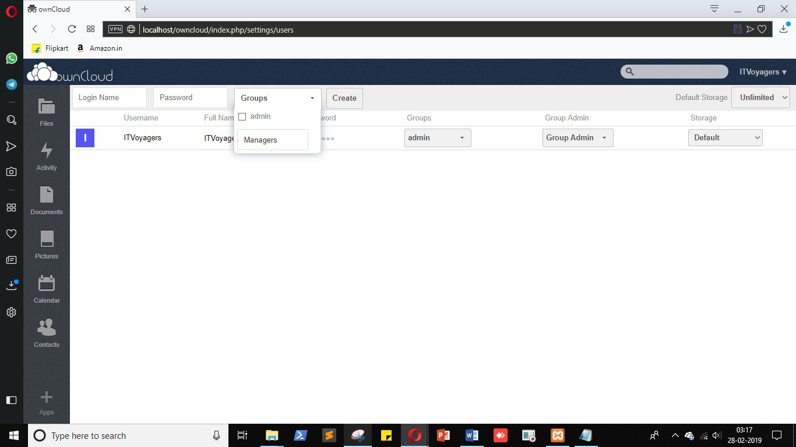

Our group is been added, now select it.

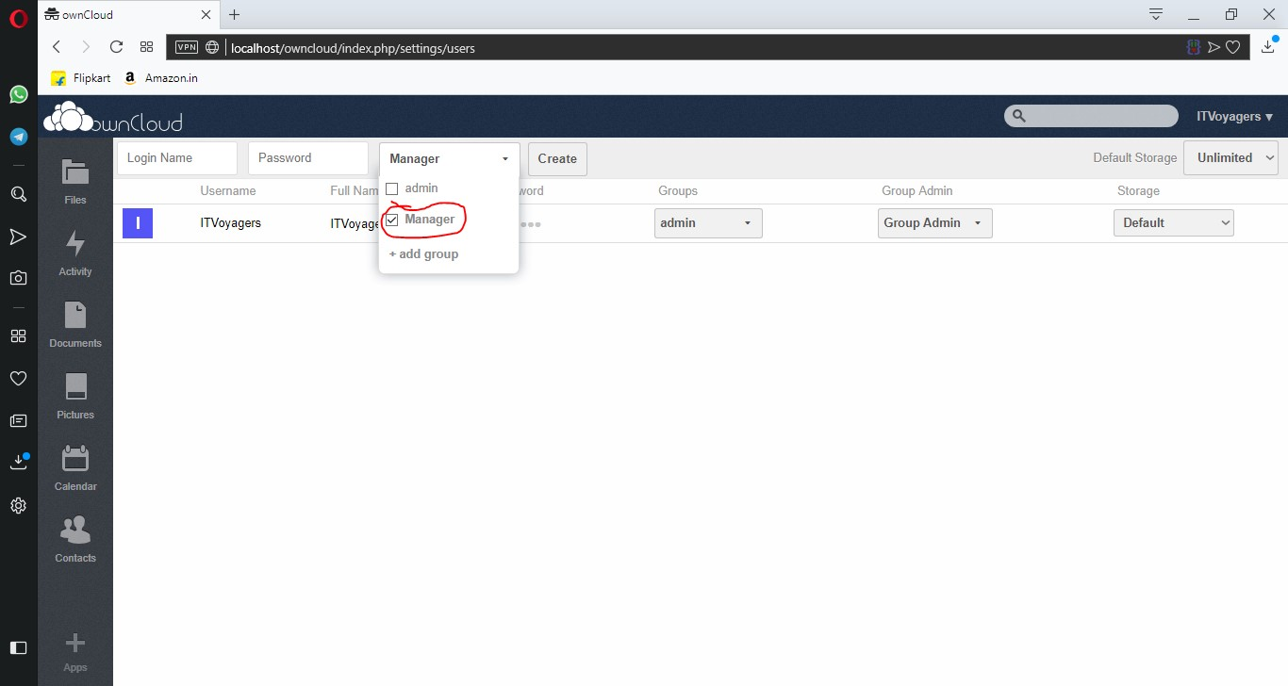

Now enter “Login Name” and “Password” for the user and click on “Create”.

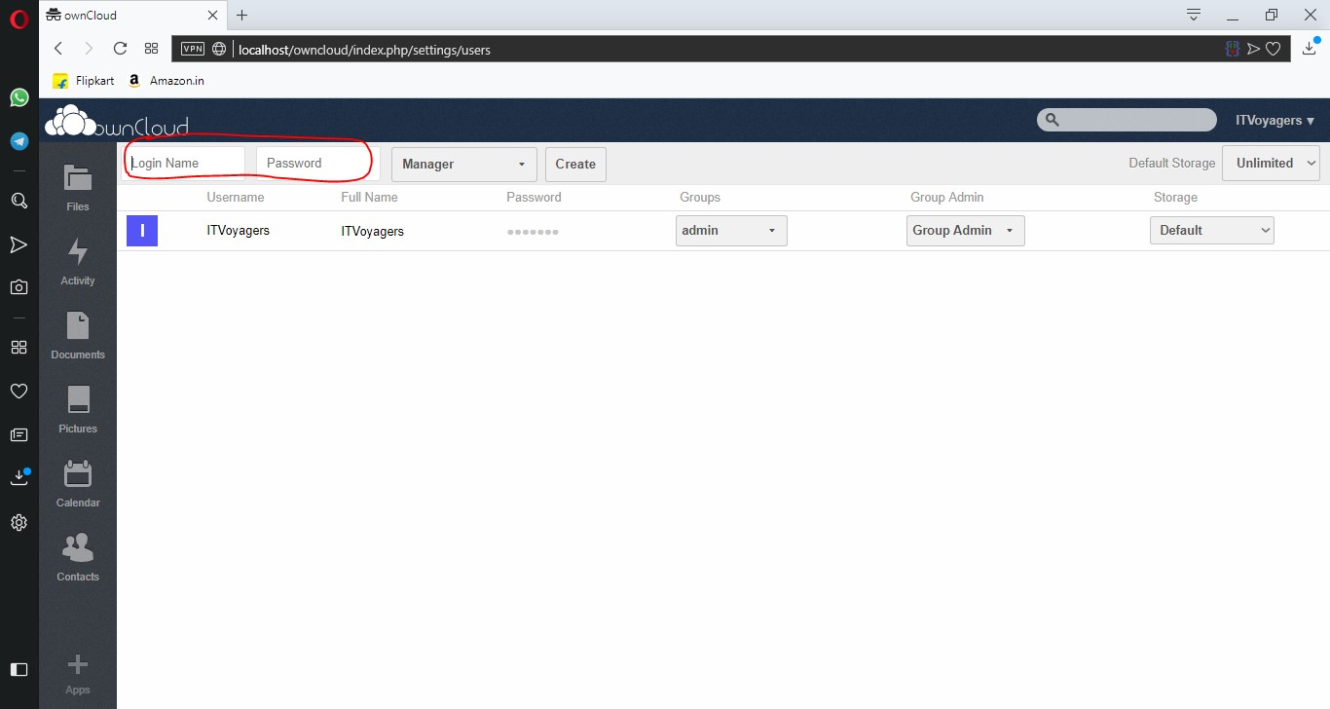

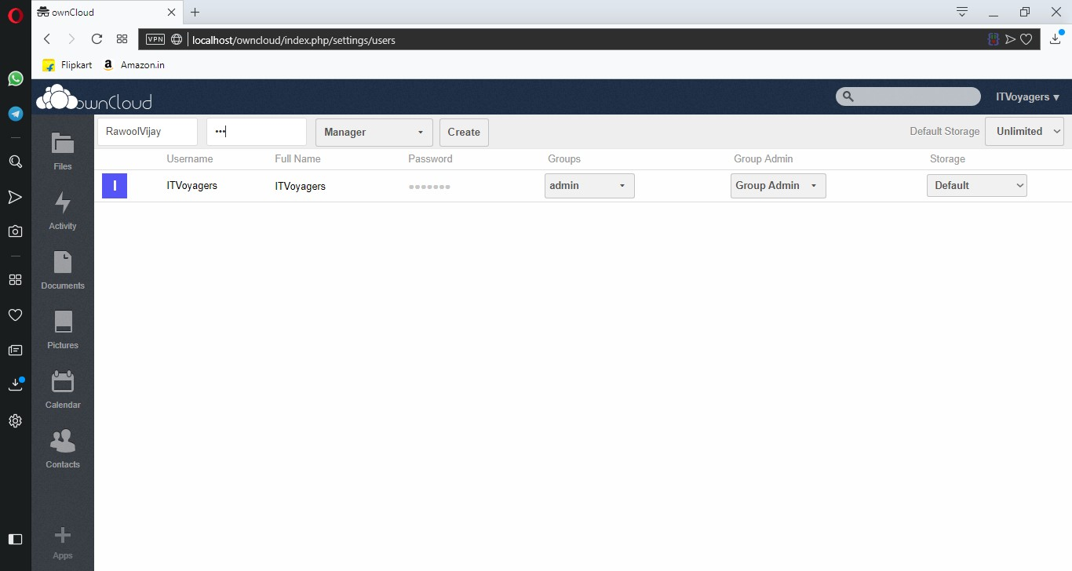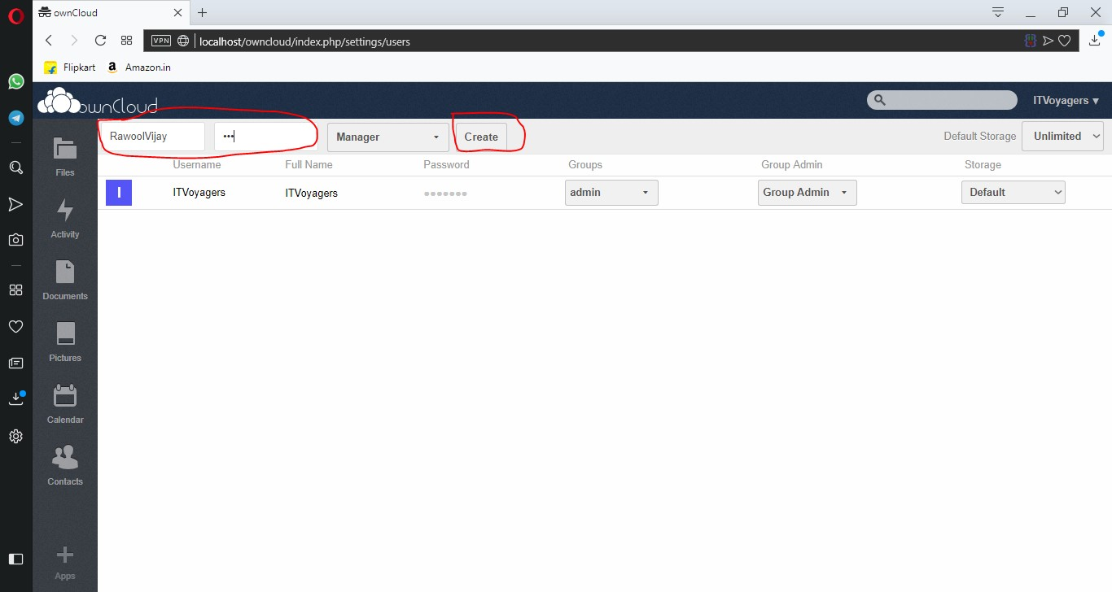

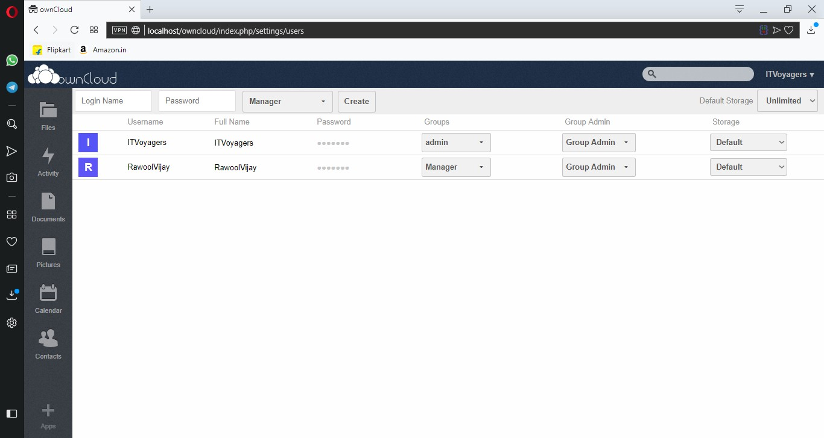

Our user is been added we can change the storage limit for the new user.

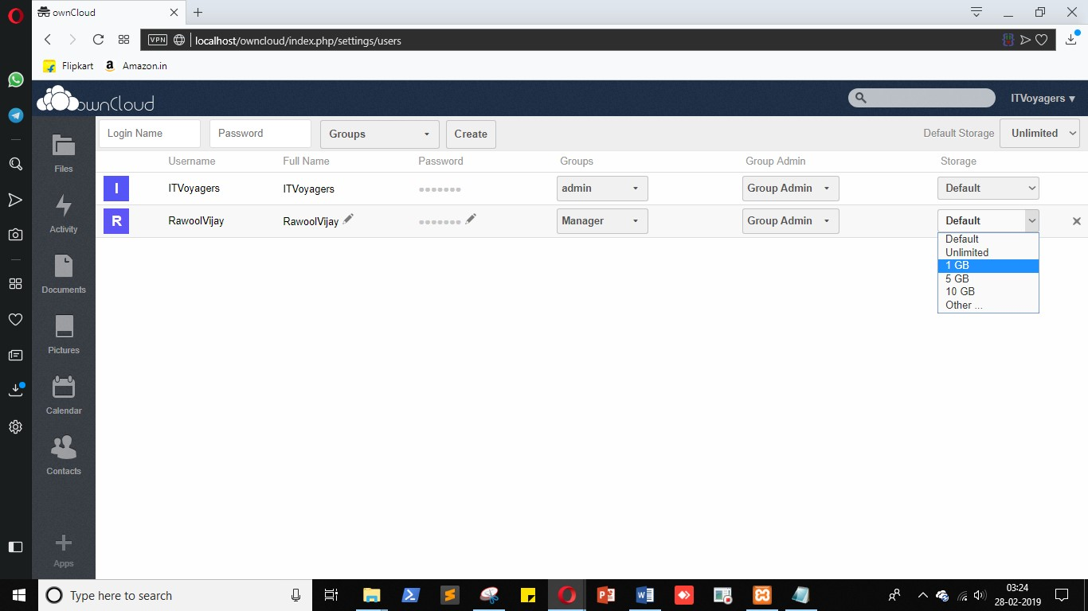

Default limit is unlimited as mentioned above.

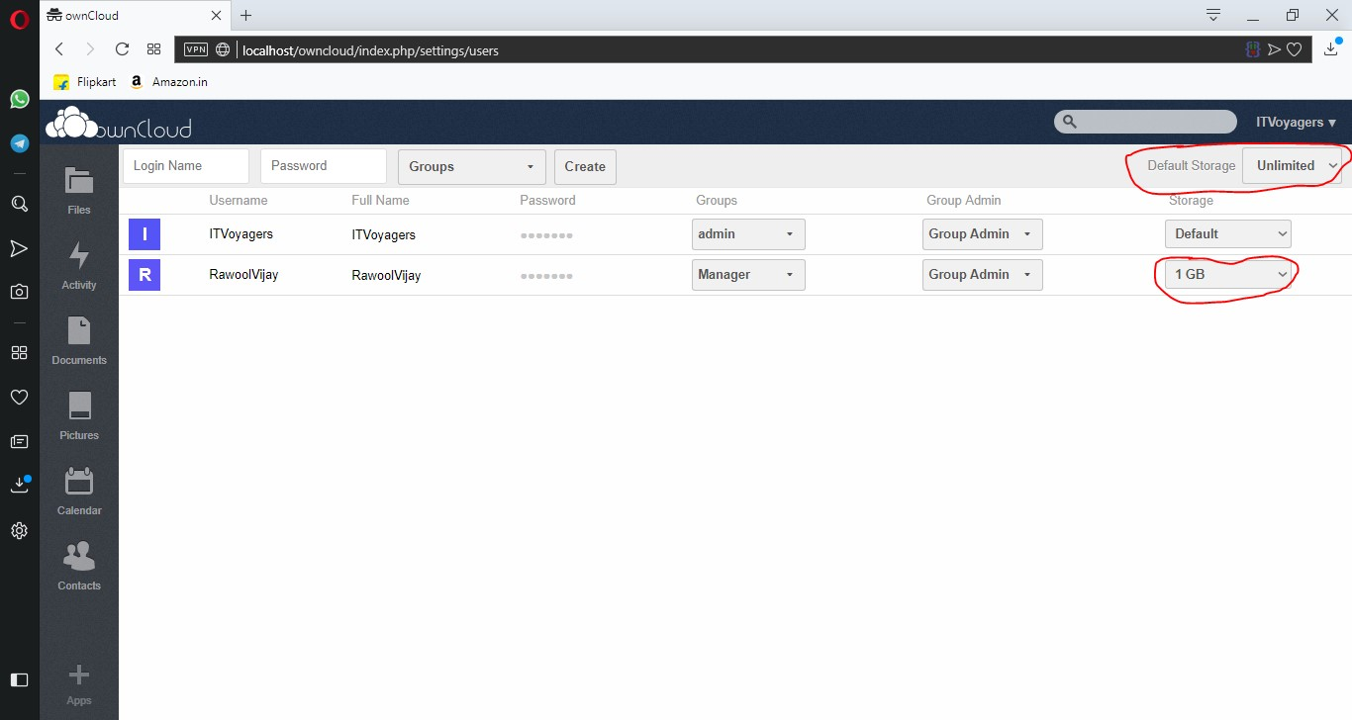

Let’s add another user but this time in “admin” group.

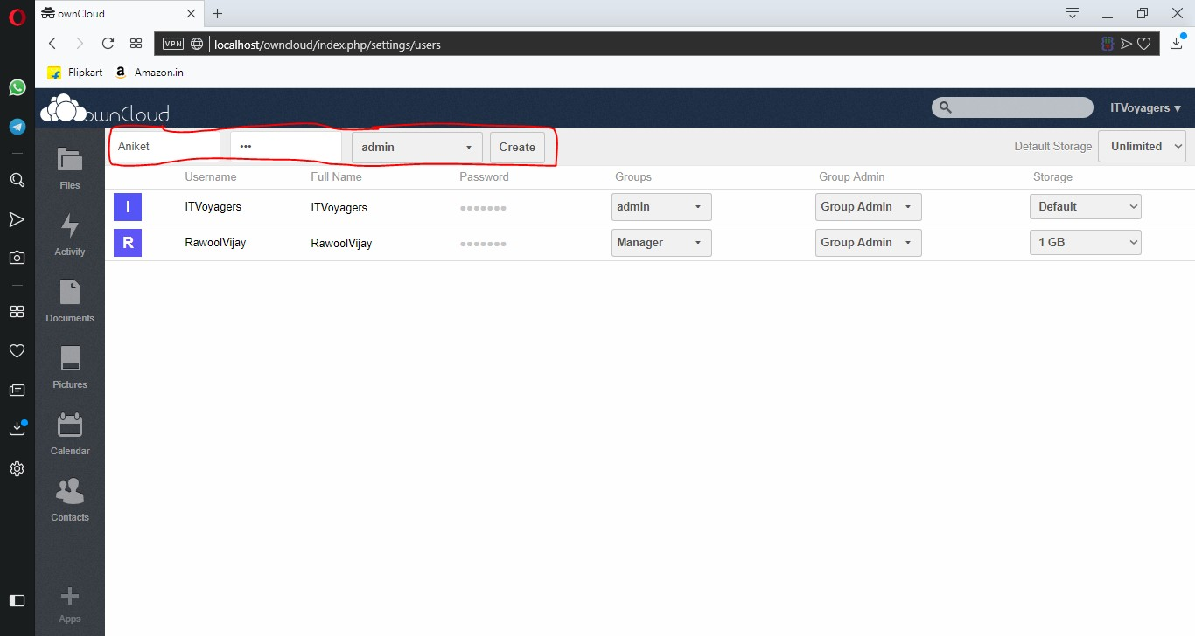

If it shows “admin, admin” in group just click on it and uncheck one “admin”.

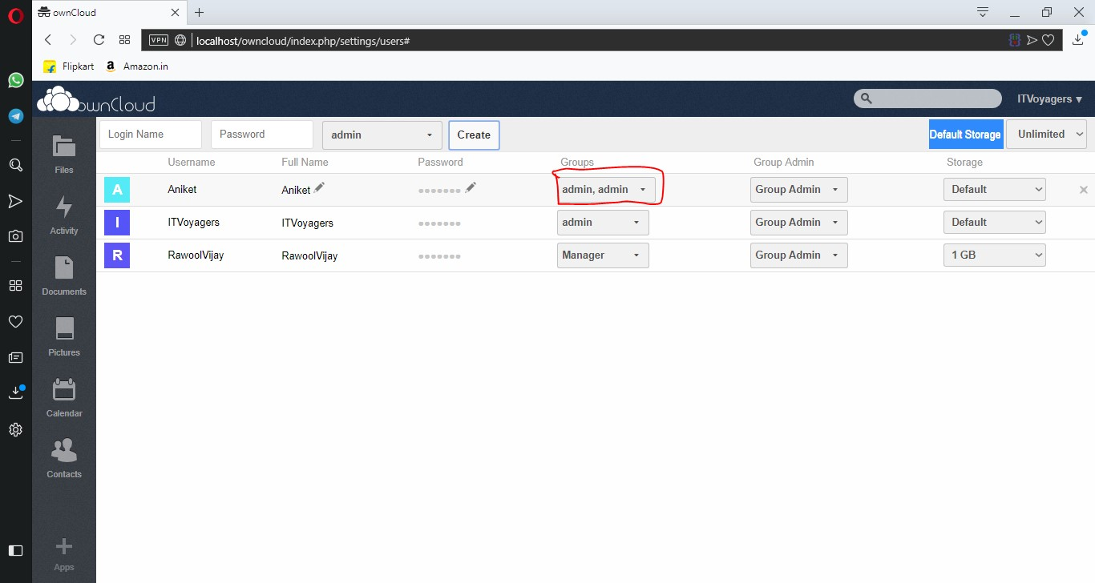

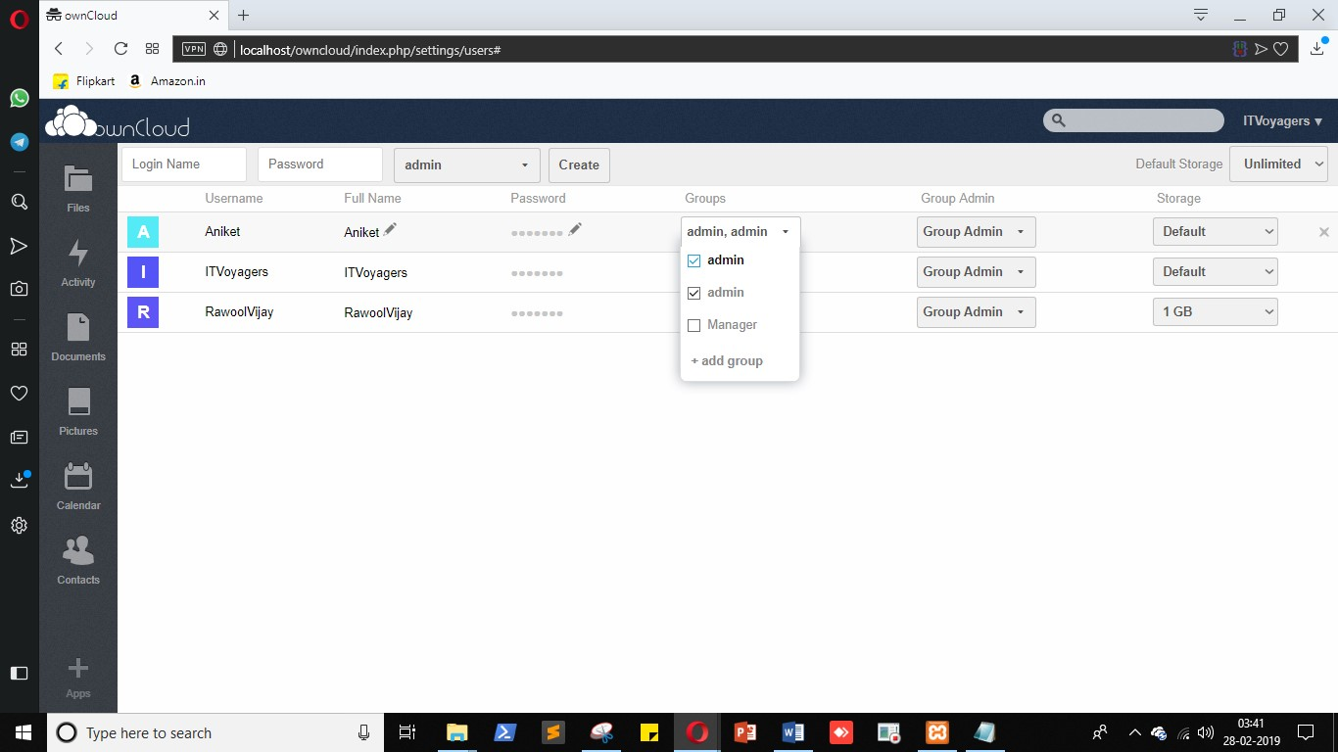

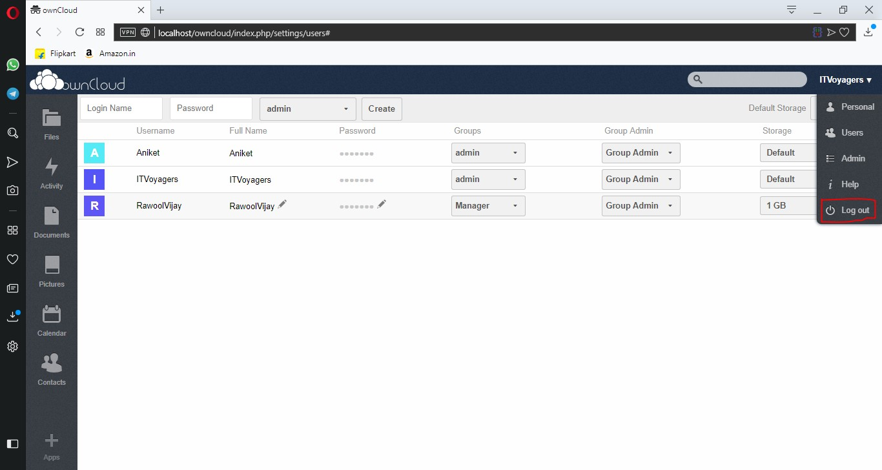

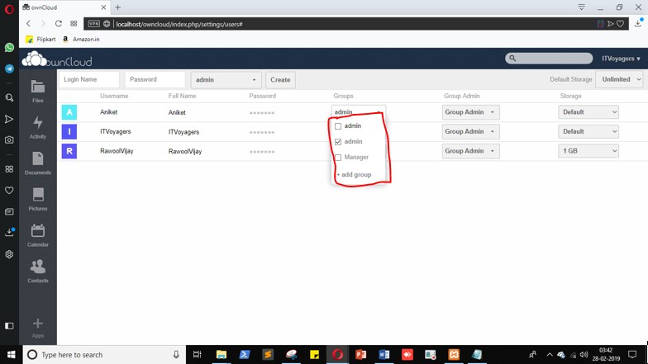

Note: Sometimes it fails to register user in “admin” group so please check before logging out. You can check by refreshing the page.

Now “Log out” from the admin account.



Try log in with user you just created.

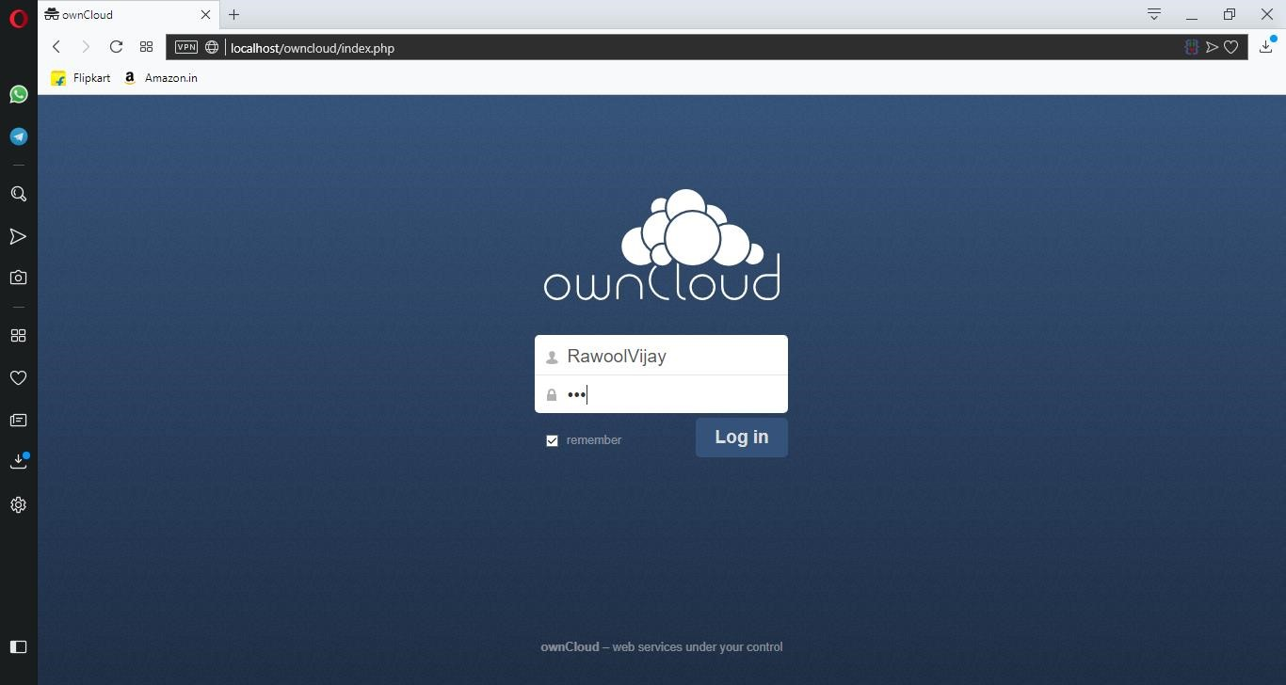

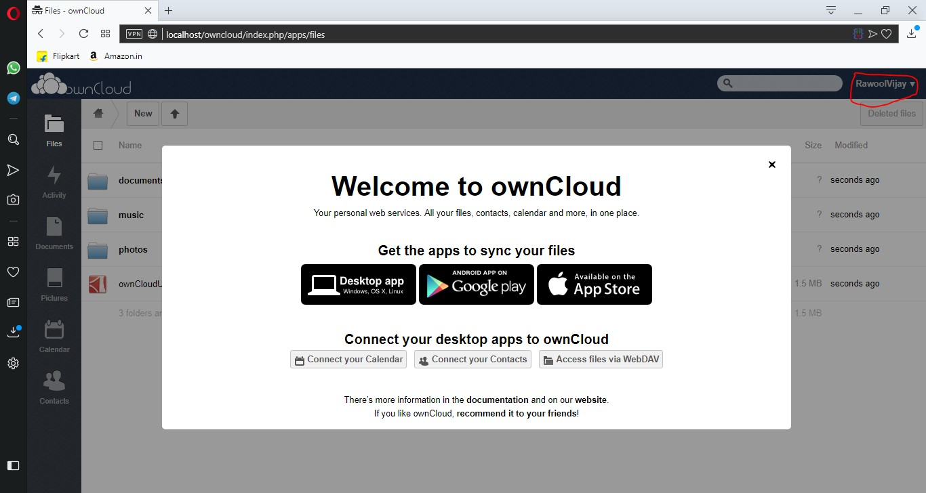

Yes we have logged in.

As you can see this user don’t have any privilege link adding users and creating group because it’s not in “admin” group, now “log out” from the account.

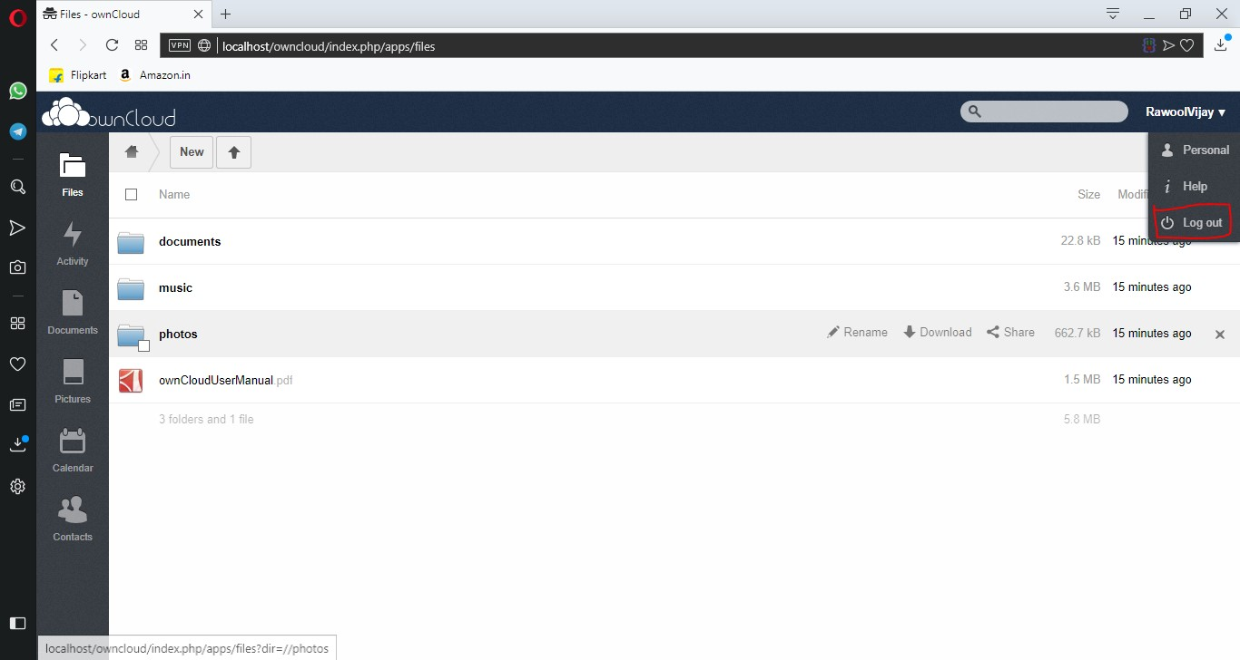

Now let’s try to log in from the user account who is in “admin” group.

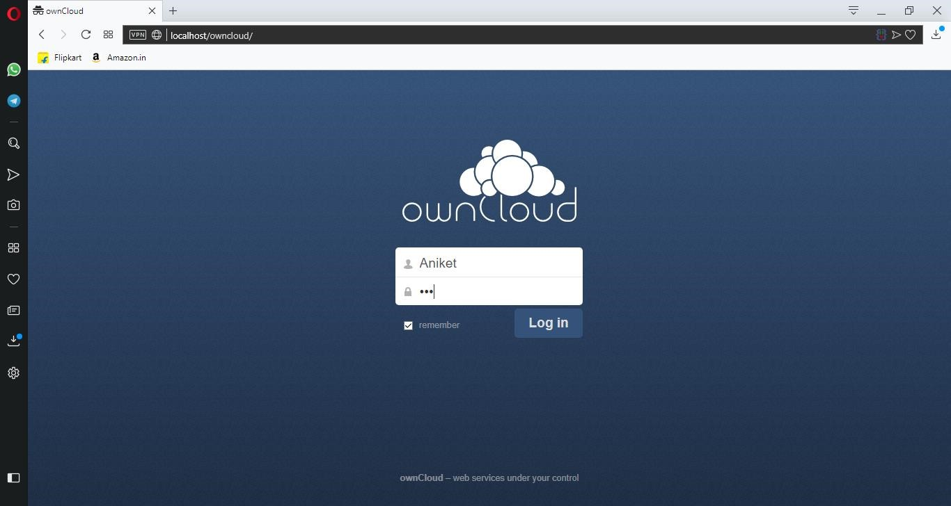

Enter login details and click on “Log in”.

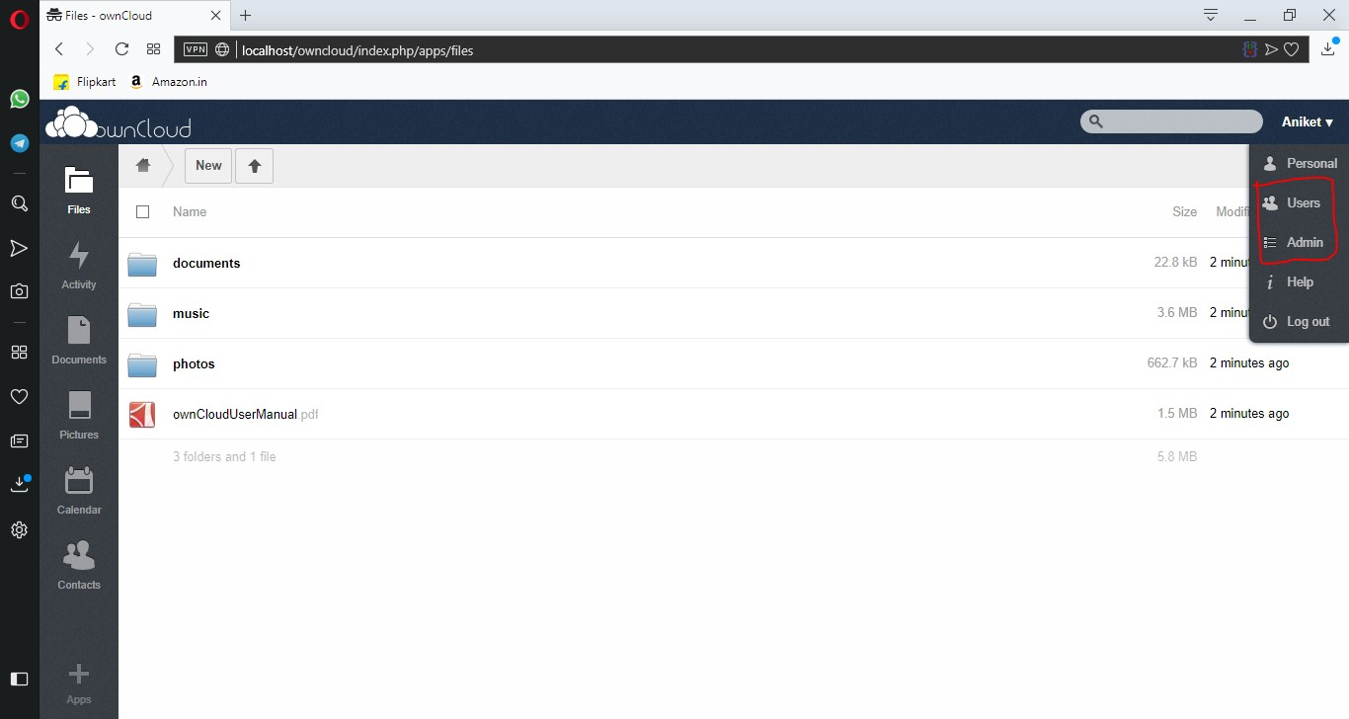

As you can see this user has the privileges of admin because he is in “admin” group.

Note: If it doesn’t shows the privilege then go to admin account and check if this user group is “admin” group.

This user has all the rights that admin possess like adding or deleting user.

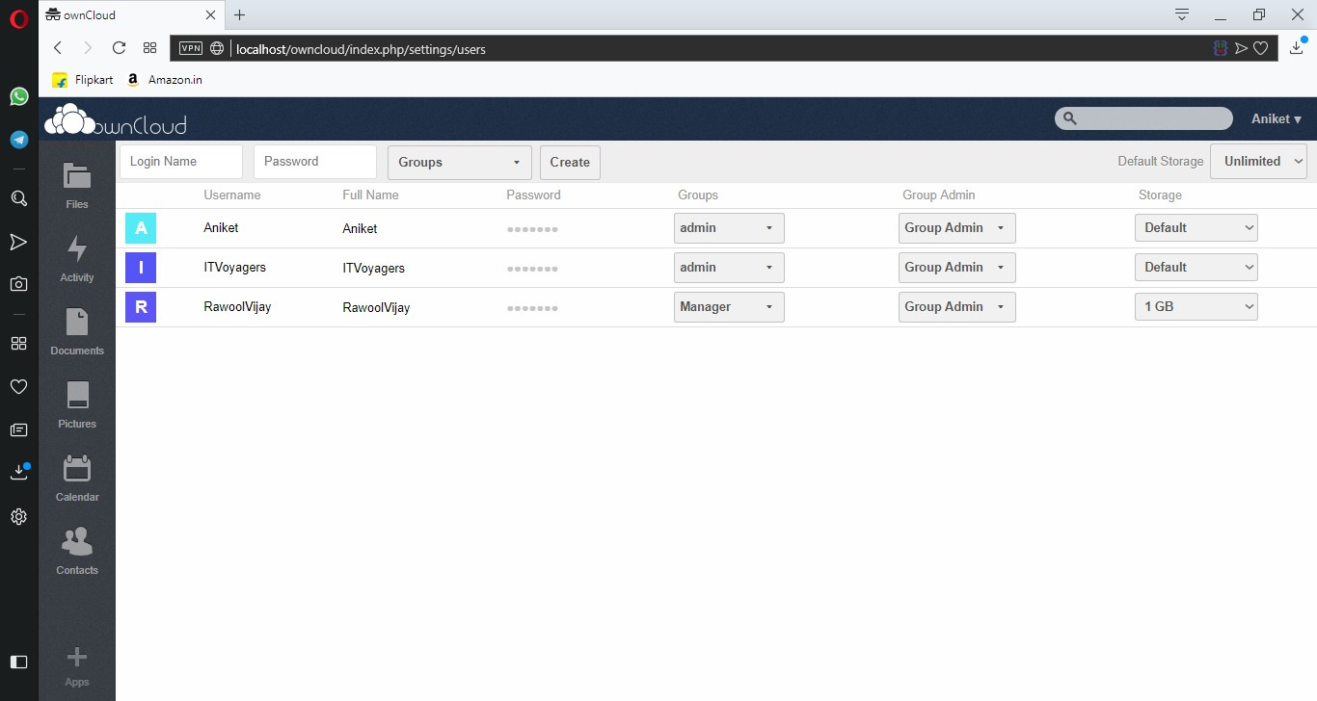

**Practical 10**

**AIM :-** Case study on Google Cloud Platform(In GCP charge only 1/-rupee for creating account and after 3day of tryer free gcp it will take the amount).

**STEPS:-**

1. Open any browser and type <https://cloud.google.com/>and then click on **TRY GCP FREE**.

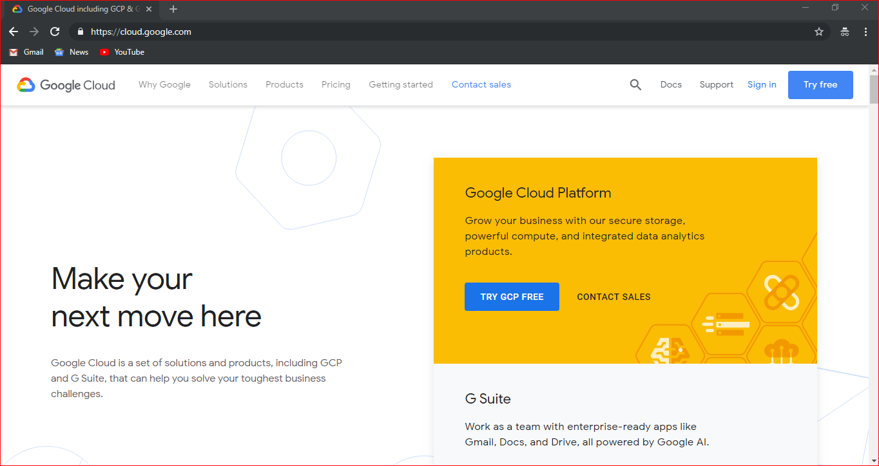

1. After click on TRY GCP FREE your email page is open for sign in, **enter your email-id and password.**

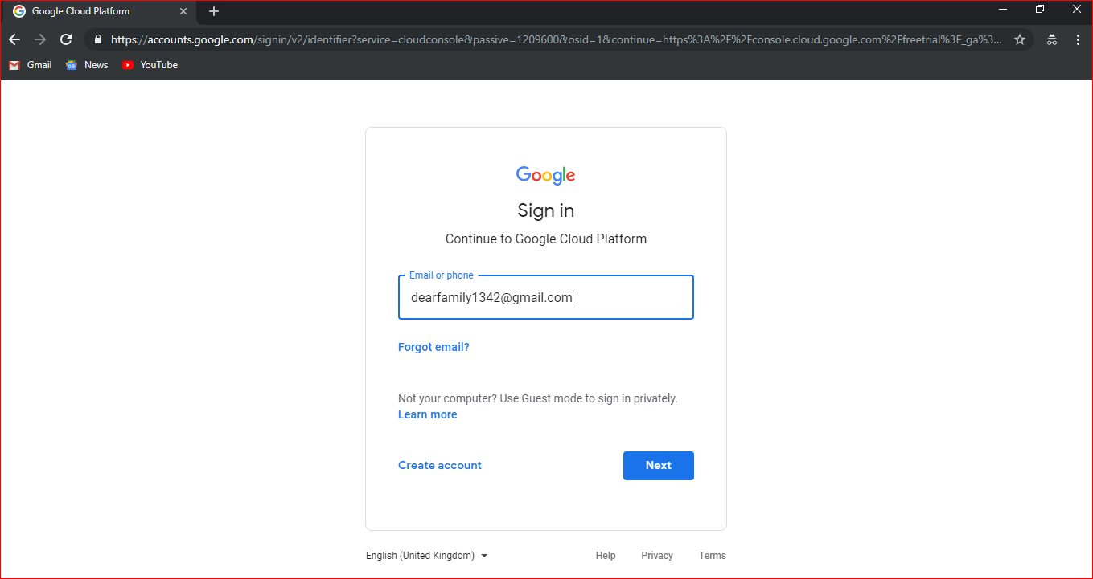

1. After login your account it will ask to **accept the service**, then click on **AGREE AND CONTINUE**.

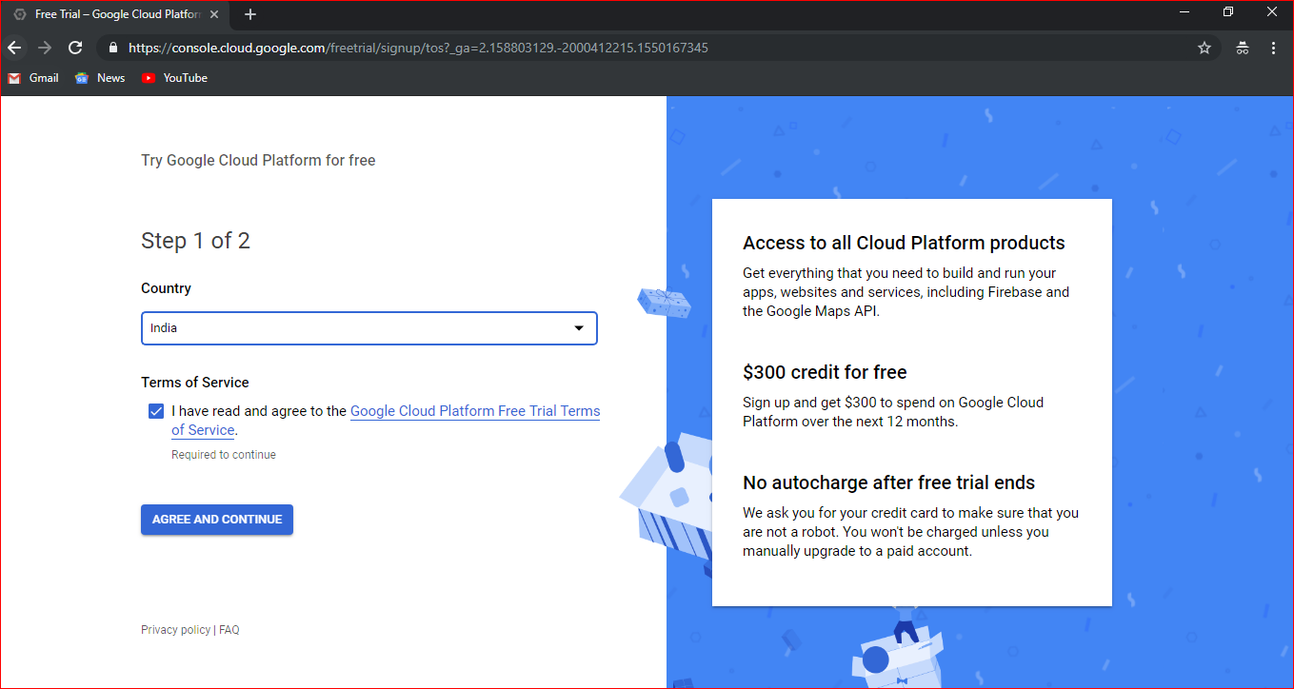

Enter the details here as sown here

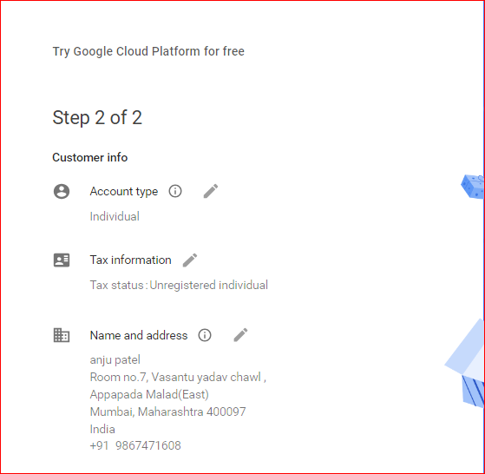

Enter the card detail here to make payment and then click on START MY FREE TRIAL.

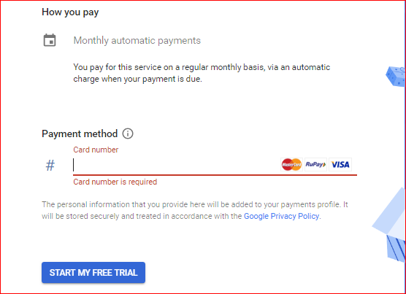

Now it will ask for your **CVC number** enter cvc number , then click on **CONTINUE**.

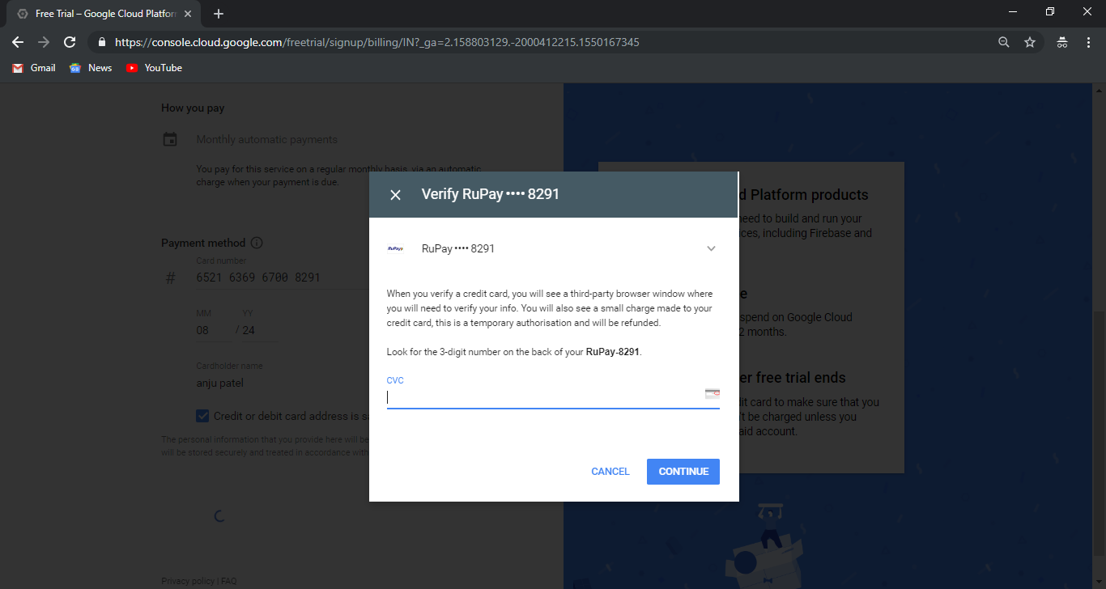

1. After doing all the above step your free tryer gcp window appear.

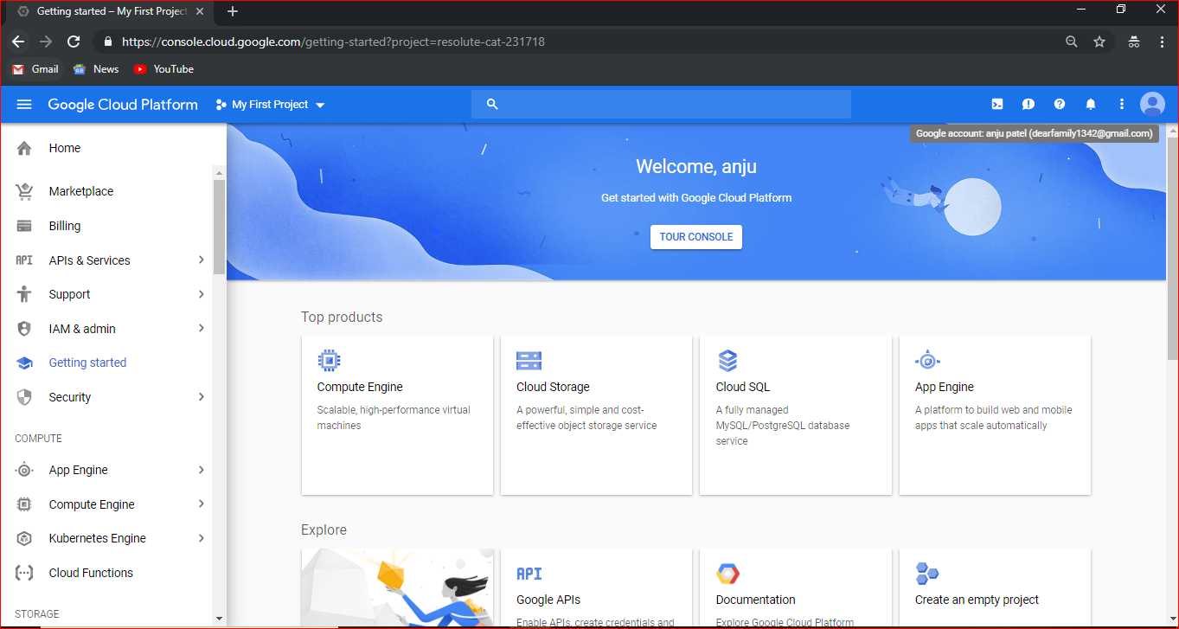

1. To check **Payemt Overview, go to Billing**

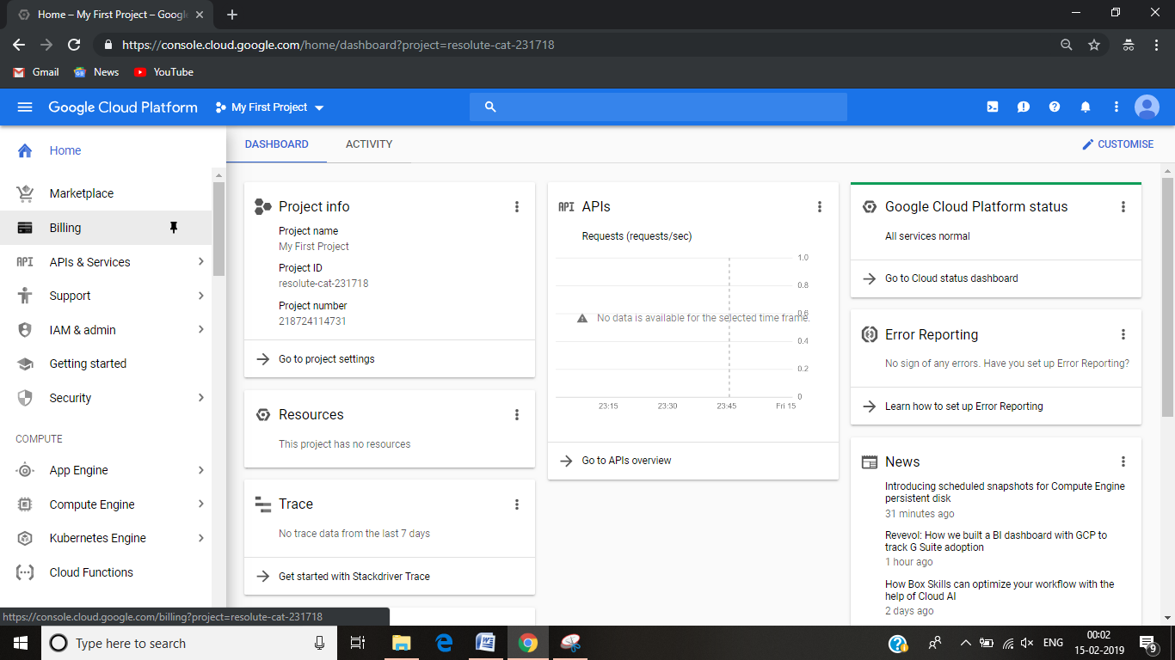

Now click on **Payment Overview**.

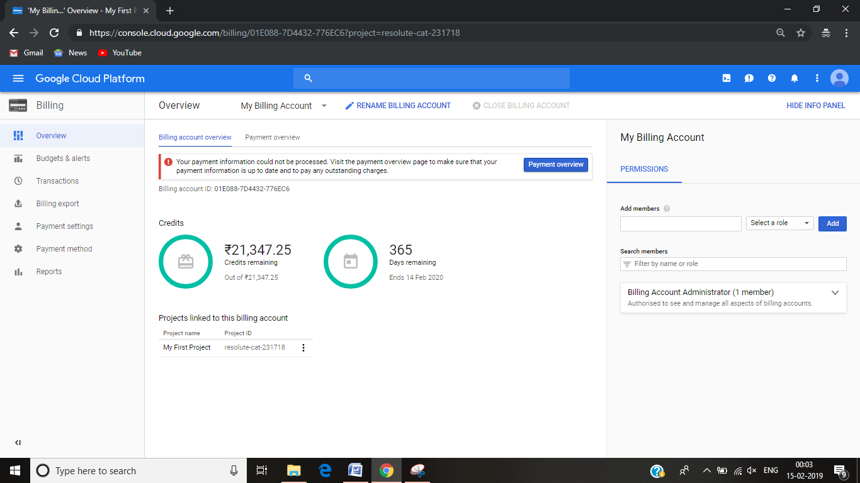

Click on **Verify Now**

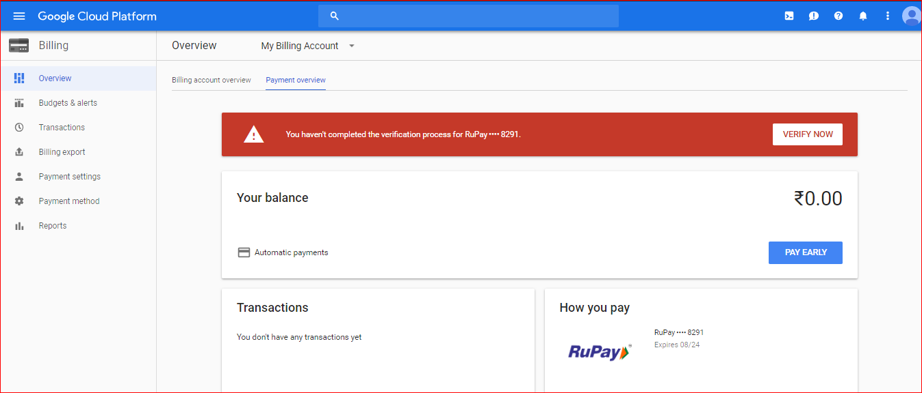

Again it will ask for **CVC number**.Enter cvc number , click on **CONTINUE**.

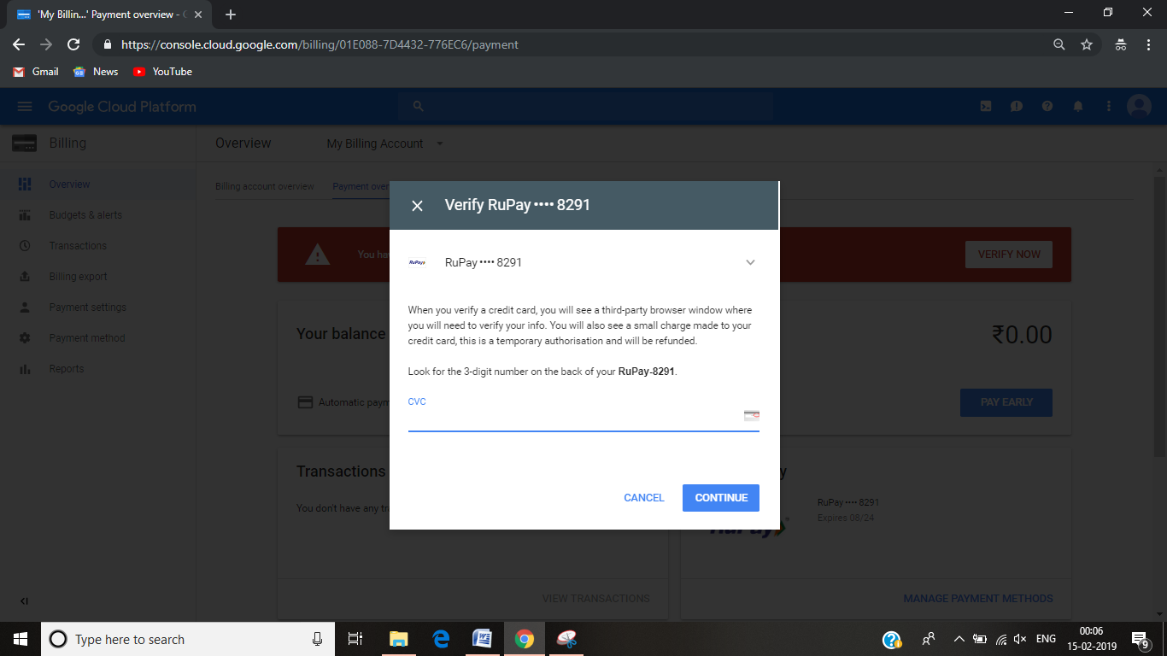

It send the **OTP on your registered mobile number**, Enter number Click on **SUBMIT**.

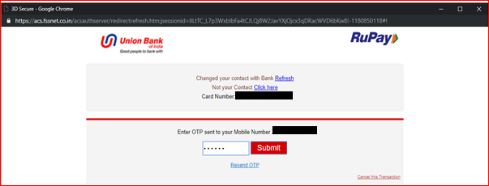

1. Now come back to **HOME**🡪**Compute Engine**🡪click on **VM Instances.**

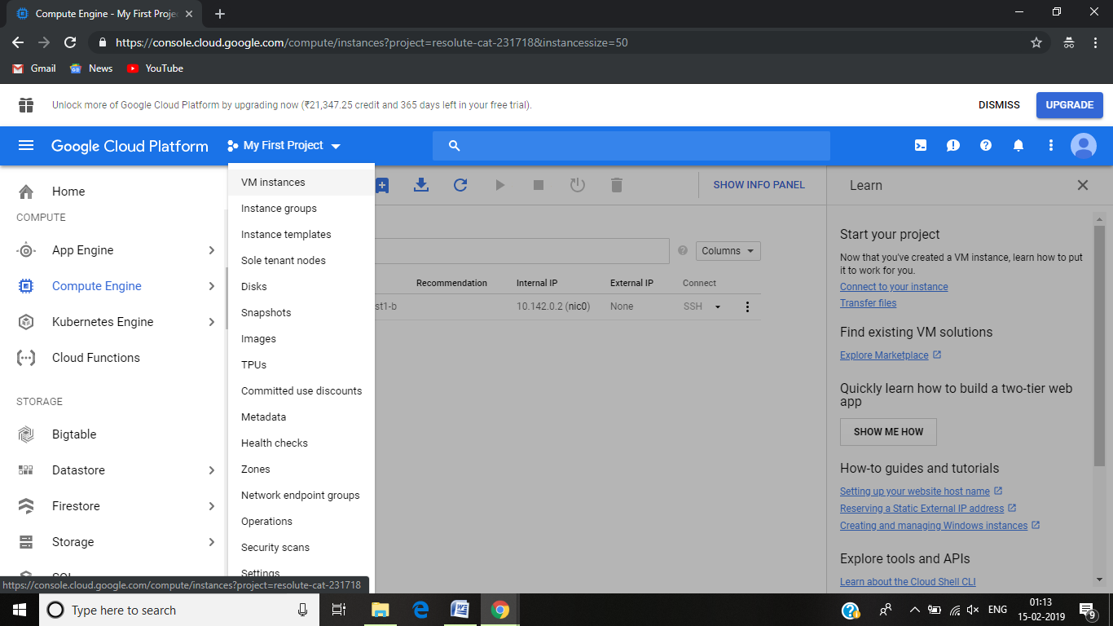

1. Now click on **CREATE**.

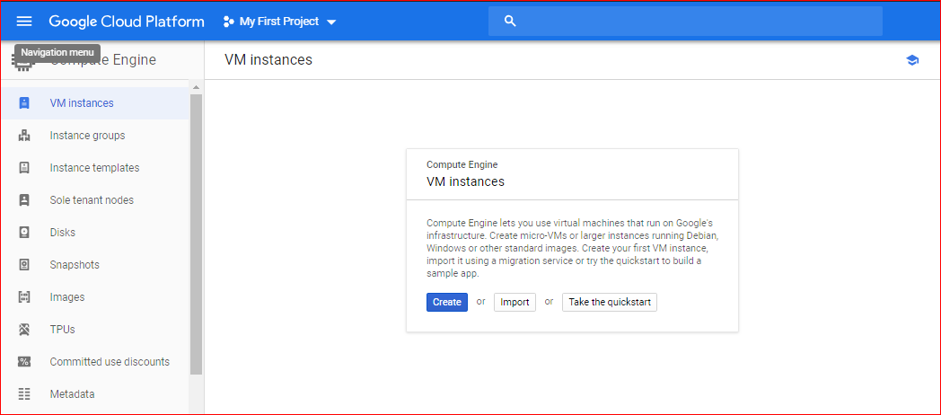

1. Give your **instance name** and you can give your Machine CPU to 2vCPUs to running better ,then click on **CREATE**.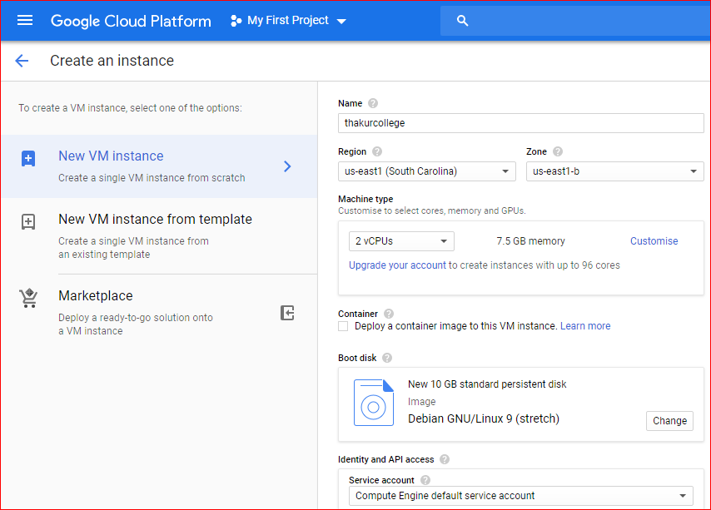

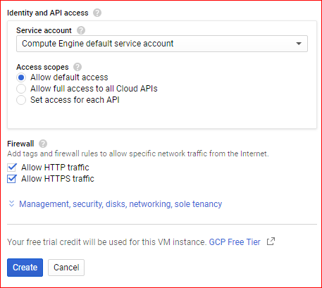

1. Now here your instance is created, **select the instance and from SSH select Open in new Window**.

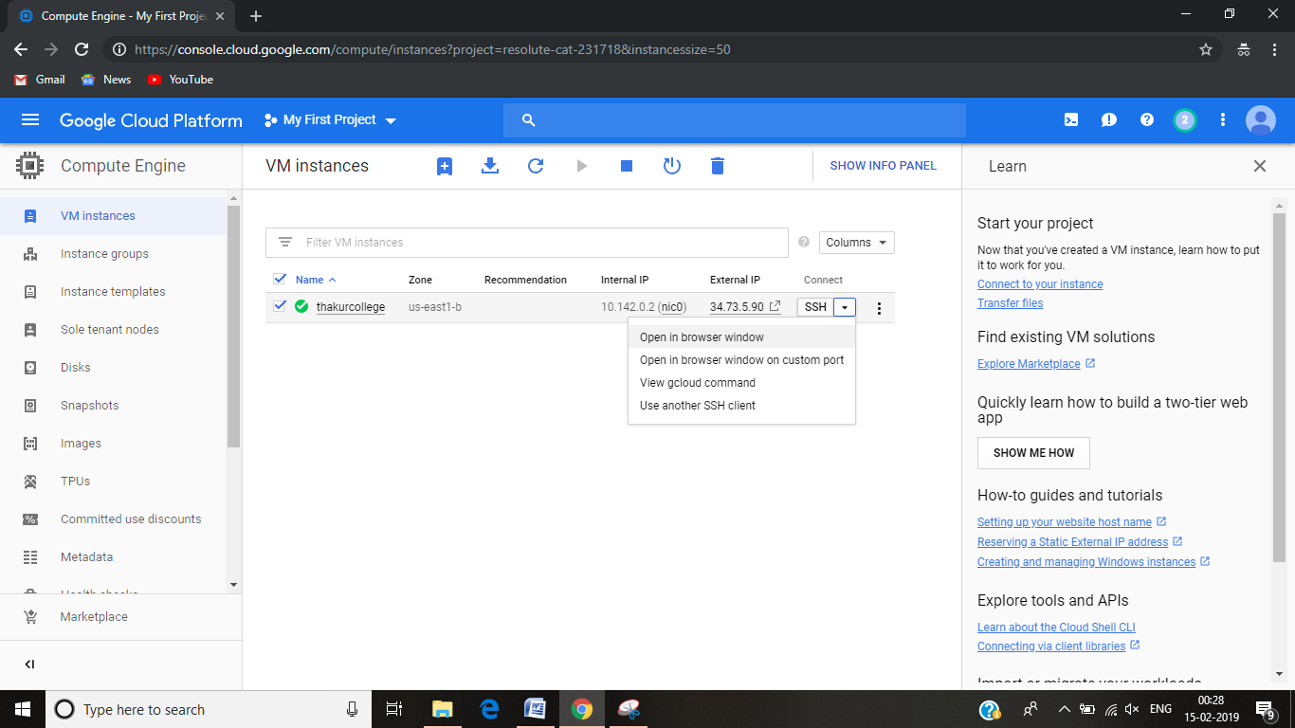

1. Now new Command line window will appear. Here I had done some simple command of linux you can try more command here.

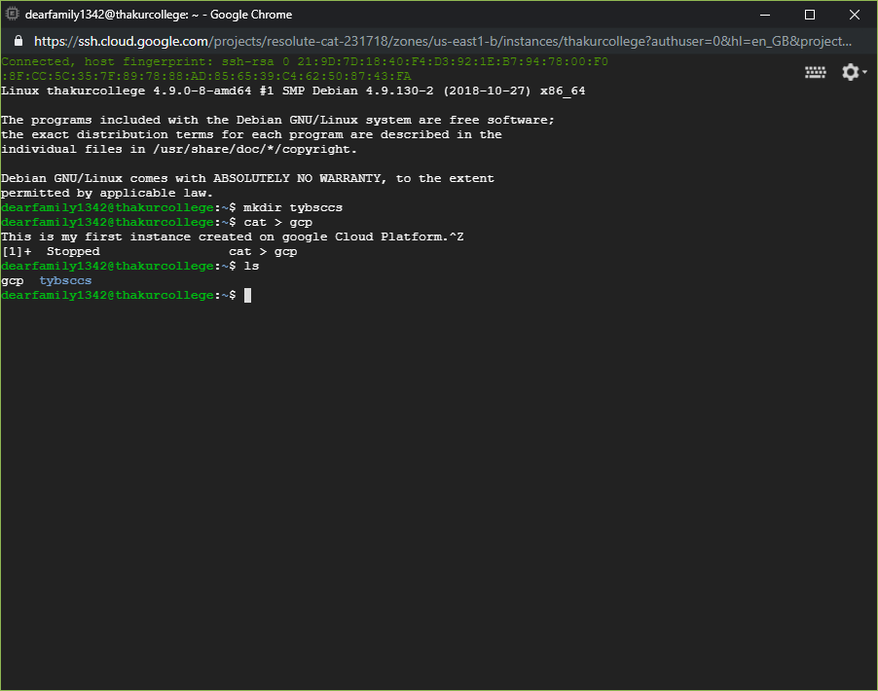

1. For stoping the instance click **square symbol**.

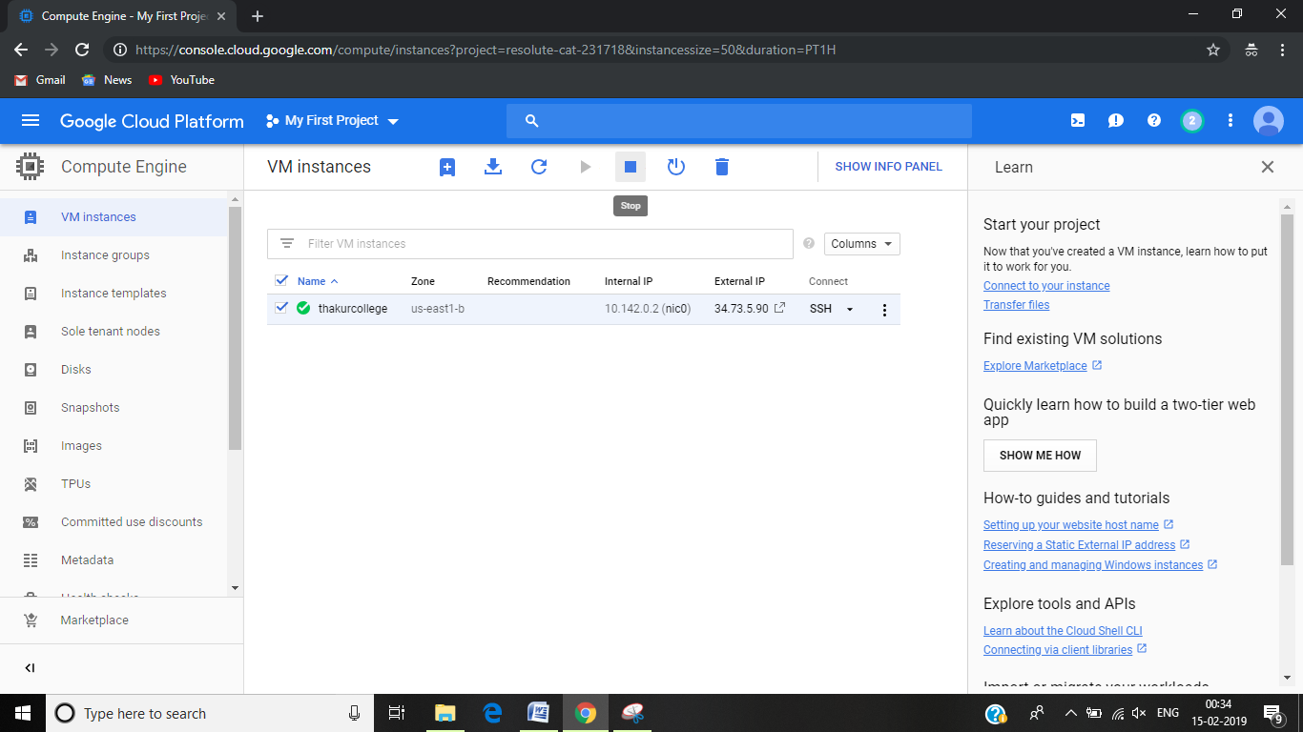

________________________________________FINISH___________________________________